Survey of Women’s Health in the ACT
Report Launch presentation
Transcript, captions and image descriptions of presentation slides
September 2023
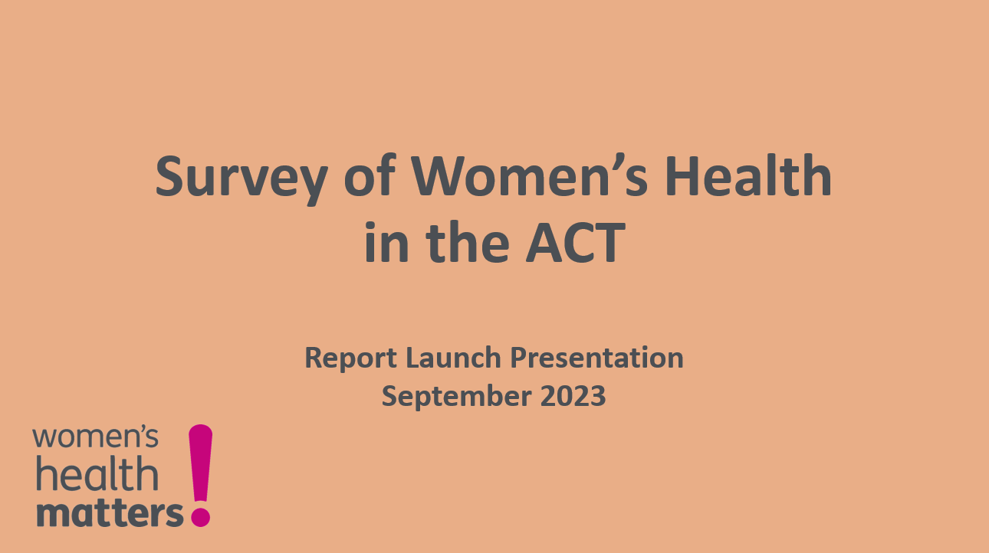
Image description: Slide 1 – Title slide – Text on a salmon coloured background reads “Survey of Women’s Health in the ACT: Report Launch Presentation September 2023”, accompanied by the Women’s Health Matters logo (the words “women’s health matters” with a pink exclamation mark)

Audio and captions:
Hello, my name is Dr Merri Andrew. On behalf of Women’s Health Matters, I acknowledge the traditional custodians of the ACT, the Ngunnawal people, and recognise any other people with connection to the lands of the ACT and region. I acknowledge and respect their continuing culture and the contribution they make to the life of this region.
This presentation is a digital version of the one I gave on 26 July 2023, at the launch of Women’s Health Matters’ Survey Report on Women’s Health in the ACT.
In it I:
- Describe process of designing and implementing survey
- Outline some findings & implications, & our next steps
First, I would like to acknowledge my colleagues who worked on the project.
- Romy Listo, who worked on developing the project plan and did some early work on the survey design
- And Molly Stanley and Jodie Kirkness, who worked on logistics, communications and design
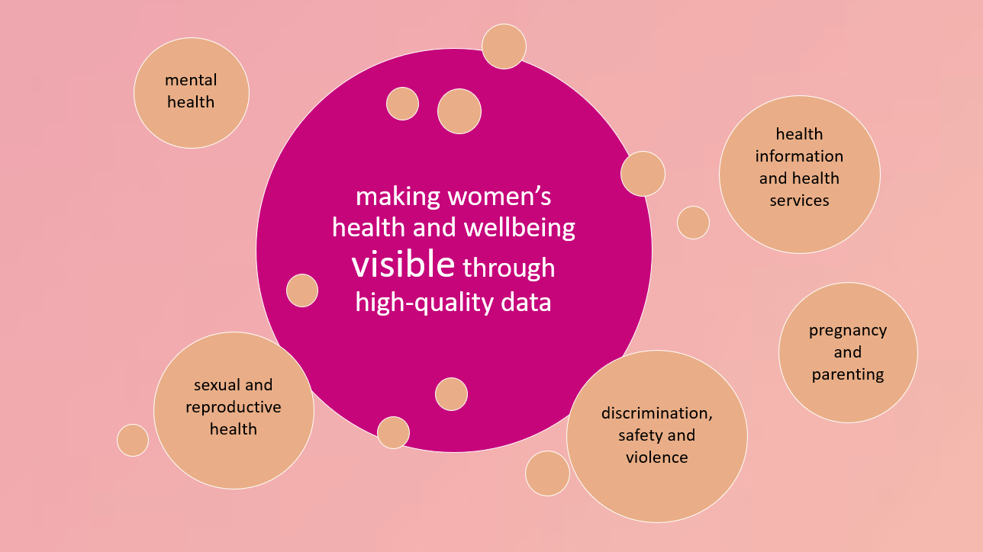
Image description: Slide 2 – A large pink circle on an orange-pink background reads “making women’s health and wellbeing visible through high-quality data” with the word “visible” larger than the other text. Smaller salmon-coloured circles are scattered around the large pink circle, with text reading “mental health”, “sexual and reproductive health”, “discrimination, safety and violence”, “health information and health services” and “pregnancy and parenting.”

Audio and captions:
So, the aims of the survey were to:
- make the state of women’s health and wellbeing in the ACT visible through high quality data
- support advocacy for
  - gender-responsive health services
  - health-supporting communities
The survey was designed to cover some key areas of women’s health:
- General experiences of health, including mental health
- Experiences of using health information and health services
- Deeper look at sexual and reproductive health
- Pregnancy and parenting
- Discrimination, safety & violence
- And of course we asked a lot of demographic questions
The survey was open to women and femme-identifying people and people who align themselves with those groups, who were aged 18 years or over and living in the ACT and region.
- In total, 1668 valid responses were collected (exceeding our target of 1000)
- thanks to many of our friends and stakeholders who helped make that happen!
- And of course thanks to Snow Foundation who funded this project, and ACT Health for funding WHM in general
- We hope to conduct more waves of the survey in the future; we will build on and improve survey design & method as we go
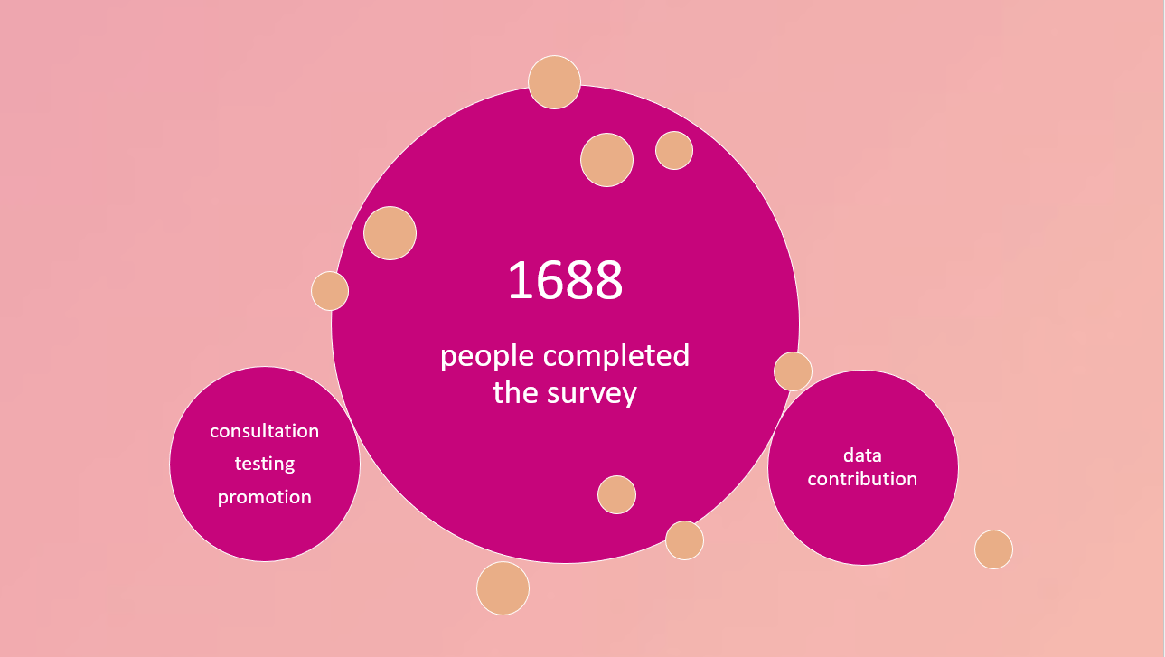 Image description: Slide 3 – A large pink circle on an orange-pink background reads “1668 people completed the survey”. Smaller pink circles on either side read “consultation, testing, promotion” and “data contribution”.
Audio and captions:
A little about the process of designing the survey and how we went about doing it.
So, how did we decide what to focus on and how to word the questions?
- We did a big consultation process
- Several people and orgs gave feedback (thank you)
- We tested the survey in a focus group
- We had to cut a lot of questions out of our initial drafts, including some on COVID-19 and some on experiences of using support services in situations of violence
- You can see the survey instrument online via the QR code as Appendix
  - This also indicates where questions are adapted from other surveys
- If, as hoped, we can do more waves of the survey, we will refine it further and consider adding some of the questions we couldn’t include (or others) on a one-off or less frequent basis

Why a new survey and not just using other data?
- It is true there is a lot of good data already out there!
- For example, the ACT General Health Survey and the Australian Longitudinal Study on Women’s Health
- Some datasets are not designed to look closely at gendered experiences of health and wellbeing (e.g. Wellbeing Framework);
- Some do take a gendered approach but have a different focus (e.g YWCA Canberra focus on housing and homelessness), or smaller numbers in the ACT (e.g. Australian Longitudinal Study on Women’s Health)
- Through this survey we have a large enough sample to be able to consider how variables relate to each other
  - e.g. how experiences of difference kinds of violence might relate to experiences of health service usage
- We have also been able to gather large amounts of qualitative data (people’s open-ended responses to questions)
- Most of this analysis is yet to come over the coming months and years
A little more on the process:
In terms of promoting the survey
- we were able to get such a good size sample (1668) by promoting the survey vigorously over 3 months
- We offered an incentive for people to do the survey, the chance to win one of two $100 vouchers
- We promoted it through social media and traditional media, print and radio, with support from our friends and colleagues in other community organisations, and very helpful posting by ACT Health to their tens of thousands of followers
In terms of data cleaning and analysis:
- The incentive was effective but it also contributed to lots of invalid responses (from out of area, bots, scammers)
- It required lots of data cleaning to remove these
- We are very confident data is high quality now
- Next time will consider other ways to minimise this workload
- For data management and analysis we used Stata package
- We also had the presentation of data reviewed by an ANU survey specialist
Like every survey, ours had strengths and limitations.
- In terms of the strengths – we had a large sample – significantly larger than ACT General Health Survey [note: larger for cohort of women] & larger than ALSWH sample in ACT
- We asked lots of demographic questions – Aboriginal & Torres Strait Islander status, disability, cultural and language background
- Our sample is broadly representative of ACT community
- However we have proportionally fewer young [under 24] and older [55+] people than in the population generally – our survey respondents were concentrated around the 35-44 age group
- And proportionally fewer people born overseas and speaking language other than English as main language or preferred language
- This is a challenge with online surveys in English & one we will aim to address in future iterations e.g. through translated versions and community outreach
- Survey participants elf-selected, so this may reflect our networks
- However, a large sample gives confidence and we have a large sample
- This enables stronger analysis between variables
- And of the data from people with particular identities/characteristics
- Will enable us to explore collaborations with other advocacy and community groups to look more closely at subsets within the data and advocate together
- We hope it will be a community resource

Turning now to the findings
- I only have time for a few, so please do take a look through the full report (via QR code at end of this presentation)
- Here I will begin to flesh out some of the implications of the findings
- I acknowledge more work is needed to contextualise these in order to contribute to policy and health services development
- There are plenty of positives for many people living in the ACT
- I acknowledge the ongoing work that people are doing
- Our role is to look for ways to improve health and wellbeing, which means looking closer at areas where there are problems and barriers
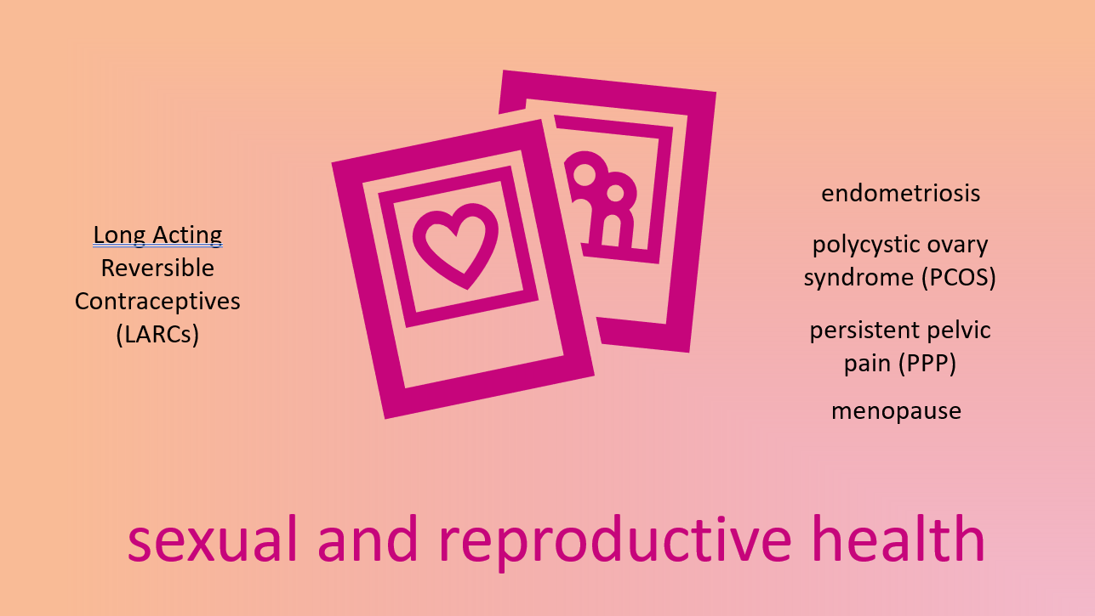
Image description: Slide 4 – Text in pink on a salmon-pink background reads “sexual and reproductive health.” In the centre pink icons of framed pictures show a love heart and two stylised people icons side by side. To the left of the pictures is the text in black “Long Acting Reversible Contraceptives (LARCs)” and to the right, “endometriosis, polycystic ovary syndrome (PCOS), persistent pelvic pain (PPP), menopause.”
Audio and captions:
The survey shows sexual and reproductive health needs more attention.
One positive is the relatively high uptake of Long Acting Reversible Contraception compared with Australia-wide studies.
- This is important because LARCs are more effective, take less effort, cost less over long term and have higher satisfaction than other kinds of contraception
- Taken together, 39% of respondents in our survey used some form of Long Acting Reversible Contraceptive (LARC), which in our study we defined as including IUDs, implants, injections and vaginal rings
- National level studies show rates of between 11% and 24%
However, people experiencing reproductive health conditions such as endometriosis, PCOS, persistent pelvic pain and symptoms of menopause do not have access to satisfactory services for these conditions.
- People had poor experiences accessing care for polycystic ovary syndrome (PCOS) and endometriosis
- Over half of people who had been diagnosed with or treated for these conditions said they were ‘Dissatisfied’ or ‘Very dissatisfied’ with their healthcare for the conditions
- Further analysis of open-ended responses will be useful for understanding the health needs and barriers facing people who may be experiencing these conditions.
We found similarly poor experiences accessing care for Persistent Pelvic Pain (PPP) more generally.
- PPP is pain below your belly button and above your legs that is present on most days, or more than 2 days of your period (for people who have periods), for six months or more
- This includes people who have endometriosis
- PPP is widespread – over a quarter of people in our survey had experienced PPP
- Around two thirds of those (17% of the survey sample as a whole) had missed work or study as a result in the last 12 months
- This indicates the importance of measures such as reproductive health leave
In relation to menopause, we found that over 40% of people who had gone through menopause reported they were ‘Dissatisfied’ or ‘Very dissatisfied’ with access to support services.
- Open ended responses indicated that many people did not know about options to seek help with symptoms of menopause, that they may be being constrained by stigma, sexism and ageism, and implicitly encouraged to believe they simply needed to cope in silence
- Again, further analysis will be useful to unpack this.
Overall these findings indicate need for strategic and coordinated approaches to sexual and reproductive health overall, more health promotion and access to high-quality services and support for people with reproductive health conditions
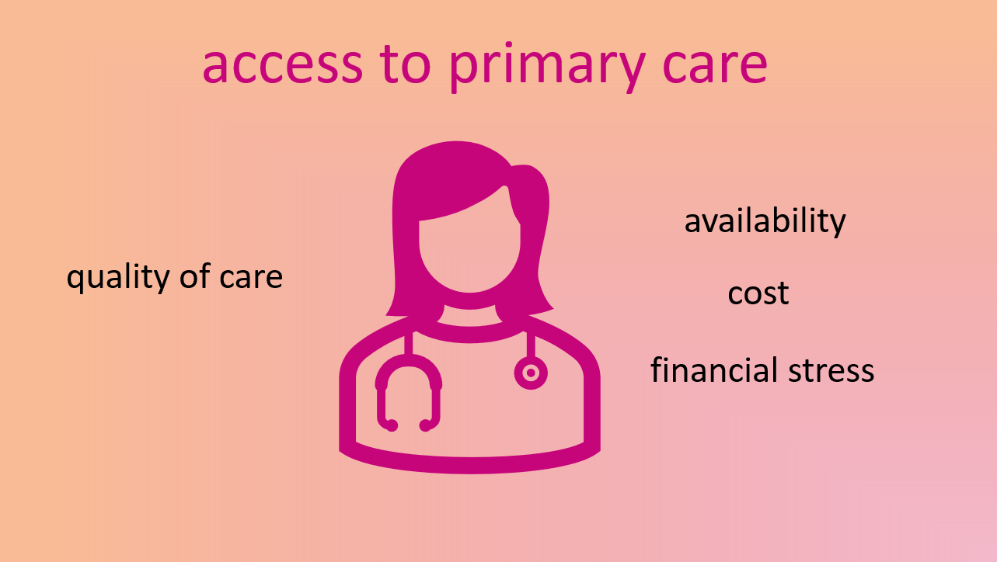
Image description: Slide 5 – heading text in pink on a salmon background reads “access to primary care”. The slide shows an pink icon of a person with shoulder length hair, wearing a stethoscope around their neck. To the left of the icon, text in black reads “quality of care” and to the right, “availability, cost, financial stress”.
Audio and captions:
Turning now to access to primary care, we found that this too needs attention.
- General Practitioners or GPs are important and over 92% of our respondents had consulted a GP in last 12 months
- Respondents rated experiences with GPs well overall for
  - the quality of GPs’ skills,
  - their explanations,
  - their opportunities to ask questions,
  - how well the doctor listened,
  - their respect for patients’ dignity and different backgrounds, and
  - the accessibility of facilities
- However, we found gaps in access to GPs, especially in relation to cost and appointment availability
- A quarter of respondents rated access to GPs as only ‘fair’ or ‘poor’ (that is, in the bottom half on a five-point scale)
- The problems most commonly reported were
  - difficulty getting an appointment (61%) and
  - too expensive (24%)
- Over three quarters rated their access to bulk-billing GPs as only ‘fair’ or ‘poor’
- We found that people who reported more experiences of financial stress also rated their access more poorly, compared with respondents as a whole

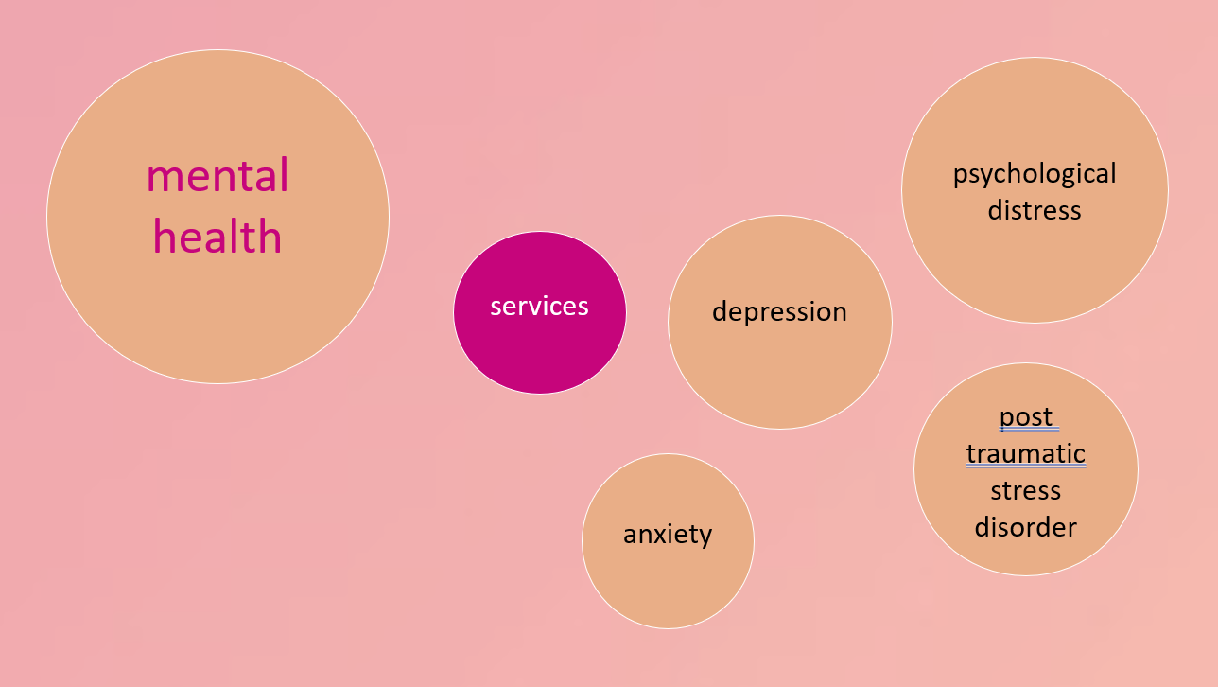
Image description: Slide 6 – a large salmon coloured circle to the left on a pink background contains text reading “mental health” in pink, while smaller salmon circles to the right contain text reading “anxiety”, “depression”, “psychological distress”, and “post traumatic stress disorder” in black. Between the large and small circles a small pink circle contains text in white reading “services.”
Audio and captions:
The third area I’d like to focus on is mental health. We found that mental health needs attention.
- In our survey psychological distress was widespread
- 19% of respondents reported psychological distress at levels indicating they probably have a serious mental illness
- This is higher than previous ACT General Health Surveys, but similar to some recent national studies looking at the impact of the COVID-19 pandemic
- Most respondents in our survey had been diagnosed with or treated for a mental illness at some time in their lives and 45% in last two years
- The most common conditions reported were:
  - anxiety
  - depression
  - post-traumatic stress disorder
- Despite widespread experiences of psychological distress and mental illness, only just over a third of respondents had consulted a psychologist, counsellor or other mental health worker in the last year
- Access to mental health services was rated most poorly out of a list of 14 types of health services
- And 70% of respondents rated access to mental health services as only ‘fair’ or ‘poor’
- Mental health and access to mental health services is a common thread in concerns expressed to us across a range of areas in our work, and one we will be aiming to focus more on over the coming years
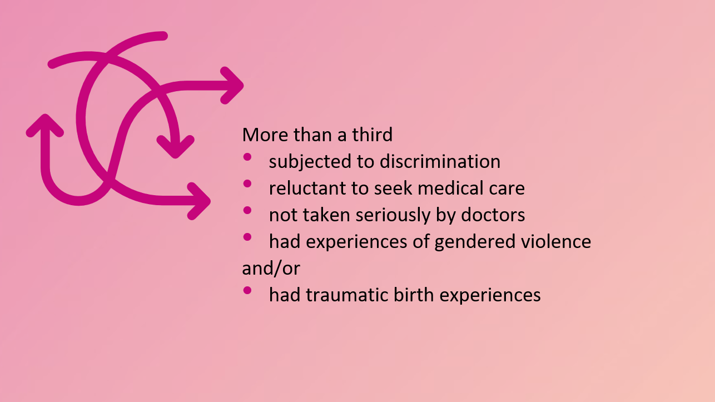
Image description: Slide 7 – on a pastel pink background, curving, tangled pink arrows are shown at the left. To the right of the arrows, text in black reads: “More than a third: subjected to discrimination, reluctant to seek medical care, not taken seriously by doctors, had experiences of gendered violence and/or had traumatic birth experiences.”
Audio and captions:
The final area of our findings I’d like to emphasise is that across our survey, many people reported experiences that undermine their health and wellbeing, and also undermine their ability to improve their own health and wellbeing.
- While most people had satisfactory experiences with accessing medical care generally, significant numbers of people – more than a third – had one or more of these experiences:
  - A third of people reported having experienced discrimination, with the most common reasons for discrimination being gender, age, appearance
  - However it’s important to note the underrepresentation of migrant and refugee people in our study, which also indicates that discrimination on the basis of cultural background and language background may be underrepresented also.
  - Over a third of people reported that they only go to doctor if no other option, and a quarter reporting they avoid seeing a doctor
  - Over a third of people reported they were taken seriously by doctors only somewhat or not at all
  - And many people across our study reported experiences of gendered violence, such as reproductive coercion, sexual violence, domestic and family violence, workplace sexual harassment, and institutional violence
  - Just under half of people who reported giving birth had traumatic birth experiences

- These findings Indicates the need for better access to gender-sensitive, equity-oriented and trauma-informed health care across all types of care (primary care, different specialists, health promotion and information).

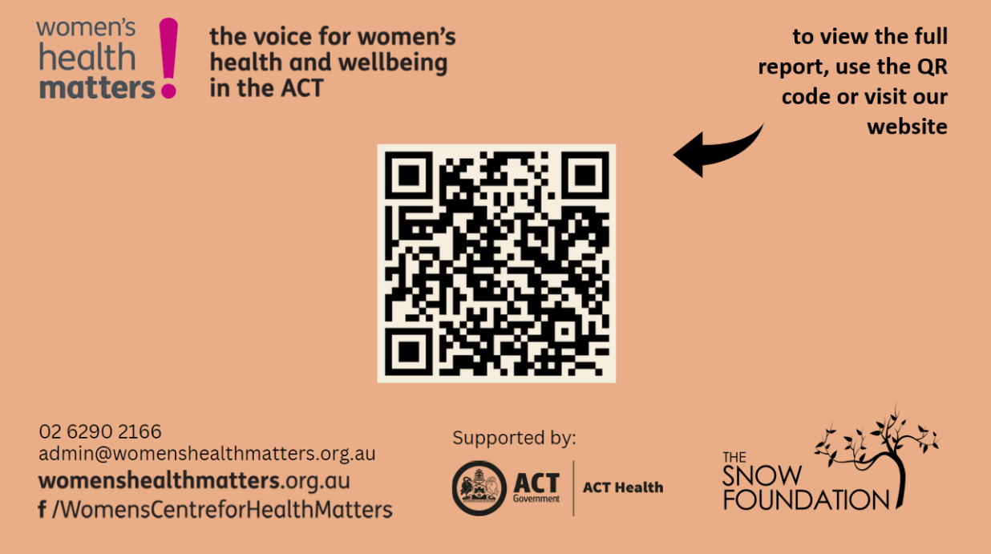
- Image description: Slide 7 – On a salmon-orange background, several logos and blocks of text are positioned around a black and white QR code, which has an arrow pointing to it from text reading “to view the full report, use the QE code or visit our website. One logo reads “women’s health matters! The voice for women’s health and wellbeing in the ACT”, another block of text reads “02 6290 2166, admin@womenshealthmatters.org.au, womenshealthmatters.org.au, f/WomensCentreforHealthMatters”, another reads “Supported by:” followed by the logo of ACT Government (black and white swans around a crest) ACT Health, and The Snow Foundation (a curved tree with leaves).
Audio and captions:
That brings us to the end of the presentation.
To wrap up, in the next steps with this project:
- We’ll be doing further analysis to look at subsets of the survey sample and consider the relationships between variables
- We’ll be analysing the qualitative open-ended responses that people have given us
- And well be looking at how we can use the survey data in our other projects, for example, understanding needs of people who’ve been subjected to different kinds of violence
- We’ll be seeking collaborations to look deeper at the data and see how we can use it to improve health and wellbeing in the ACT
- And we’ll be promoting the report and encouraging people to read it!
- Which you can do by using the QR code on the screen, or visiting our website, which is www.womenshealthmatters.org.au (that’s women’s health matters as one word with no spaces or punctuation)
- Or you can phone us on 02 6290 2166
- Or you could email admin@womenshealthmatters.org.au
Thank-you for your interest in our work and thank you for watching, listening to or reading this presentation.

