What makes public spaces safer for ACT women?

Emma Davidson
January 2019
Acknowledgements
Thank you to all the ACT people, particularly women, who contributed reports using the Safety Map tool developed by the Women’s Centre for Health Matters. We hope that through documenting women’s feelings of safety in ACT public spaces, we can better influence change in Canberra’s urban planning design, leading to improved use of public spaces by women.

Publication/Copyright Information
ISBN 978-0-6484409-1-8
© 2019 Women’s Centre for Health Matters Inc.

Published by Women’s Centre for Health Matters Inc.
This publication is protected by copyright. Apart from any use permitted under the Copyright Act 1968, no part may be reproduced without acknowledgement.

About Women’s Centre for Health Matters Inc.
The Women’s Centre for Health Matters Inc. (WCHM) is a community based organisation which works in the ACT and surrounding region to improve women’s health and wellbeing. WCHM believes that the environment and life circumstances which each woman experiences affects her health outcomes. WCHM focuses on areas of possible disadvantage and uses social research, community development and health promotion to provide information and skills that empower women to enhance their own health and wellbeing. WCHM undertakes social research and advocacy to influence systems’ change with the aim to improve women’s health and wellbeing outcomes. WCHM is funded by ACT Health.
About the Author
Emma Davidson is the Deputy CEO of the Women’s Centre for Health Matters. She has completed a Bachelor of General Studies from Griffith University. She has experience using quantitative and qualitative data to support the development of community understanding of the lived experience of women.

Contents
Introduction 4
Mapping feelings of safety in the ACT 6
Findings 7
Who Made Reports 7
Where people felt safe or unsafe 8
Why people felt unsafe 11
Gendered differences in why people felt unsafe 12
Lighting 13
Threat of assault from other people in the area 13
Isolation 14
Infrastructure 15
Reputation 15
Graffiti, vandalism, litter, or evidence of drug use 16
Other 16
Why people felt safe 16
Improving women's use of public spaces 18
Why women felt unsafe 18
Making an area feel safer 19
Appendix A 20
Suburbs by District 20

Introduction
The design and structure of cities is well understood as having an impact on a city’s walkability and usability, which in turn has impacts on the health and wellbeing of people who live there.

Because it has the potential to encourage or inhibit the social participation of women, urban planning in the ACT is an important issue. Urban planning and design affect the accessibility of services such as health care, education, shopping centres, banks, post offices, and public transport. This is particularly important for women who are more likely to be reliant on active travel and public transport, such as older women, women with disabilities that prevent driving, students, and women who cannot afford car ownership.

Women’s feelings about their safety affects the amount of time they spend walking, running, or cycling for recreational purposes, their willingness to go out at night, or their willingness to go out alone. The repercussions include reduced participation in physical activity, reduced active travel for work or study, and reduced participation in community or social events at night.
“Perceived safety from crime was associated with increased time spent walking in the local neighbourhood, and more specifically with recreational walking.”
WCHM knows from our previous work that perceptions of personal safety can influence the extent to which some people in the ACT use public places and spaces, preventing some people from fully participating in the community.

For example, to ensure that spaces (and public events) were safe for women, WCHM used safety assessments to consult with ACT women and identify how to go about making changes to improve the safety of a location.

In WCHM's report Where do older women feel unsafe and why?, published in 2015, we found that the perceptions of safety in public spaces for older women in Canberra were often based on their own personal experience, or the experiences of other women. Feeling unsafe in a public space resulted in older women restricting their participation in public spaces, particularly after dark and when they were alone. Women said that they felt unsafe in public spaces where there was poor lighting or barriers to visibility, in isolated areas or where there was no passive surveillance, where there was no clear signage, with inadequate security or access to help, or where there were other people in the area who may be a threat to their personal safety.

That is why WCHM developed the Safety Mapping Tool to gather information from Canberrans (particularly women) about the public places and spaces in the ACT where they feel safe or unsafe, and to understand what elements contribute to those spaces being perceived to be safe or unsafe.

This report documents the findings from the Tool since it was launched in June 2016. It confirms that women and men use public spaces differently, and have different ideas about what makes them feel safe or unsafe in those spaces.

While we know that women are more likely to experience physical violence in their home by someone known to them, the results show that the fear of sexual assault by strangers in public spaces does affect women’s willingness to be in public spaces. This is different to the reasons that men give for feeling unsafe in public spaces, which were worries about being robbed, or concern for the safety of others.

All women have a right to feel safe in their community. But our research into women’s feelings of safety in public spaces in the ACT shows that even in areas with low rates of reported crime, women feel unsafe due to the risk of assault or sexual assault, particularly after dark. Areas where women report feeling unsafe include public parks, bus stations, and in commercial areas where they may be visiting shops and restaurants.

Changes to the physical environment that result in women feeling safe in these public spaces would enable women to participate freely in their communities, such as going out socially, feeling safe to use active travel to get home from work after dark, physical activity for health and fitness, and participating in community events.
“…the neighbourhood social environment was associated with physical activity in the expected direction and that perceptions of personal safety was a mediating mechanism through which the social environment may operate to influence leisure-time physical activity (LTPA) and walking among women…”
WCHM have provided advice to ACT Government on public places where women felt unsafe, why they felt that way, and what can be done to improve feelings of safety in public spaces, throughout the collection of data using the Safety Mapping Tool. WCHM will continue to use the voices of women to influence the future design of public spaces in the ACT by providing feedback to ACT Government about the reasons that contributed to women’s safety concerns, with the aim of improving urban planning and design in the ACT and making Canberra a more inclusive community.

Mapping feelings of safety in the ACT
In 2016, WCHM launched the Safety Mapping Tool to identify public spaces in the ACT where women feel safe or unsafe, and why they feel that way. The aim was to gather information about a broad range of public spaces, from women of all ages.
The Safety Mapping Tool, designed by Black Swan Productions and produced with assistance from ACT Government, can be used on desktop or mobile devices in a web browser.
To make a safety map report, the user must select a point on a map, or mark out a geographic area. The user then provides some information about themselves and how they feel in the area:
- Gender (choose from Female, Male, or Other)
- Age (choose from <17, 18-24, 25-34, 35-44, 45-54, 55-64, 65-74, 75+)
- Do you have an impairment or disability that impacts on your use of public spaces? (text)
- How they feel in the area (choose from Very Safe, Safe, Unsafe, Very Unsafe)
- Why did they feel this way? (text)
- Weekday (choose from list of week days)
- Time of day (choose from All the time, Morning, Noon, Afternoon, Early evening, Evening, Midnight, Early morning, Dawn)
- Comments (text)
The only mandatory fields, once a point or area has been marked on the map, are gender and how they feel in the area. These fields were made mandatory a short time after the Safety Map was launched, which means that some reports were made without identifying gender.
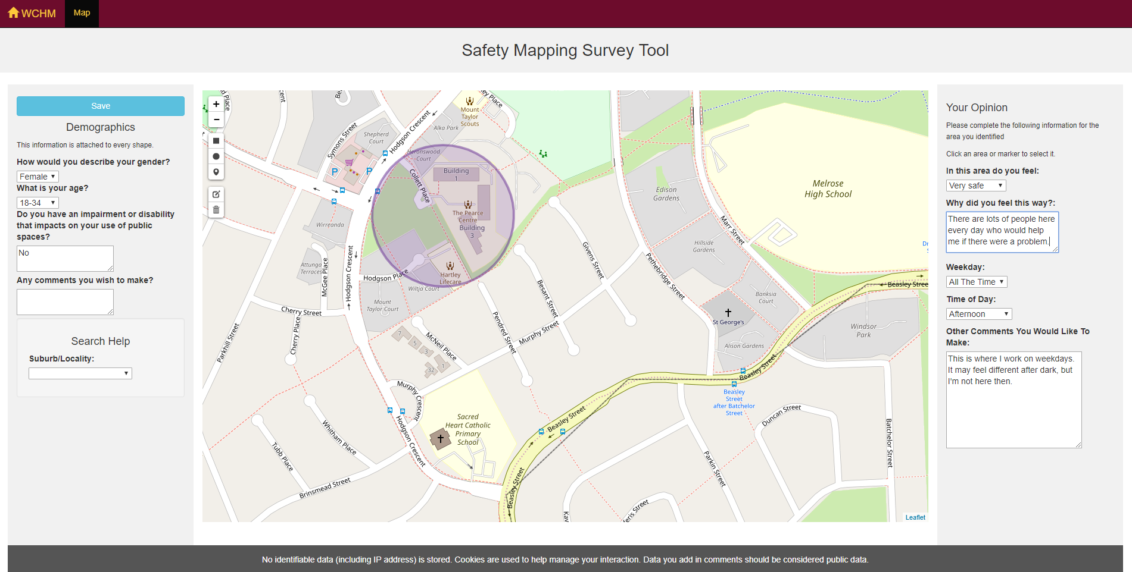

Findings
Between 23 June 2016 and 21 August 2018, a total of 363 valid reports were made using the online Safety Map tool.
The data presented in this report does not include reports where there was not enough data for analysis (eg no indication of how the person feels and no comments about the location). Reports that didn’t include a setting for how the person feels (eg safe or unsafe), but did include comments about the area, were included in analysis.

Who Made Reports
Of the total reports made about ACT spaces, most were from people who identified as female (82 per cent). Thirteen of those women identified as having a disability. Most women who made reports were aged 18 to 54 years old, with 59 per cent of all the reports from women in the 18 to 34 years age group, and 32 per cent from women in the 35 to 54 years age group. Only 7 per cent of reports were from women who stated their age as 55 years or older, and 4 reports were made by women who did not choose an age group.
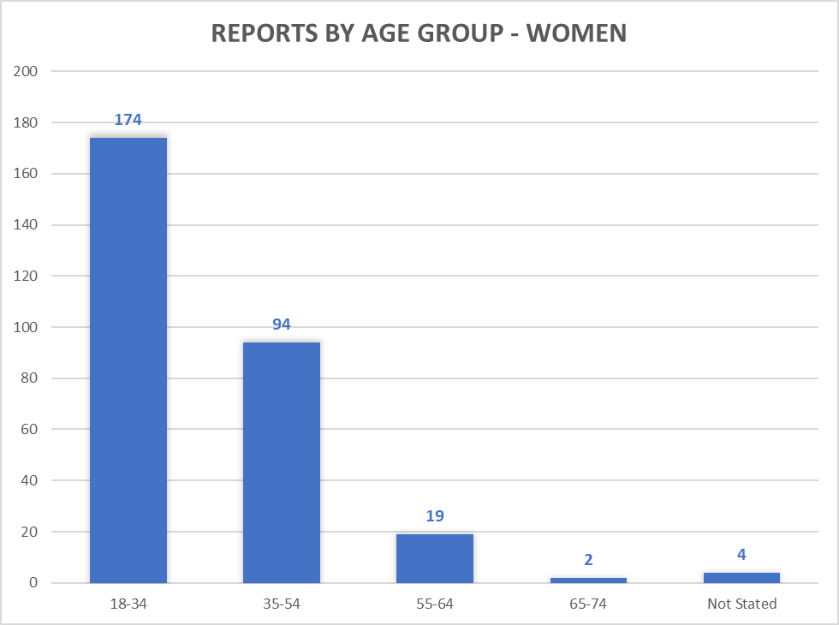
Figure 1 All reports by people who identified as female, by age group
Only five per cent of all reports were made by people who identified as having a disability, although 27 per cent of all reports were made by people who chose not to state whether they have a disability. Of the 19 reports where the person identified as having a disability, all the reports were about feeling unsafe or very unsafe.
Of the reports made by women aged 18 to 34 years, ninety per cent of the reports were about feeling unsafe or very unsafe. For women aged 35 to 54 years, the percentage was ninety three per cent. Of the women aged 55 years or older, or the women who did not state their age, all of the reports were about areas where they reported feeling unsafe or very unsafe.

Where people felt safe or unsafe
A listing of the suburbs by district is included in Appendix A. Only suburbs for which valid reports were received have been listed. Therefore, there are no suburbs listed for the new residential areas in the Molonglo Valley district, which had a population of 4,578 in the 2016 Census.
Of those suburbs where people reported feeling “unsafe” or “very unsafe”, 59 per cent were in the Inner North district. Six of the top ten suburbs with reports of feeling unsafe or very unsafe were Inner North suburbs.
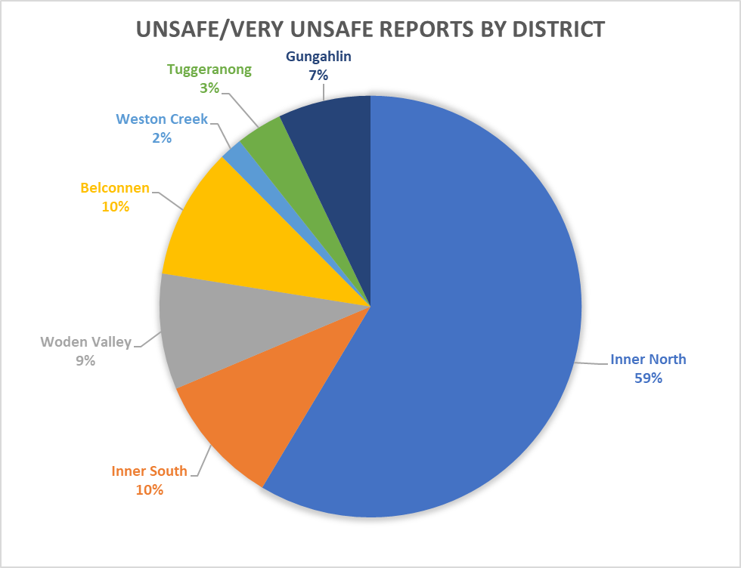Figure 2 All reports where the person felt unsafe or very unsafe, by district
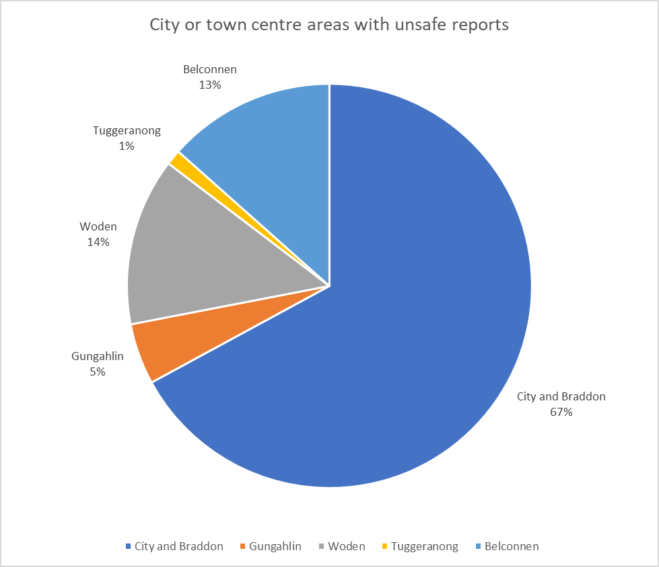Looking specifically at reports made by women who reported feeling unsafe or very unsafe in town centre or CBD areas, 36 per cent were about parks, with 15 per cent of all town centre and CBD reports of feeling unsafe being about Haig Park specifically. Only six per cent of the reports were about bus stations. Half of the reports were about areas in the town centre or CBD that were not parks or bus stations, such as on streets in commercial zone areas.
Figure 3 All reports where the person felt unsafe or very unsafe in town centre or CBD areas

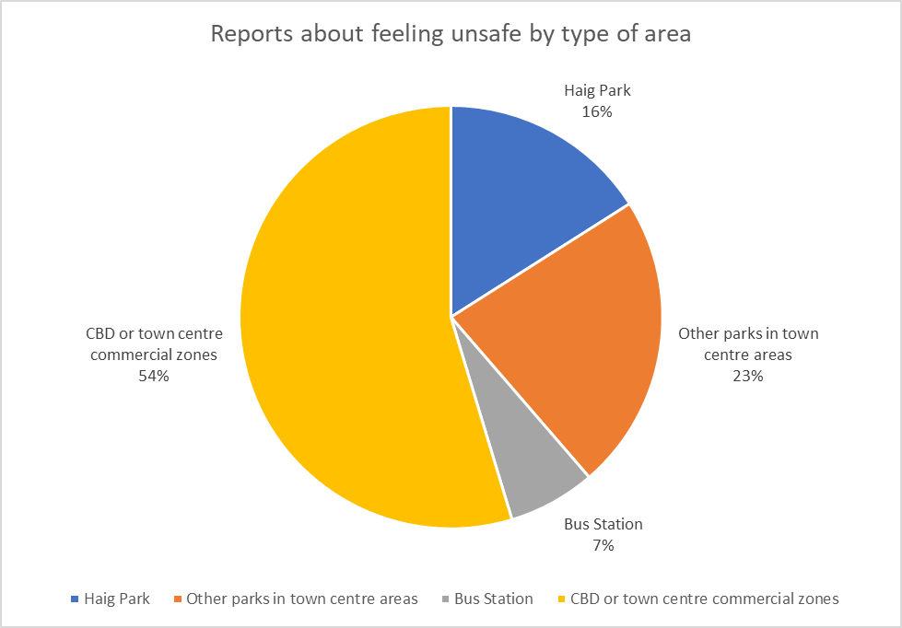Figure 4 All reports where the person felt unsafe or very unsafe in a town centre or CBD area, by the type of public space

Why people felt unsafe
Reports where comments were made about why people felt unsafe were counted. A total of 233 reports were made that included comments, including 189 reports with comments from women, 32 reports from men, and 12 reports from people whose gender identity was Other or Not Stated. Some reports commented on feeling unsafe for multiple reasons, such as both lighting and people in the area.
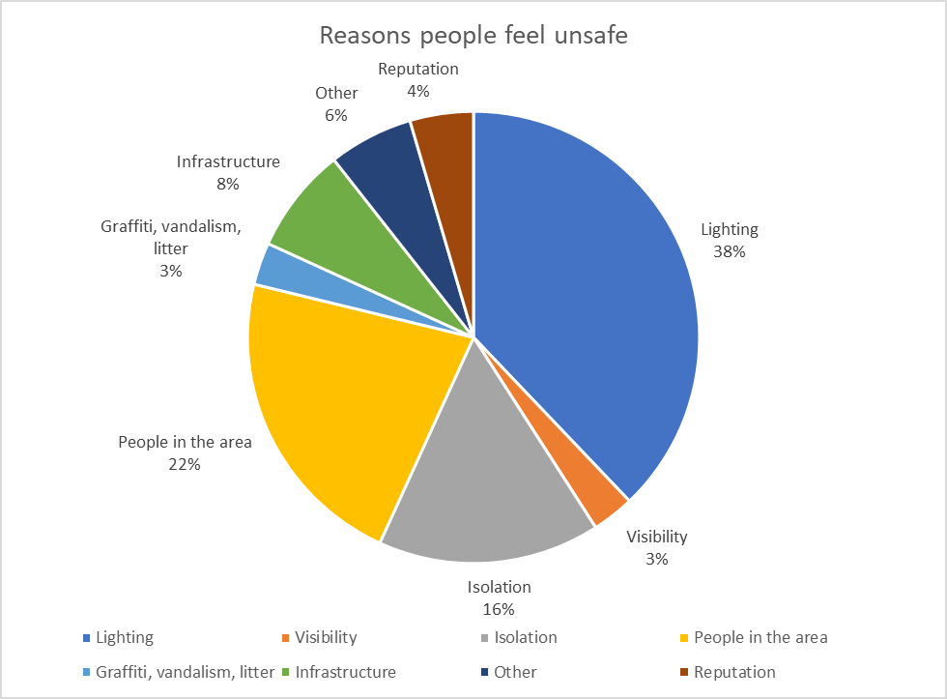The three most common themes in the comments about why people felt unsafe were lighting, other people in the area, and isolation.
Figure 5 Reasons given in the comments about why people reported feeling unsafe in public spaces

Gendered differences in why people felt unsafe
There were some gendered differences in what people commented on in their reports of why they felt unsafe. Women were more concerned than men about lighting, with 46 per cent of reports made by women commenting that they felt unsafe because of lighting.
Only women commented that they felt unsafe because of areas that were isolated or deserted. Twenty per cent of reports with comments made by women about why they felt unsafe talked about isolation.
Both men and women were concerned about other people in the area, with men commenting on this in 31 per cent of reports of feeling unsafe, compared to 24 per cent of reports by women. However, the comments made by men indicated that their feelings of safety about other people in the area related to risks of mugging or violence, while women’s comments indicated concerns about risk of sexual assault by men. The risk associated with isolation in comments made by women about why they felt unsafe was also associated with risk of assault.
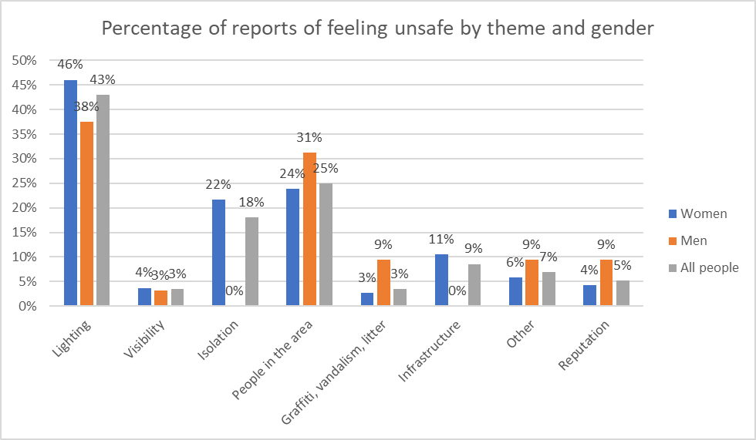A total of 42 per cent (n=79) of all reports from women about why they felt unsafe commented on either isolation or other people in the area.
Figure 6 Reasons why people reported feeling unsafe in public spaces, by gender

Lighting
Reports that commented on an area being dark, poorly lit, or having broken lighting were the most common.
Forty six per cent (n=87) of all reports made by women who felt unsafe included comments about lighting, compared to 38 per cent (n=12) of reports by men.
Examples of comments by women about lighting include:
“The path is on my walk home from work, so I can't avoid it. It is badly lit and there are trees closely surrounding it. It often feels sketchy/dangerous.”
“Street lights are out, it's very dark and don't feel safe walking at night.”
“When riding through here at night, as dark and minimal lighting due to dense trees.”
“The area is very poorly lit and trees block lighting. It's scary to not even be able to see if you're being followed.”
Of the 87 reports by women who commented on lighting, 35 also commented on isolation, and 18 also commented on other people in the area. Of the 12 reports by men with comments on lighting, only 2 also commented on people in the area, and none commented on isolation.

Threat of assault from other people in the area
The second most common theme in comments about why people felt unsafe was other people in the area. These were comments specifically about seeing people in the area that they felt may be a threat to their personal safety.
A total of 58 reports included comments about people in the area, of which 45 reports were made by women, ten were made by men, and three by people who identified their gender as Other or Not Stated.
Comments by men about people in the area included references to the risk of violence from people affected by alcohol or drugs, harassment by people who are homeless or collecting money for charity, and concerns about safety around people who have a mental health condition. No men made comments in relation to concern about sexual assault specifically. No comments by men about people in the area identified the people perceived to be a threat using their gender.
Comments by men about people in the area included:
“You can't walk past here without being harassed by chuggers and bums.”
“Dodgy people”
“Lots of break ins, drug related crime, and aggressive residents driving unsafely here.”
Of the 45 reports by women who commented on the risk from people in the area, sixteen used language that identified the people they were concerned about as male. Seven of these reports that identified male people in the area as a personal safety risk also commented on alcohol or drug use.
Comments by women about people in the area include:
“Was approached by a man who made some comments which made me feel very unsafe, and was later followed.”
“Scummy dudes mugging people. Definitely feel uncomfortable when I'm walking along the park (never through) and not on my bike.”
“A man hangs around here and tries to block women's path.”
“… Young men in packs are unpredictable; the area is vandalised and littered and alcohol becomes evident in the evenings …”
“Have had many bad experiences in this carpark, including a physical attack.”
“Scary weirdos”
“dangerous men”
Several reports by women described specific incidents where they had been followed or abused.

Isolation
Isolation, whether due to a lack of people in the area or a lack of passive surveillance of the area, was the third most common theme.
Isolation was commented on in 22 per cent (n=42) of reports where women felt unsafe, and one report by someone who identified their gender as Other or Not Stated. No reports by men who felt unsafe included comments about isolation. Comments by women about isolation include:
“This whole area at night is very isolating and scary. Too many dark places, and not enough people around.”
“There is no surveillance from surrounding buildings, especially at night. The lighting is not good.”
“Not much pedestrian movement after dark, the buildings block sightlines along buildings, lots of unlit corners.”
“Dark poorly lit, almost no foot traffic. Know of several sexual assaults that have taken place there over the last few years.”
“At night walking back to my car with drunk men around and in a fairly isolated space.”

Infrastructure
There were 20 reports about feeling unsafe or very unsafe in an area as a result of infrastructure issues, such as cycle pathways merging with a road. All of these reports were made by women.
Eleven of those 20 reports also commented on lighting or people in the area. Examples include:
“Uneven footpaths, construction in the way, people drive like idiots. Lots of dark places.”
“Low lighting, narrow path near houses. Feel unsafe riding through there at night.”
“This area is extremely dark at night. I regularly would like to commute from Kaleen to Belconnen town centre. There is no safe 'on road' option with cycle lanes, so cycling around the lake shared path should be a good option. Because it is so dark, I feel very unsafe doing this after sundown.”
“Works mean you cannot use the underpass and have to cross commonwealth avenue - stopping to wait for crossing lights - so I am stationary which make me feel vulnerable. I have heard there have been women assaulted in this vicinity.”
“I have been loudly abused by cyclists and terrified by their speed”
The remaining nine comments about infrastructure focused on the potential for collisions between pedestrians or cyclists and other road users. Examples include:
“No green lane for cyclists travelling north. A difficult intersection to navigate.”
“traffic moving to left across bike lane”

Reputation
The reputation of an area had an impact on how safe people felt. A total of twelve reports (of which eight were made by women, and one by a person who identified their gender as Other or Not Stated) commented on an area’s reputation or history of assaults (including sexual assaults) being the reason they felt unsafe there.
Examples of comments from women include:
“… Know of several sexual assaults that have taken place there over the last few years …”
“The area is incredibly dark and known for incidents of sexual assault.”
“… I know a woman was raped here.”
“Haig Park is dark, and is notorious for sexual assaults”
Many of these comments about the reputation of an area specifically referenced sexual assault, and were in reports made by women. Men did not make reports with comments about the reputation of an area for sexual assault.

Graffiti, vandalism, litter, or evidence of drug use
Graffiti, vandalism, litter, or evidence of drug use in the area were included in comments in a total of eight reports. Three of those reports were made by men, and five by women.
Of the women who commented on graffiti, vandalism, litter, or evidence of drug use, only one did not also comment on lighting or people in the area. For example:
“Haig Park is dark and there are not many people around, but lots of shadows that people could be lurking in. Because I have seen syringes on the ground during daytime, I feel that there may be injecting drug users in the park at night, and I am worried about being mugged if I walk through there after dark.”
Of the three reports by men, one also commented on lighting, but the other two had no comments about other aspects of perceived safety. An example of a comment by a man on this theme:
“Graffiti, property damage and broken glass.”

Other
Other reasons for feeling unsafe were provided in a total of sixteen reports. Eleven reports were by women, three by men, and two by people who did not identify as female or male.
“Cattle on Bicentennial Trail in MacGregor”
Most of these comments also included comments about lighting, visibility, isolation, the area's reputation, or people in the area:
“Dark, smells”

Why people felt safe
Only 40 of the total 363 reports indicated that they felt safe or very safe in an area. Of these reports, 29 identified as women and eight as men.
In reports where the person provided comments about why they felt safe or very safe, twelve reports commented on people in the area, and seven commented on lighting.
Examples include:
“lots of people and businesses open”
“Plenty of public visibility, good lighting, very good pedestrian access.”
“There are often families and people exercising in this area, so I feel like they would see if anything went wrong.”
There was one report that mentioned visibility, but it also mentioned lighting and people in the area. One report mentioned passive surveillance on a footpath overlooked by apartment buildings, and also mentioned lighting and well paved footpaths. Three reports in total mentioned well paved footpaths, but all mentioned lighting or people in the area in addition to the footpaths.
In three reports, the person had chosen safe in the field asking how they felt in the area, but their comments indicated some level of also feeling unsafe:
“Although I feel 'safe' in this area - there always seems to be infighting between friends and social 'cliques' at the Woden interchange. I generally feel uneasy around the interchange.”
“I have only received verbal harassment from passing cars, and no direct threats to my or my family’s safety.”
“I feel safe but saddened by the lively Woden town square we once had now looks run down & desolate. And what's with the empty grass field that was once a car park? Who comes up with these terrible ideas?”

Improving women's use of public spaces
Perceptions of safety in a public space do not necessarily correspond with crime statistics in the same space. But they do impact on whether and how women use a public space.
The majority of reports in the Safety Mapping Tool were made by women aged 18 to 54 years but they gave similar reasons for feeling unsafe as the reasons given in the earlier report Where do older women feel unsafe and why?. This means that the things that result in women feeling unsafe in a public space are common to women of all ages.
Half of the reports about feeling unsafe in public spaces in the CBD and town centres were in commercial zones that are not parks or bus interchanges, such as on the street. Improving perceptions of safety in these areas would mean that more women would be likely to use active travel to and from work or education after dark, or would socialise without needing an escort to leave the area when they want to go home.
Improving the perceptions of safety in the suburbs, where most women live, also means that more women are likely to walk, run, or cycle as part of active travel or recreationally.
These changes enable greater participation in the community and strengthen social inclusion, as well as improving health and wellbeing through increased physical activity.

Why women felt unsafe
The gendered difference in why people felt unsafe in a public space was about the nature of the threat to their personal safety. This means that the indicators for an area feeling unsafe are different for women than for men.
Women’s comments indicated that their primary concern is the risk of sexual assault by men. Poor lighting and visibility were important factors that impacted on being able to see possible threats of assault, so areas with visibility issues reduced the feeling of safety. Women also felt less safe in areas that were isolated or lack passive surveillance, with comments indicating that they were concerned that there would be nobody who could help them if they were attacked in that area.
For men, the comments indicated that their primary concern was the risk of mugging or harassment by people asking for money. The risk of violence was not always a direct concern about their own safety, but was sometimes about the safety of others in the area. Men did not report feeling unsafe in areas that were isolated, but were more likely than women to comment on vandalism, graffiti, litter, or evidence of drug use contributing to them feeling unsafe in an area.
Women were also more likely to report feeling unsafe as a result of the reputation of an area.

Making an area feel safer
Improved lighting and visibility, activating a space for use by people from a range of age groups and genders, and increasing passive surveillance will all contribute to perceptions of safety in an area, and would contribute to making public spaces feel safer for women who were concerned about the opportunities for sexual assault by men.
Reducing graffiti or litter in an area had far less impact on women's feelings of safety, and is therefore less important for improving women's perceptions of safety than improving lighting and active use of the space.
In a city undergoing a shift to higher density and population levels, it is important that these perceptions of safety are considered in planning the interstitial spaces between buildings and transportation, such as the walk from residential homes to a bus station, or from an office or restaurant to a carpark.
The following recommendations from Where do older ACT women feel unsafe and why? apply to making public spaces safer for all women in the ACT:
- Good lighting makes public places and paths visible and inviting at night. It also encourages their use and assists in natural surveillance.
- Locate parks, play areas and public open spaces so they are visible from adjoining buildings such as roads, houses, streets and schools.
- Ensure footpaths and parks are well maintained, that routes have good sightlines to entrances and exits, that landscaping is pruned to ensure that sightlines are clear, and that there are opportunities for surveillance.
- Identification of safe routes.
- Better signage and other information.
- Access to security.
- Pathways and road crossings should be safe and suitable for people with reduced mobility. Avoid having public areas or pedestrian pathways that are unsafe or unsuitable for people with reduced mobility, such as badly maintained footpaths that may cause falls and injuries.
These are things that can easily be incorporated into the development of new suburbs, and can also be achieved in many established areas of Canberra where women have said they felt unsafe. For example, areas that women reported as isolated and dark could be improved by adding a service or facility that would be regularly used by a mixed demographic at nights. Areas with poor lighting may be improved enough by having trees trimmed that they don’t need expensive lighting infrastructure installed.
Public spaces that feel safer after dark would enable greater participation in community life for women, and for anyone in our ACT community who has concerns about the risk of physical assault in public areas after dark.

Appendix A

Suburbs by District
District | Suburbs for which reports were received
Inner North | City  Braddon  Turner  Acton  Lyneham  Dickson  O’Connor  Ainslie  Reid  Watson  Campbell
Inner South | Narrabundah  Parkes  Griffith  Barton  Forrest  Kingston  Fyshwick  Symonston  Yarralumla
Woden Valley | Phillip  Lyons  Mawson
Belconnen | Belconnen  Bruce  Charnwood  Kaleen  MacGregor  Evatt  Florey  Holt
Weston Creek | Chapman  Stirling  Waramanga  Weston  Fisher
Tuggeranong | Hume  Kambah  Wanniassa  Bonython  Chisholm  Greenway
Gungahlin | Gungahlin  Nicholls  Mitchell  Moncrieff  Amaroo  Casey  Bonner  Harrison  Ngunnawal  Palmerston
Molonglo Valley | N/A
Other ACT | Coree  Paddy’s River

Foster S, Hooper P, Knuiman M, Christian H, Bull F and Giles-Corti B, “Safe RESIDential Environments? A longitudinal analysis of the influence of crime-related safety on walking, International Journal of Behavioral Nutrition and Physical Activity, 2016, p 5, accessed online 11 December 2018: https://ijbnpa.biomedcentral.com/track/pdf/10.1186/s12966-016-0343-4
Women's Centre for Health Matters, Where do older women feel unsafe and why?, 2015, Canberra, accessed online 14 December 2018: http://www.wchm.org.au/resources/resources-for-women/draft-womens-safety-matters/
Timperio,A, Veitch,J and Carver,A, Safety in numbers: Does perceived safety mediate associations between the neighborhood social environment and physical activity among women living in disadvantaged neighborhoods?, Preventive Medicine, 2015, accessed online 11 December 2018: http://hdl.handle.net/10536/DRO/DU:30070609
Australian Bureau of Statistics, 2016 Census QuickStats, viewed online 14 November 2018, http://quickstats.censusdata.abs.gov.au/census_services/getproduct/census/2016/quickstat/80110?opendocument
Women's Centre for Health Matters, Where do older women feel unsafe and why?, 2015, Canberra, accessed online 14 December 2018: http://www.wchm.org.au/resources/resources-for-women/draft-womens-safety-matters/

