Making ACT bus stops work for women
Women’s perceptions of safety from recent changes to some of ACT’s bus stop locations

Pip Courtney-Bailey

Amber Hutchison

Julia Tran

Sandra Wiens

November 2019

Introduction
Men and women use public spaces differently and have different concerns about how public spaces meet their needs and what makes them feel safe in public spaces. Research shows that women report feeling more afraid in public places than men, particularly in relation to fear of crime. This is despite the fact that the evidence shows that women are more likely to experience physical violence in their home by a current and/or previous partner.
Over the years, the Women’s Centre for Health Matters (WCHM) has explored the views and experiences of ACT women regarding their personal safety and what impacts on their perceptions of safety. Our research has shown that their perceptions of personal safety, as well as of actual safety, influence the extent to which they use ACT’s public places and spaces – and that it can reduce their access to certain areas where they feel unsafe, limit their social participation and impact on their use of essential services such as public transport.
Our report on the results from the WCHM safety mapping tool, identified that women felt unsafe in spaces that are poorly lit, are isolated or where there are areas of entrapment. In the WCHM report on safety in public spaces for older women, feeling safe for women included good lighting, physical structures such as level and safe paths, adequate signage, no or limited entrapment sites and clear visibility of the area.
So women’s perceptions and fear of safety in public spaces may be influenced by the better design of public spaces. The ACT women’s plan also 2016-26 recognises this:
“Safety and perceptions of safety in public places are key to women’s equal and full participation. There is a requirement for all areas of government to consider how to ensure women feel safe. In areas such as urban planning, public transport, and institutions such as university campuses, women’s safety considerations are key.”

Exploring the safety impacts of recent changes
Note: ‘Safety’ refers to personal safety—specifically, how safe a woman is and how safe they feel in that environment.
During 2019 the ACT government has made significant changes to the transport system in Canberra to accommodate the tram line from Gungahlin to the city. The bus system was revamped with the mission of “safe, active, efficient & cost-effective, accessible and socially inclusive, sustainable, integrated with land use planning public transport.” As a result, many of the bus routes were changed and many bus stops were decommissioned.
In September WCHM began to hear from many women that changes to ACT’s bus routes had affected them and their feelings of safety. Anecdotally, women told us the changes to some of the bus routes meant that they now needed to use bus stops that they felt were unsafe, or which had led them to change to alternate transport methods, or to change their travel behaviours and patterns to avoid those stops, or to use those bus stops with extra caution.
As a result, WCHM conducted a short survey to explore this further and to obtain information from ACT women about the changes that had affected their feelings of safety at the bus stops they now had to use, and to identify and map the locations of those bus stops. In the short time the survey was opened we received 144 responses.
Women described the changes that had impacted on them and their feelings of safety:
‘There is minimal to no lighting, both at my closest bus stop and the few that come before it. Also to get to my house from the bus stop I must either walk through the reserve which is pitch black or side streets and alleys which have no or incredibly poor lighting.‘
‘The route from the new bus stop to my street is on an unlit bike path, set back from the road. Nearby drivers cannot see me, and there are lots of trees and not a lot of visibility. I usually use my phone torch so I can see the path. I worry about being knocked over by cyclists but also about potential assault etc as I am very vulnerable.’
‘I feel unsafe as no-one can see you there in the dark. No need to be there in the first place except to get on to the next little portion of your trip. Anyone can grab a child there and no-one would know... lots of car traffic with no visibility from others etc.’
‘No housing overlooks these walking paths (they're all major transport corridors or parks- there would be no witnesses). Have been previously harassed, followed in these areas.’
The footpaths are also not well maintained making them dangerous to walk on at night where I have limited visibility. Also the lack of lighting makes it hard to see me when waiting for a bus at night, and buses have almost missed me and not stopped - this could leave me stranded …...’
‘The route to & from the bus stop... poor lighting; near an underpass; park to walk through; crossing busy road as too scared to use the long dark underpass.’

‘Not an obvious bus stop, no path on that side of the road, inadequate lighting. The pathway lights don't always work, the sensors turn off before you go past so are left in darkness.’’

‘At night time I have to use an underpass to get under southern cross that has no lighting (I need to use a torch) and there are no houses close by, I feel very vulnerable and unsafe. Sometimes I try to run cross the six lanes of Southern Cross traffic in peak hour (with no traffic lights or crossing) rather than use the underpass, as that feels safer.’

‘The path from the bus stop to the laneway I walk through is dark, overgrown and mostly covered in dirt/weeds.’

‘This means walking further away from my house, and walking further in the dark. The walk down the Street and then into my street is extremely dark and the footpaths are bad. The other day I fell in a big pile of leaves that has built up and doesn't get moved away by the government.’

‘Bus stop not well lit at night. Bus shelter not weather/rain proof. Cars set down and park in the bus bay. Feel very vulnerable while waiting 20-45 mins for connecting bus.’

‘I now do not go out at night due to the 30-40 minute walk. I need to make sure I'm home before dark. I also have a disability and at times use a cane so I'm unable to run/protect myself if I need to when walking to and from the bus. This fact probably makes me more vulnerable to others. It's now also difficult to buy groceries as it's tough walking 30-40 minutes while carrying groceries.’

‘I can't use this stop anymore since the 3 was cancelled so I had to walk across the ANU campus in the dark for 15-20 minutes to get to the ANU bus stop at Unilodge. I often study late at the research school of earth sciences (I'm an honours student), so now in the winter time I have to drive every day when before I would bus every day.’

‘On the old system, after dark, I walked to the nearest main road and was not exposed. Now I have to walk through Phillip shops when they're all closed, past the caryards etc. I am disabled and cannot run to safety if I need to. I no longer go out after dark at all.

‘Not well sheltered. Isolated. Because of my past life experience, I am fearful that if a woman is the only passenger waiting there, she is not safe from attack and sexual assault.’
The results of the survey were then analysed to identify the specific bus stops which women had highlighted, and 77 individual bus stops were identified from those responses. Of those, 40 were selected for further investigation because they were highlighted as the most problematic for women in terms of their safety at the stops, and this was also informed by virtual observation via Google maps.
WCHM staff conducted women’s safety audits of all 40 of those bus stops, a method which we have used over many years. A women’s safety assessment is a process that involves women walking through a physical environment, evaluating how safe it feels, and using that feedback to highlight the need for changes. One of the guiding principles of the women’s safety audit is that women are the experts about their own sense of safety and have knowledge about the spaces that they use.
Photos were taken of the bus stops and surroundings – ‘the journey home’ - to show the factors which contributed to perceptions of safety for women. And for several of the bus stops, photos were taken at night to convey the concerns that women had highlighted to us.
The audits identified a number of common factors which contributed to women feeling unsafe and more vulnerable at those stops which were audited:

Lighting
- Bus stops which had no lighting or which did not have sufficient lighting directly over the bus stop.
- Bus stops which had no lighting illuminating the paths to and from the bus stop.
- Bus stops which only had nearby street lighting that wasn’t sufficient in illuminating the bus stop.

Isolation
- Bus stops which were located on arterial roads and were isolated due to large green spaces or nature reserves.
- Bus stops which had a lack of visibility and line of sight from any residential areas.
- Bus stops where the visibility of the bus stop was obstructed by back fences and alleyways.
- Bus stops which had poorly lit lanes or alleys leading to and from the bus stop.

Areas of possible entrapment
- Bus stops which had paths leading to underpasses, alleyways and other areas which were not visible to pedestrians or cars or houses and which were possible entrapment sites.
- Bus stops which had dense bush or trees and embankments which were possible areas of entrapment.

The problem
Perceptions of safety impact on women’s choices of transport. When people feel safe, they spend more time walking in their local area. In the ACT, feeling unsafe in public spaces (including after dark) resulted in older women restricting their participation in public spaces, particularly when alone.
While some women avoid active travel, including between their home and bus stop, other women have no choice but to use a transport mode where they feel unsafe. In both cases, the design and location of bus stops contributes to their perceptions of safety, and consequently has an impact on their willingness to use public transport and to walk between their home and a bus stop.
There are gendered dimensions to perceived safety. Within the ACT, the risk that most impacts women’s feelings about their safety is the threat of sexual assault. Research by WCHM shows that even in areas with low rates of reported crime, women felt unsafe due to the perceived risk of assault or sexual assault, particularly after dark. For men, the primary safety risk related to risk of mugging or being harassed for money. When women talk about lighting, isolation, and entrapment sites such as adjoining dark bushland, their concern is about a risk that may result in serious injury or death, which is why it is so important to them that someone nearby can see or hear them.
Women in the ACT have lower average and median incomes than men, which makes the costs of car ownership less manageable. Women have been found to travel similar distances to men each day, but women make 13 per cent more trips in a day because they do more trip-chaining, and are more likely than men to be making a trip to pick up or drop off others. This means that women are more likely to be starting or ending shorter, more frequent trips in residential areas. If we want women to make the choice to use public transport for more of these trips, improving perceived safety is important.

Ways to improve perceived safety at and around bus stops
Improved lighting, reduced isolation, and eliminating possible areas of entrapment would all contribute to women feeling safer at bus stops and on their journey to and from the bus stop.
In our audits many of the bus stops that had problems with isolation and areas of entrapment were located on arterial roads, bordered by dark bushland and/or the back fences of residences.
ACT urban planning recommends putting people first. This must go beyond personal safety from a crime perspective, as detailed in the ACT Crime Prevention & Urban Design Resource Manual, and include design principles that improve the perception of safety for people who may be at greater risk of assault or may have reduced capacity to escape threats. This includes the needs of women, young people, older people, people with disabilities, LGBTIQ people, and people from culturally and linguistically diverse backgrounds.
Principles on urban planning around public transport stops in other Australian jurisdictions, such as Victoria, include that paths to public transport stops should be along active frontages, and should avoid underpasses. Urban planning design principles also recommend avoiding parkland or green open space bordered by the back fences of houses. Instead, these areas can be designed so that green spaces are bordered by the front fences of houses rather than the back fences.
Implementing these types of principles in the ACT means avoiding the placement of bus stops on arterial roads bordered by bushland, open spaces, or the back fences of houses. Instead, bus stops should be placed on nearby residential streets where the footpath will pass the front of houses. This also means that pedestrians who need to cross the road after alighting at the bus stop are crossing a smaller, less busy street than if the bus stop had been on an arterial road.
Lighting is important, not only at the bus stop, but on the paths leading to/from the bus stop. Safety does not cease to become important when a person leaves the bus stop, but remains important in their decision to use the bus stop for the entire distance between their home and the bus stop.
These changes will make buses a more attractive and user-friendly transport option for a wider diversity of people in our community, including those who are most in need of an affordable, accessible, safe transport option.

Following is a summary of the findings about some of the individual bus stops from the WCHM safety audits, which include the photos which convey the key factors which led to women feeling unsafe.
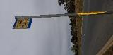
Bus stop 4710
Bus stop 4710 is on Mirrabei Drive in Ngunnawal. The bus stop is on a busy road which has large a green space between road and residential zone.
“It’s dark and there is absolutely NO lighting. If I didn’t bring my little flashing light, the bus driver cannot see me until the last minute!”
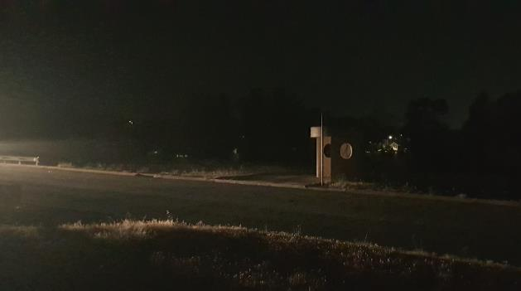
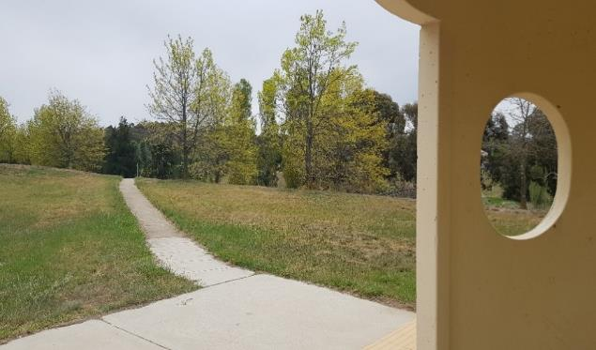
Behind the bus stop is a large green space and Ginninderra Creek. This entire section of Mirrabei Dr has no street lighting within sight (Figure 1). The closest street lighting is at the roundabout about 300 metres to the right and dimmer suburban lighting about 300 metres behind the bus stop. The only other source of lighting at night is from high speed road traffic as shown in Figure 1. To the right of the bus stop at about 40 metres on a walkway declining below street level towards the left is an underpass, and towards the right is a bridge over the creek (Figure 2). Areas such as the underpass, among the trees, the bridge, and the dips in the valleys on both sides of the road are hidden from view of residential area and are possible entrapment sites as well as trip hazards when no paths can be seen at night without torches (Figure 3 and 4). Due to the large green space between the road and residential area and the complete darkness of the bus stop, including the pathways leading away from the bus stop, it would be difficult for a woman travelling to and from the bus stop to be heard or seen by passers-by in the immediate vicinity of the bus stop and the journey home.
Figure 1: Bus stop 4710 is only visible at night from motor vehicle lights.
Figure 2: Pathway on the right of bus stop 4710.
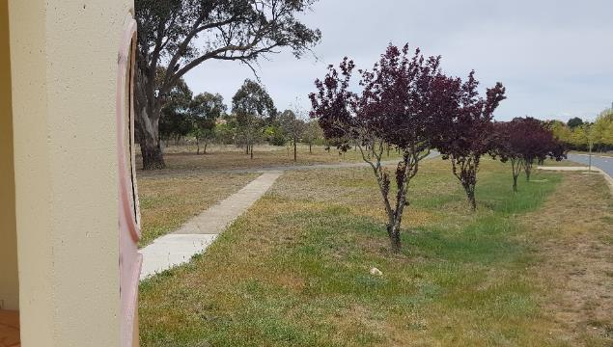
Figure 3: Pathway on the left of bus stop 4710 along Mirrabei Dr (far right).

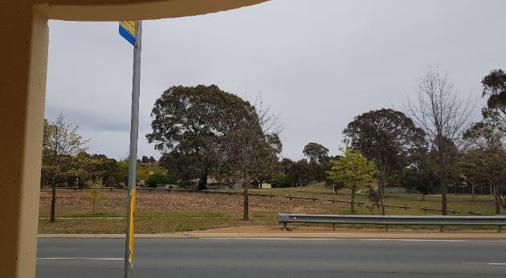
Figure 4: Green space in front of bus stop 4710.

This bus stop is isolated, has numerous areas which could be possible entrapment sites, and has no lighting in the immediate and surrounding area of the bus stop.

360 degree view of bus stop 4710
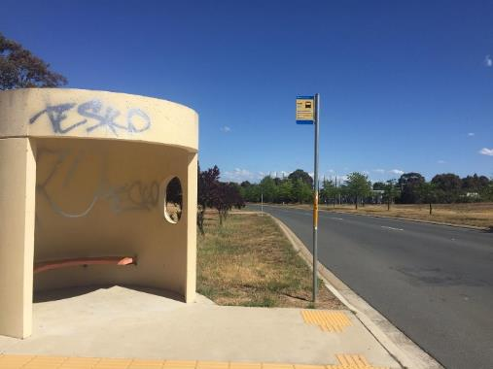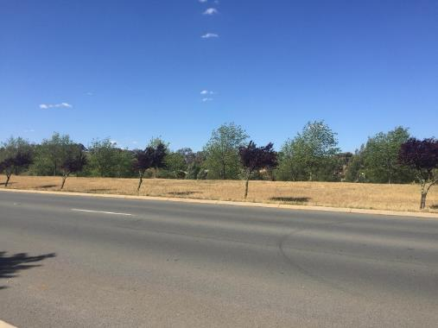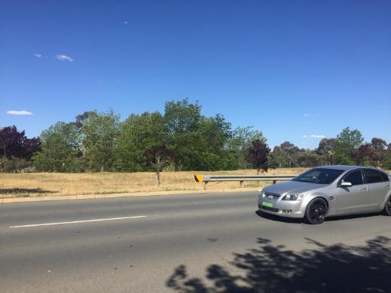
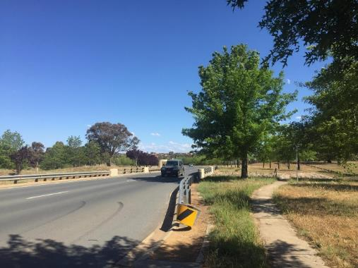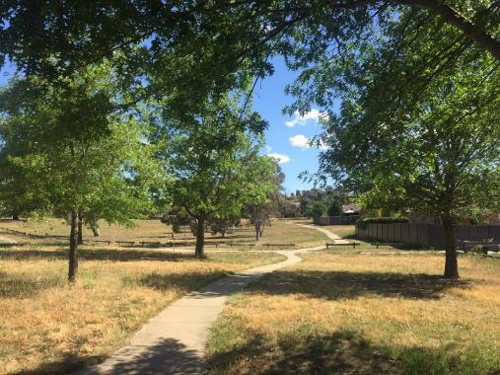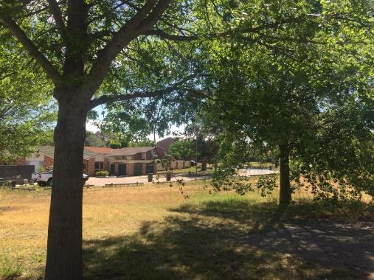

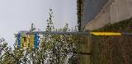
Bus stop 4711
Bus stop 4711 is on Mirrabei Drive in Ngunnawal. The bus stop is on a busy road which has large green spaces between road and residential zone.
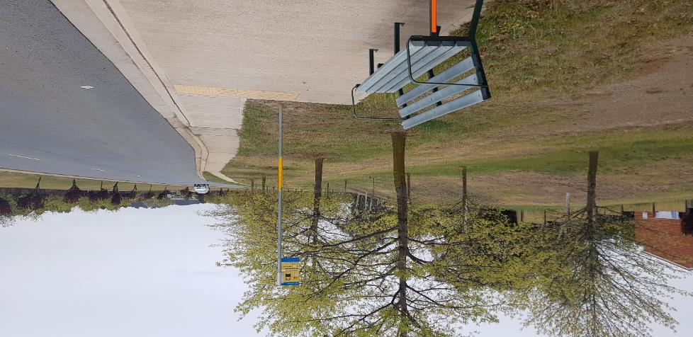
There is no immediate lighting at bus stop 4711 or on the pathways away from the bus stop, as shown in Figure 5. It is just a seat with no shelter, and only an orange reflective tape on the side for minimal visibility from oncoming traffic (Figure 5). There is no street lighting within sight of the bus stop, with only lights from road traffic as shown in Figure 6. The closest street lighting is located at the roundabout over 200 metres to the left, otherwise a smaller and dim suburban lamp was sighted about 30 metres away. To reach the opposite side of the road (where bus stop 4710 is) requires walking 50 metres on decline towards an unlit underpass (Figure 7). Areas such as the underpass, among the trees in the green space on both sides of the road are hidden from view of residential area and are possible entrapment sites. Due to the large open space between road and residential area, it would be difficult for a woman to be heard or seen by passers-by in the immediate vicinity of the bus stop as well as on pathways away from the bus stop. The pathway away from the bus stop diverts into a residential zone about 100 metres away (Figure 5), through an underpass (Figure 7), or along a road where there is no light and where there is a large green space between the path and fencing of houses (Figure 6). At night, women would feel further isolated travelling or waiting at this bus stop alongside the busy 80 km/hr road traffic and with very little visibility of the closest residential area.
Figure 5: Green space between residential area and road at bus stop 4711 as shown in daytime.

This bus stop has no lighting and shelter in the immediate and surrounding area of the bus stop, is isolated, and has numerous entrapment sites.
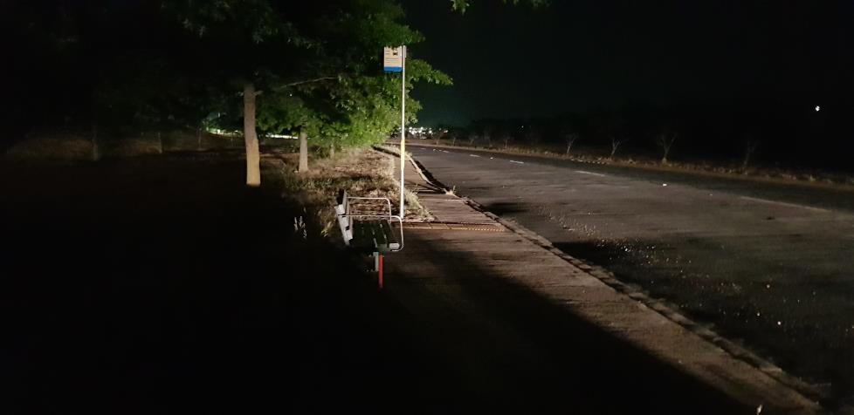
Figure 6: Bus stop 4711 and pathway only visible from motor vehicle lights.
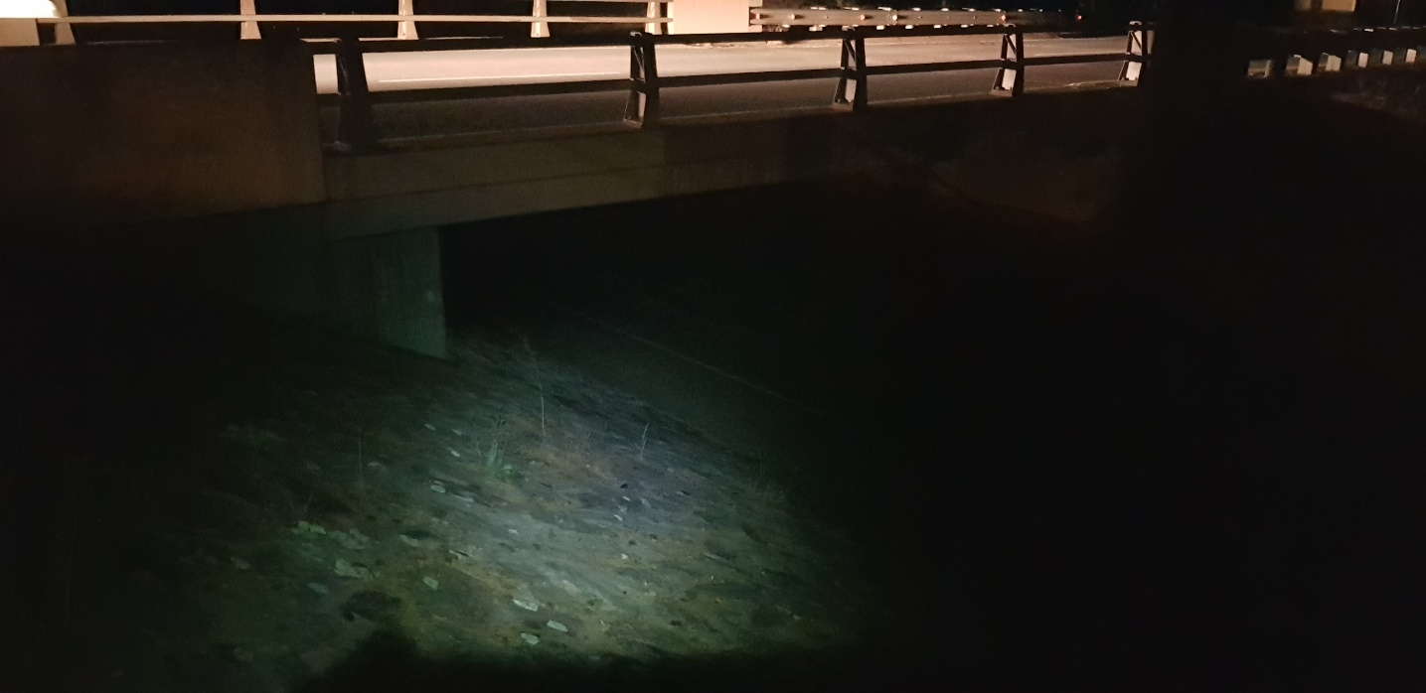
Figure 7: Picture of underpass taken with torch for spotlight and headlight from car crossing the bridge.

360 degree view of bus stop 4711
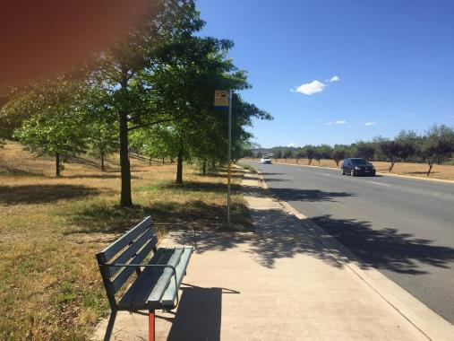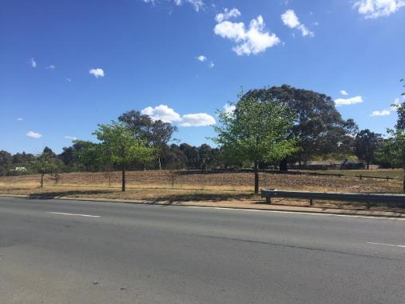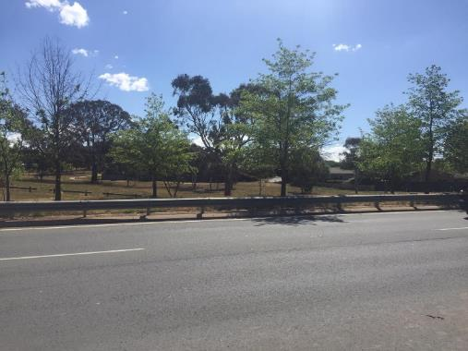
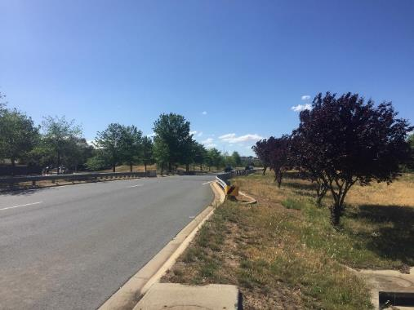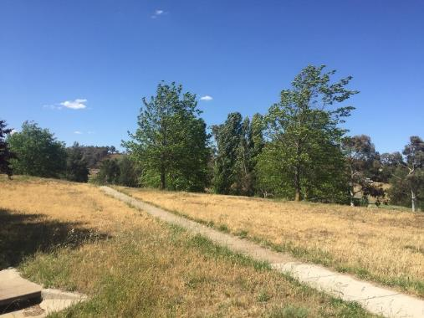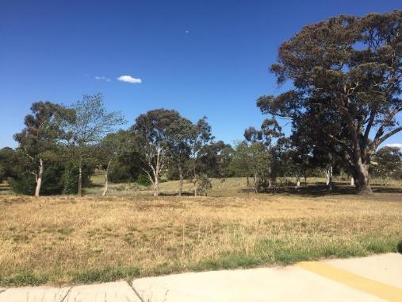

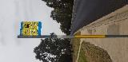
Bus stop 4913
Bus stop 4913 is on Horse Park Drive in Casey. The bus stop is on a busy road which has green space on both sides of the road. The bus stop on the opposite side of the road is 4914.
At the bus stop there are no lights illuminating the immediate area and there are no streetlights on Horse Park Dr within sight of the bus stop (Figure 8, 9, 10, 11). The area is quite isolated with housing approximately 100 metres away on both sides of the road (opposite side of the road being back fences only). When leaving the bus stop to the residential areas behind the stop to David Miller Cr, there is a path which is not lit which crosses the causeway next to bushland (Figure 8). Alternative access to residential area means cutting through green space without a designated path. There is lighting on David Miller Cr but does not illuminate past its immediate area and so doesn’t light the bus stop or path leading from the bus stop. The causeway and bush land are possible entrapment sites due to their lack of visibility from the closest housing (David Miller Cr) and the main road (Horse Park Dr).
If leaving the bus stop towards residences in Ngunnawal, on the opposite side of the road, there is an unlit green space that has no path leading from the road to the path behind backs of fences. It runs parallel to the road located at the back of housing but not visible from the road and has no lighting. Visibility is obstructed by back fences and alleyways between houses when entering the suburb.
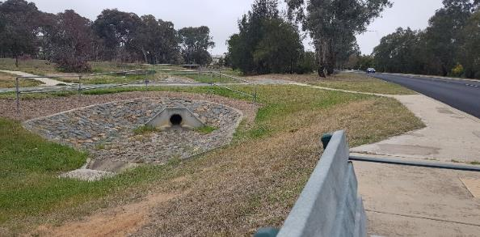
The bus stop is located on top of an embankment with suburban lighting 100 metres away and light from road traffic (Figure 11).
Figure 8: Drainage causeway behind bus stop 4913.
This bus stop has no lighting, is isolated, and has numerous entrapment sites. The lack of housing around the immediate area of the bus stop and the open space with minimal foot traffic makes the bus stop and the journey home isolated.
At night, the bus stop is extremely dark.
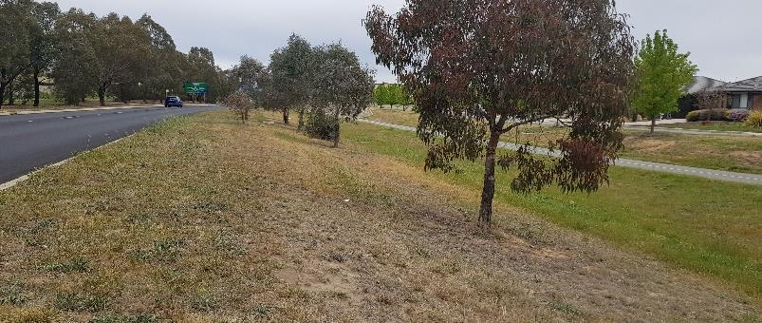
Figure 9: Green space between Horse Park Dr and residential zone on the right of bus stop 4913.

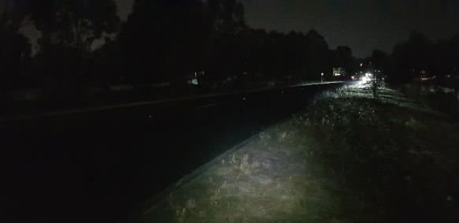
Figure 10: Horse Park Dr as pictured at night on the right of bus stop 4913 with only lighting from motor vehicles (photo taken with torch).

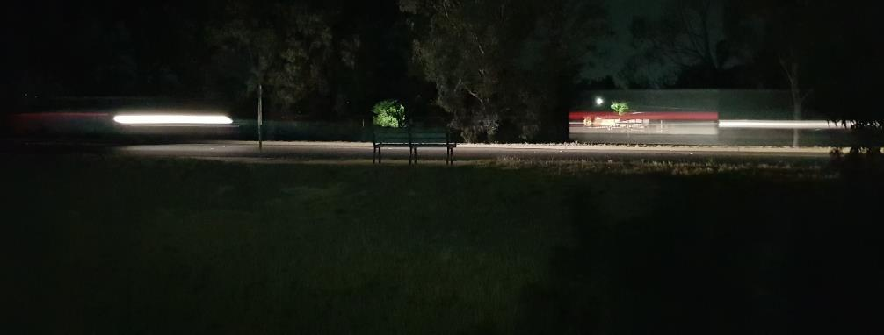
Figure 11: Bus stop 4913 seat on top of embankment can only be seen at night when there is lighting from passing motor vehicles.

360 degree view of bus stop 4913
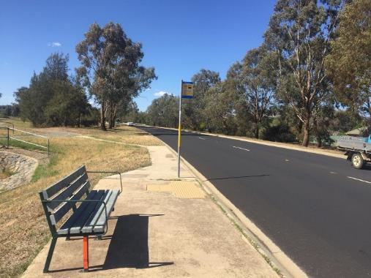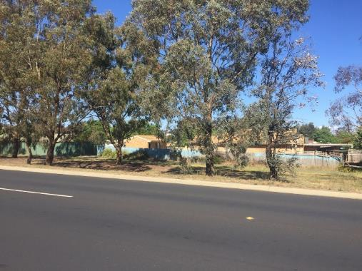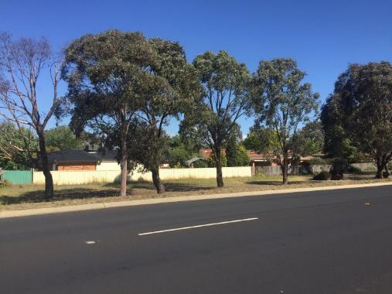
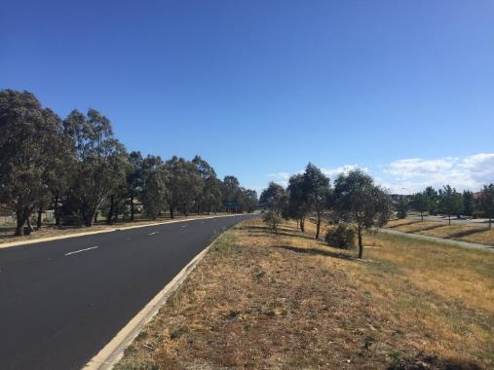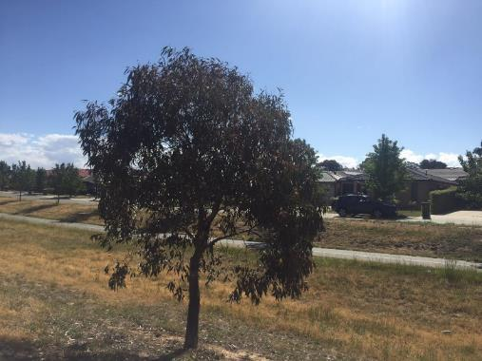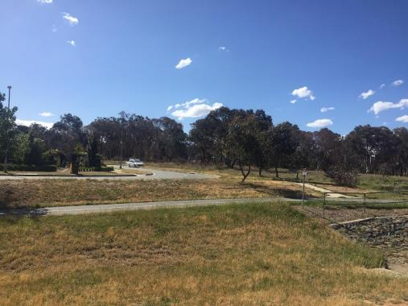

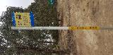
Bus stop 4914
Bus stop 4914 is on Horse Park Drive in Casey. The bus stop is on a busy road which has green spaces on both sides of the road.
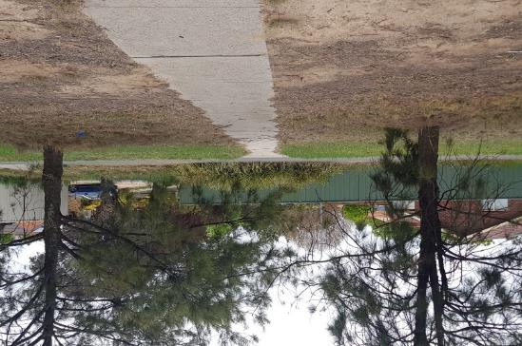
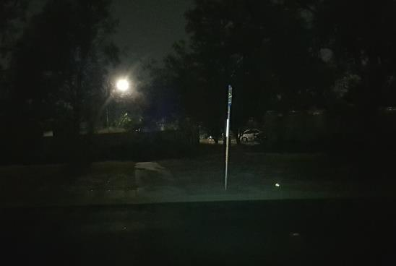
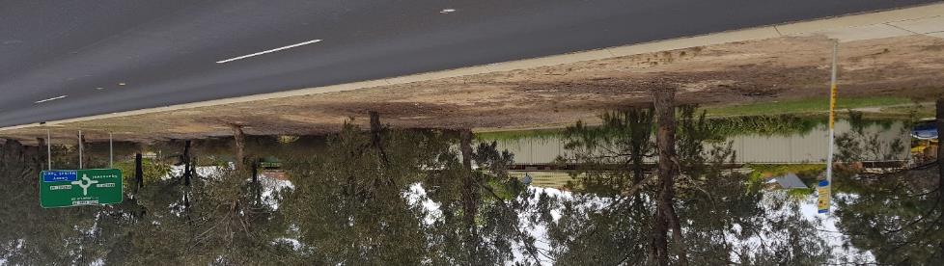
Bus stop 4914 has no immediate lighting and is only marked with a pole where there is no seating or shelter (Figure 12 and 13). There are also no streetlights on the main road leading away from the bus stop. The only light on the same side of the road as the bus stop is about 100 metres away at the back of housing, as shown in Figure 12 and 13. The pathway is beside long stretches of residential fencing to the left and right of the bus stop with alleyways into residential zones, for example in Figure 11. This pathway is about 20 metres away, perpendicular to Horse Park Dr and between the fencing and bushland, as shown in Figure 12 and 14. Travelling on this pathway is isolating from road traffic and nearby residents, leaving women not visible or heard from passers-by, especially at night when there is no lighting on the path (Figure 13). To cross the road, towards residential area opposite (on same side as bus stop 4913), would require jaywalking across the high traffic (day and night) and 60 km/hr road without lighting, and navigating green space and drainage causeway below street level, before reaching David Miller Cr. At the dip of this green space is a cycle path that is only slightly visible due to dim suburban lighting from David Miller Cr.
Figure 12: Pathway towards bus stop 4914 with one streetlight (circled) in residential zone.
Figure 13: Bus stop 4914 at night with one streetlight in residential zone (photo taken with torch).
Figure 14: Bus stop 4914 on Horse Park Drive.

360 degree view of bus stop 4914
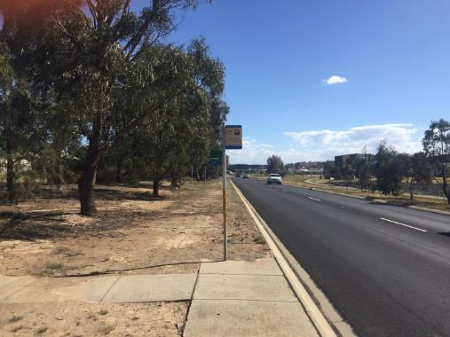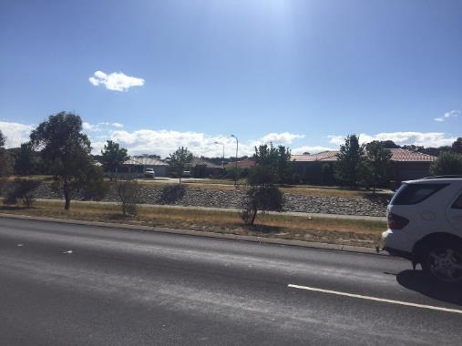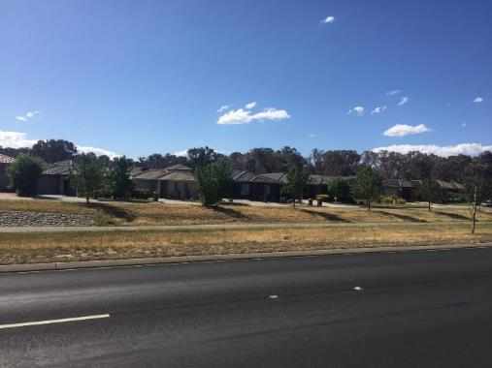
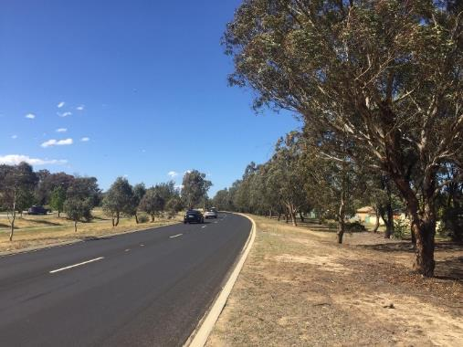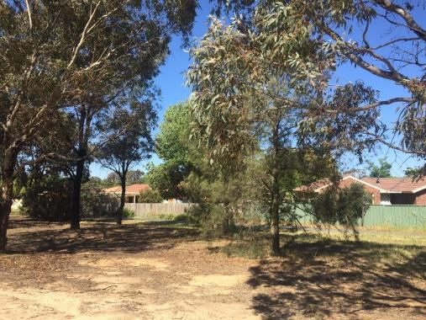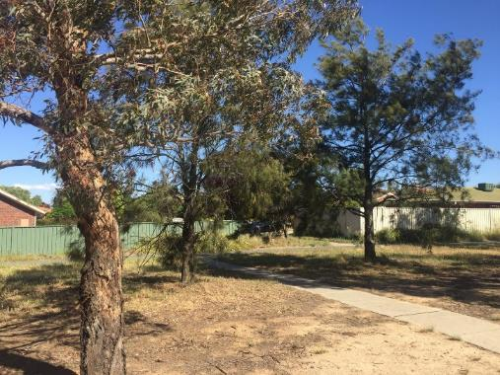

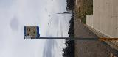
Bus stop 1342
Bus stop 1342 is located on Drakeford Drive in Kambah where traffic is very busy on three-lane road on both sides separated by a large bushland median strip. There is a large nature reserve with Village Creek running through it and surrounding bus stop 1342.
“This stop is right on the edge of Drakeford Drive – in winter have to walk in the dark across a reserve – makes me nervous.”
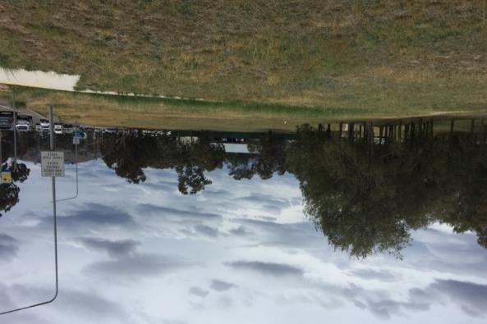
Drakeford Dr is a very busy road all times of the day, so street lighting on this road is very well-lit including bus stop 1342. However, the bus stop is just a pole with a concrete slab and pathway, but no seating or shelter.
Figure 15: Greenspace between bus stop 1342 and residential and shopping areas.
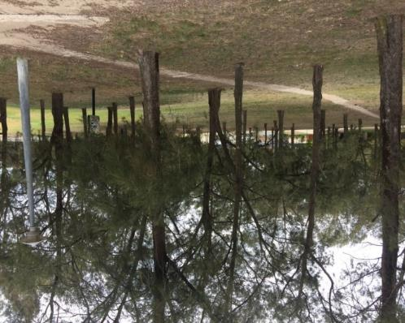
Leaving the bus stop requires walking through the nature reserve on a concrete pathway that diverts into three directions. Firstly, straight to Harrington Cct – the closest residential area around 100 metres away where there are some dim streetlamps beyond the dense bushland and creek of the nature reserve. Secondly, to the right towards Kambah Shopping Village about 250 metres walking distance alongside the creek, which is a cautioned floodway area, and through the bushland (Figure 15). As shown in Figure 15, there is no direct pathway alongside Drakeford Dr to reach the shopping area at intersection with Marconi Cr. Thirdly, diverting to the left leads pedestrians through an unlit and long underpass across six lanes of Drakeford Dr, where only one streetlamp was spotted on the opposite side of this underpass (Figure 16, 17 and 18).
Figure 16: Floodway area in the greenspace where pathway diverts from bus stop 1342.
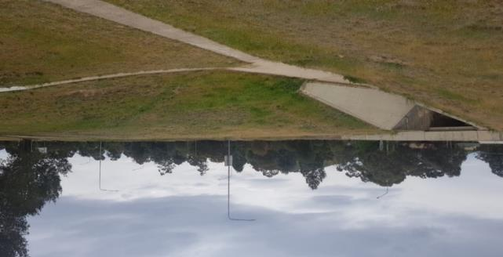
Walking through the dense bush reserve, where there is no lighting on any of the paths and underpass, is unavoidable to reach either the residential or shopping areas as shown in Figures 15, 16, and 17. In addition, with the heavy and noisy traffic, travelling these paths is highly isolating where pedestrians would not be easily seen or heard by passers-by or residents.
Figure 17: Underpass at Drakeford Drive between bus stop 1342 (and 1341).
Directly to the left of bus stop 1342, is a gravel pick-up and drop-off zone where women waiting at the bus stop may feel unsafe being approached by strangers parking at that zone (Figure 19).
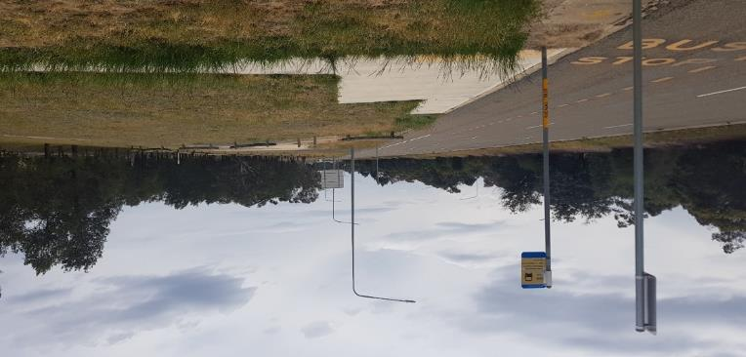
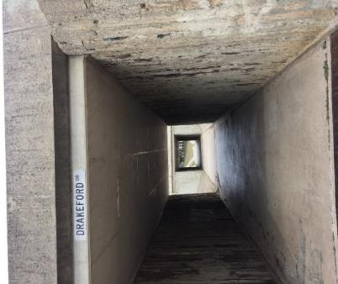
Figure 19: Gravel pick up and drop off zone to the right of bus stop 1342.
Figure 18: Underpass entrance between bus stop 1342 (and 1341) with no lighting.

360 degree view of bus stop 1342
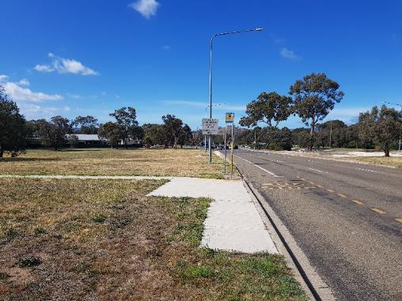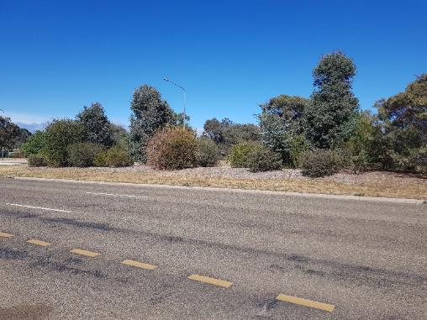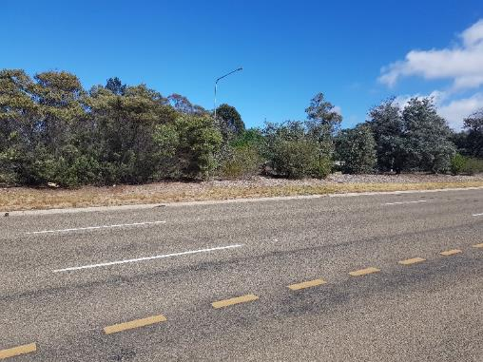
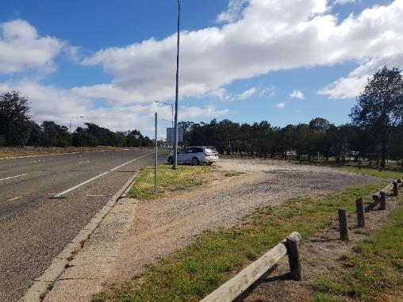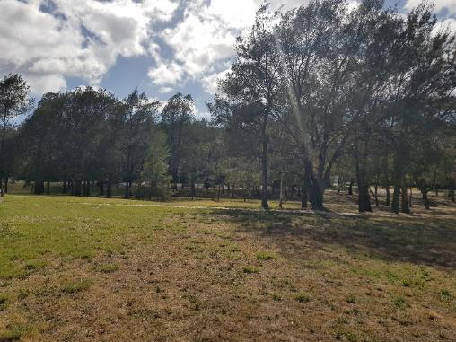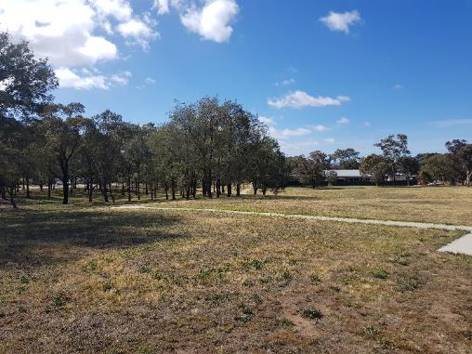

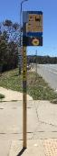
Bus stop 4070
Bus stop 4070 is on Copland Drive in Melba. The street is busy, especially at peak hour. The bus stop on the opposite side of the road is 4071.
“At night I have a 15-20 minute walk home from the R3 stop on mostly unlit bike paths along Ginninderra Creek. Or a long wait in Belconnen for a 41, followed by a shorter but still mostly unlit walk. Also, I do not feel safe using underpasses at night, so instead have to cross a busy road.”
This bus stop has street lighting that illuminates the stop, but the area behind the bus stop is green space and creek, which is unlit and would be dark at night (Figure 20 show park behind bus stop). To head to Melba (towards Conley Drive) from the bus stop, a woman has to travel on a path that heads away from Copland Dr through the green space. The path that has no lighting also has some places where it is lower than the road, completely out of view from the road or passers-by. The path veers left towards Melba into a very isolated area which has the green space on one side and ovals on the other. An alternative route is to walk down to Ginninderra Drive which has no path next to it.
Accessing the Evatt residential area requires either crossing a busy road, or heading down a path that is lit but is lower than the road. The path heading to homes in Evatt goes under the road through an unlit underpass (Figure 21 & 22) and leads to another area that is not visible from the road, but is closer to housing on Carlile St (see bus stop 4071). Both entry and exit points to the underpass are possible entrapment sites due to the lack of visibility from the road.
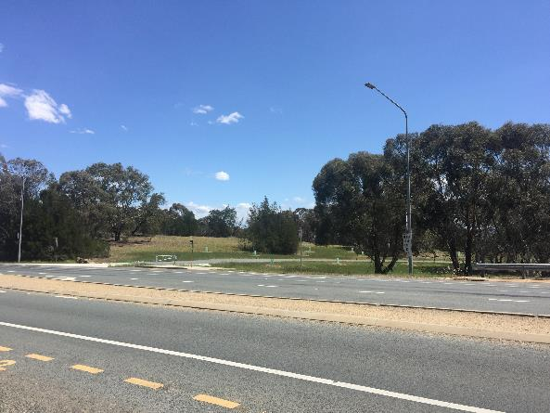
This bus stop has numerous possible entrapment zones and large dark areas around the bus stop. At night, the bus stop would be extremely dark and quiet, and would feel very uncomfortable. In addition, there is no shelter or seat at the bus stop.
Figure 20: Park behind Bus stop 4070

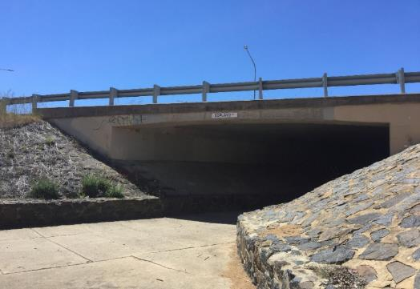
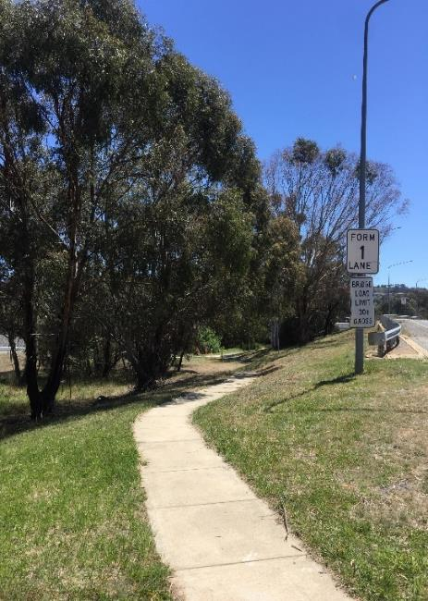
Figure 22: Underpass with no lighting under Copland Drive.
Figure 21: Path to Melba which also leads to the underpass.

360 degree view of bus stop 4070
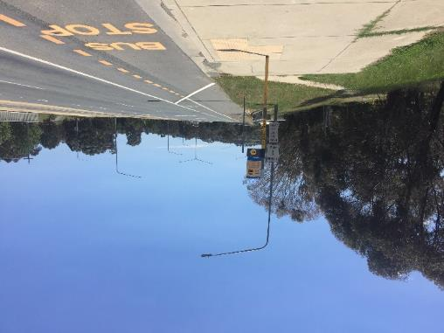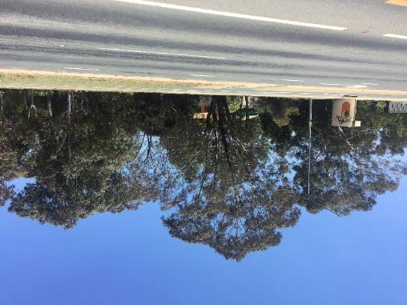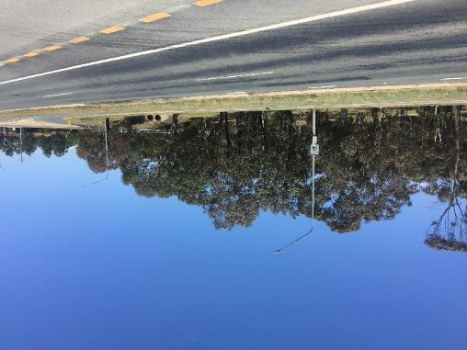
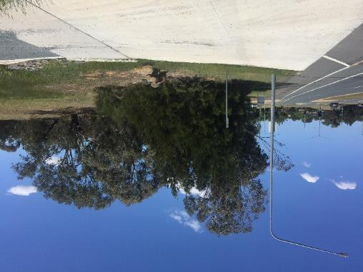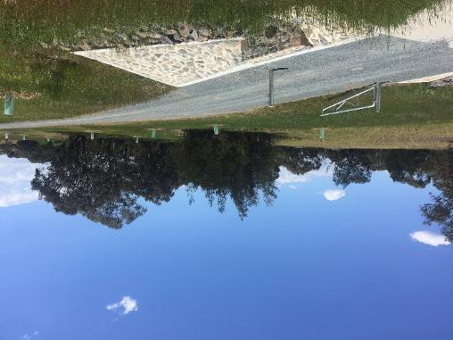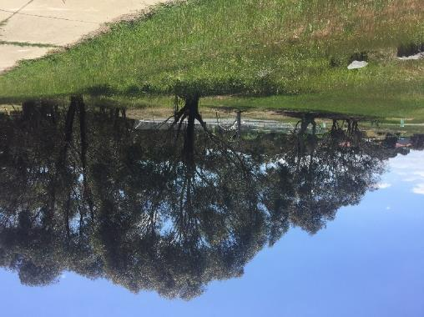

Bus stop 4071
Bus stop 4071 is on Copland Drive in Melba. The street is busy especially at peak hour. The bus stop on the opposite side of the road is 4070.
“Better lighting along the bike path both in the vicinity of stop 4071 (which is below street level), but also along the creek past the Melba playing fields and along the other side of the creek (towards Flynn). Also direct pedestrian access (with lighting) across the Melba wetlands/creek from near stop 4071 to the bike path at the bottom of Traynor or Charvin Court would be wonderful.”
This bus stop has street lighting that illuminates the stop. Behind the bus stop, there is a very bushy embankment that would make waiting at the bus stop scary for a woman at night (Figure 23 and 25). There is a storm water drain, a possible entrapment site, behind the bus stop which is hidden from the road and paths. Paths away from the bus stop are illuminated by streetlighting and there some lighting on paths close to Evatt. Housing is a short distance away into Evatt, but are back fences until you get to Carlile street. The whole area feels very isolated because of the bushland behind the bus stop.
The underpass towards housing in Melba (as discussed in 4070) is dark due to the lack of lights, and also a possible entrapment zone due to its lack of visibility from the street (see Figure 24). The path continuing to Melba leads through green space, but it is not illuminated at all.
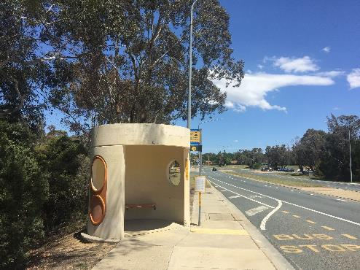
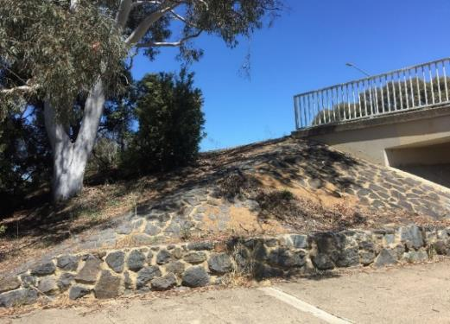
There are multiple areas which can’t be seen from the road, trees and bushes directly behind the bus stop, embankment leading to storm water drain and bush area. The underpass itself is a secluded space.
Figure 23: Bus stop 4071.
Figure 24: Underpass under Copland Drive, bus stop is behind bush – highlighted by yellow arrow.

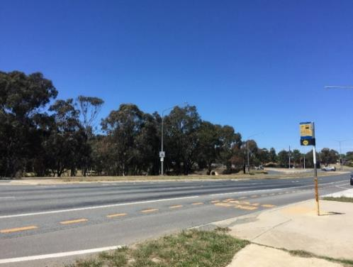
Figure 25: Large bush area (also showing bus stop 4070).

360 degree view of bus stop 4071
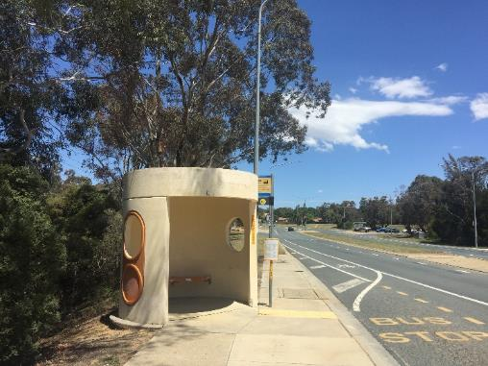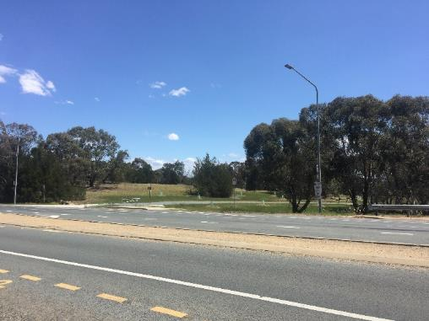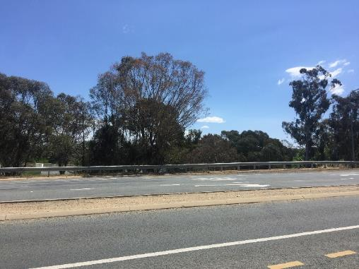
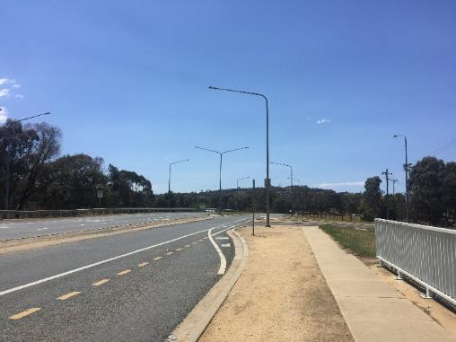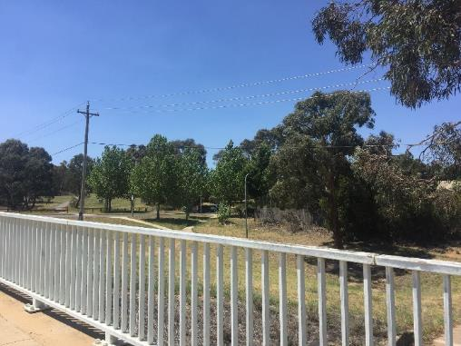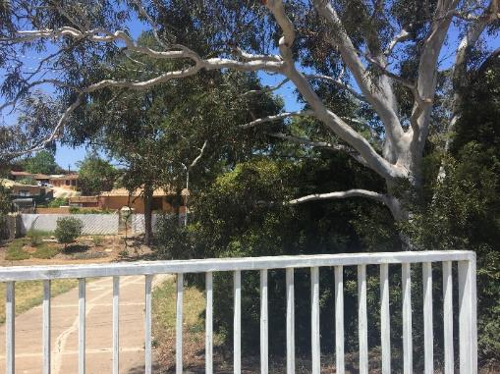

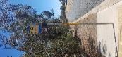
Bus stop 4357
Bus stop 4357 is located on Southern Cross Dr in Higgins (on the border of Higgins and Latham). It is a very busy road with a large green space median strip with trees and shrubs. To reach the opposite bus stop, pedestrians must cross carefully onto the median strip.
“The bus stop I now use is poorly lit, on a busy main road, has a lot of trees around it, and the path is not visible from the road. I now cross the road then walk down a poorly lit alleyway then on the street (as there are no paths for me to walk on) for approximately 1.5 km, often in the dark.”
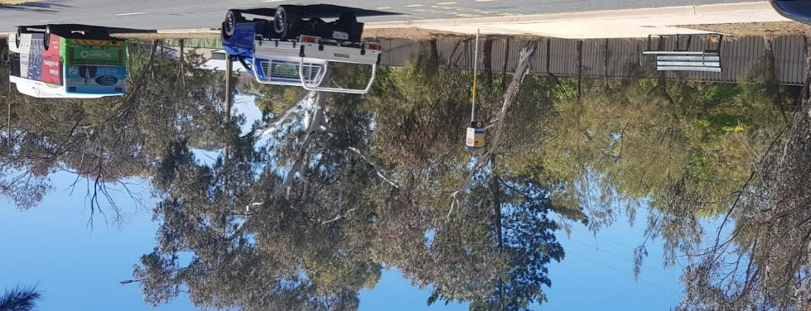
Southern Cross Dr is a very busy road all times of the day and night, with 60 km/hr. Streetlighting is spaced out evenly along both sides of Southern Cross Dr and is brightly lit for motorists. There is no direct street lighting available at bus stop 4357 but it is slightly illuminated, no more than 1.5 metre radius, by a nearby streetlight as shown in Figure 26 and 27. There is only an unsheltered seat at bus stop 4357 that sits on top of an embankment (Figure 26). A woman leaving this bus stop would either walk down the embankment to go along fencing (Figure 28) or cross the road via a bushy median strip with concrete pathway towards bus stop 4358. Refer to notes on bus stop 4358 for travel journey on this side of Southern Cross Dr. The pathway along the high fencing is below-street level so even in the day a woman walking here would not be visible to either motorists or residents. At night, this area is completely unlit as shown in Figure 27. It is also a very long pathway parallel to Southern Cross Dr that has a few unlit alleyways into residential area of Higgins (Figure 29).
Figure 26: Bus stop 4357 on top of embankment with streetlight (circled) and backed by residential fencing along pathway.

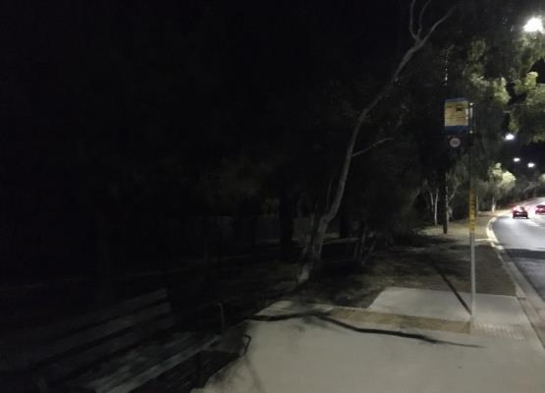
Figure 27: Street lighting on at night along Southern Cross Dr (right) in comparison to unlit pathway (left) behind bus stop 4357.

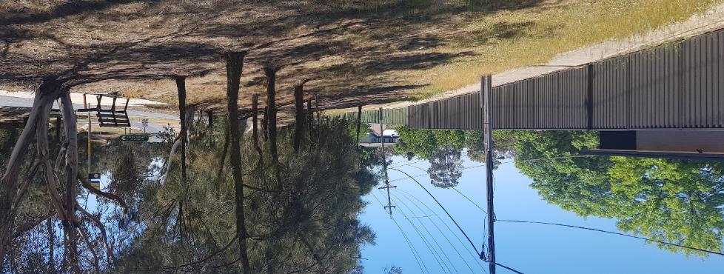
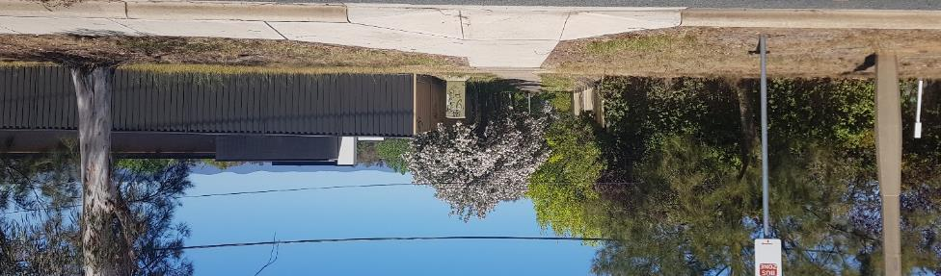
Figure 28: Unlit pathway along fencing parallel to Southern Cross Dr is at the base of an embankment of trees and powerlines.
Figure 29: Unlit alleyway entering residential area of Higgins from bus stop 4357.

360 degree view of bus stop 4357
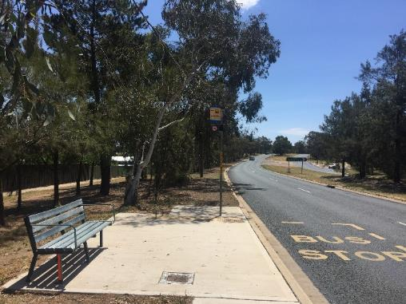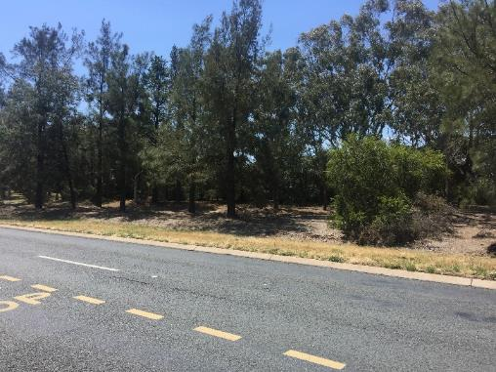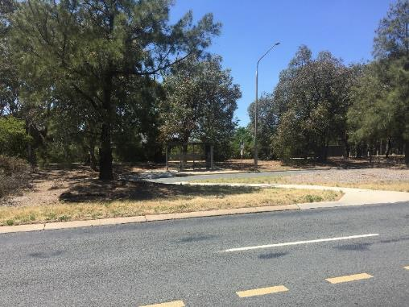
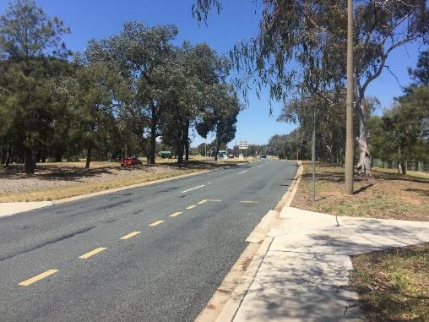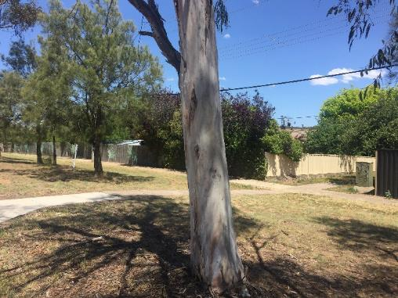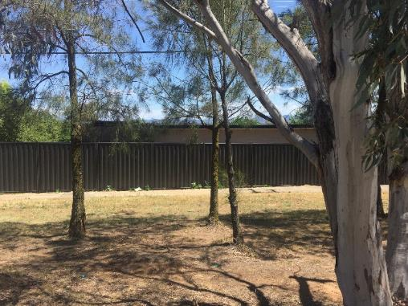

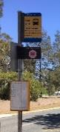
Bus stop 4358
Bus stop 4358 is located on Southern Cross Dr in Latham (border of Higgins and Latham) directly opposite to bus stop 4357.
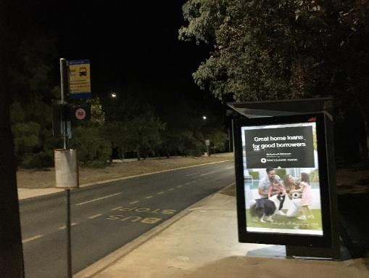
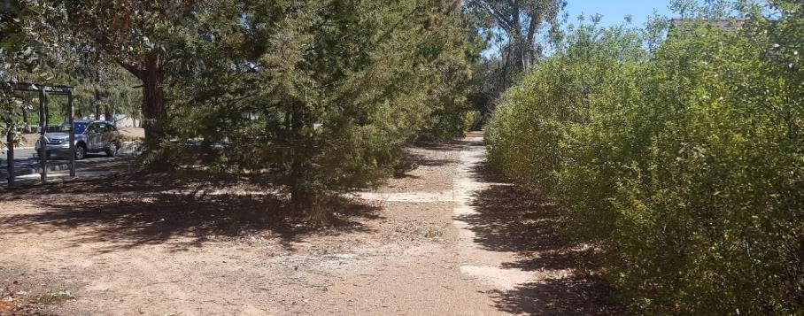
The bus stop is sheltered with seating and lighting. Southern Cross Dr is a very busy road with 60 km/hr speed all times of the day and night. Streetlighting is spaced out evenly along both sides of Southern Cross Dr and is brightly lit for motorists. As shown in Figure 30, the bus stop is well-maintained with its own lighting as well as direct street lighting. However, upon departing the bus stop, the pathway is unlit and parallel to Southern Cross Dr between dense bushes and hedges and the back of residential area as shown in Figure 31 and 32. If veering away from this pathway, a commuter would travel on a desire line path through long grass alongside housing fencing through an unlit and isolating park, as shown in Figure 33 and 3a. This dirt track is about 40 metres long, where there is a dim streetlamp marking the end of a no-through residential street in Latham. To reach Higgins residential area, there is a pedestrian crossing via bushy median strip across the well-lit Southern Cross Dr. This crossing has curb cuts and is cemented. However, once reaching the Higgins side, the paths are not lit at all and dip below an embankment between trees and high residential fencing, as described in bus stop 4357. The combination of fencing, dense shrubbery, and no lighting poses obstruction to line of sight where women would feel highly vulnerable to entrapment zones on the journey home.
Figure 30: The immediate vicinity of bus stop 4358 is well-lit on Southern Cross Dr at night.
Figure 31: Dense shrubbery lining back of houses of pathway to bus stop 4358 (on left).
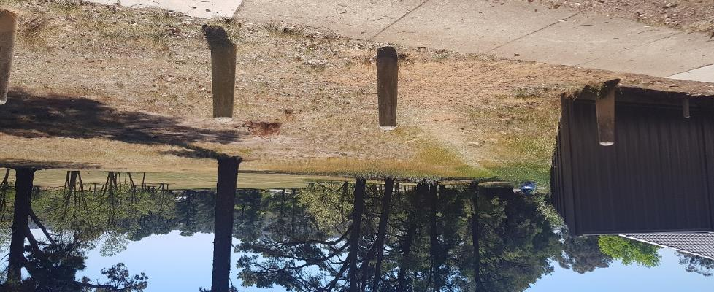
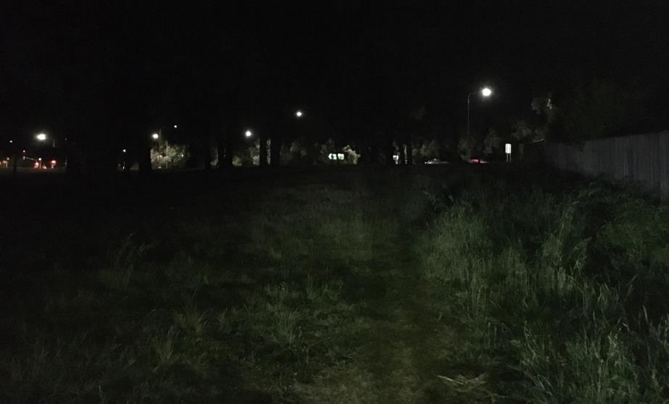
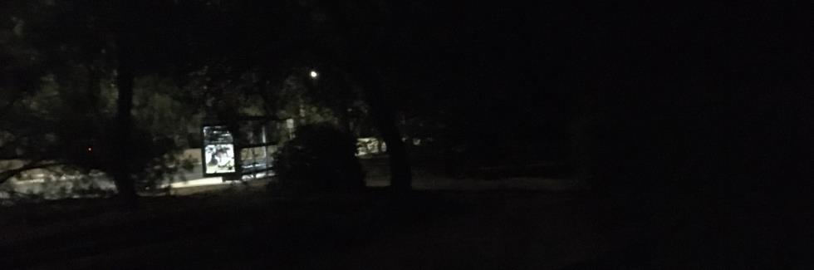
Figure 33: Isolating park around the corner of bus stop 4358 where a desire line path has been made along the fence through long grass from cement pathway into a residential area.
Figure 34: Bus stop 4358 around corner of fence (on right) beside Isolating park at night without lights (picture taken with car headlights on).
Figure 32: Bus stop 4358 (on left) is well-lit at night on Southern Cross Dr in comparison to unlit pathway along shrubbery (on right).

360 degree view of bus stop 4358
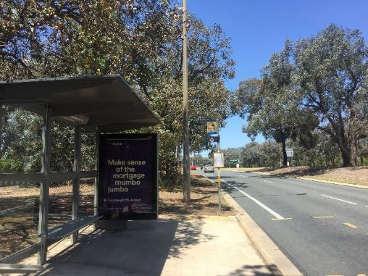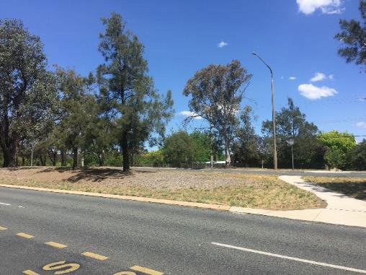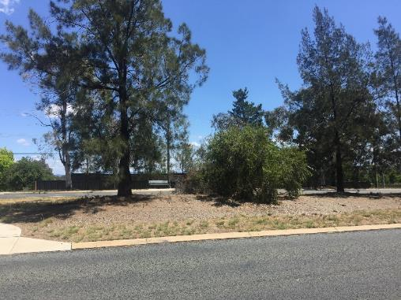
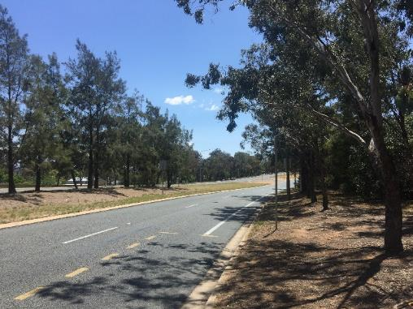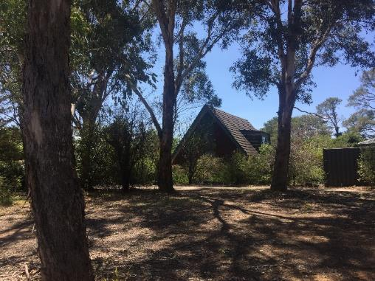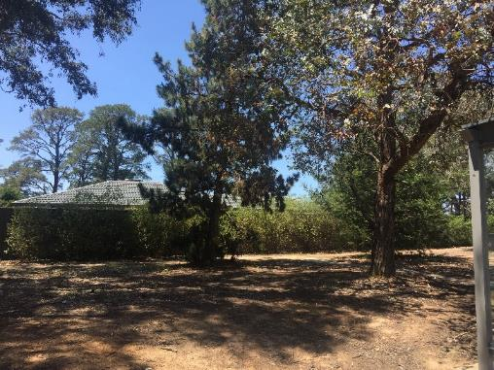

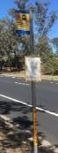
Bus stop 4273
Bus stop 4273 is on Coulter Drive in Macquarie. The street is a very busy main road especially at peak times. The bus stop on the opposite side of the road is 4274.

Bus stop 4273 is illuminated by streetlighting. The path away from the bus stop to residential housing in Macquarie is across a green space, see Figure 36 (approximately 20 metres). Once behind the trees, the path joins another path behind back fences. The area feels isolated from the street and the residential area. Heading down the path (to the right of Figure 37), the road becomes less visible due to the embankment. There is no lighting on this path. The alleyways to enter the suburb is also unlit and isolated.
To travel home towards the residential area in Weetangera, a woman would need to cross the very busy Coulter Dr. The path closest to the road is shrouded by trees and bushes making visibility to the road quite poor, this area can be dark even in the day time. There is an embankment behind the path, which is a possible entrapment site as it is not visible from the road. The nearest path travelling into the suburbs is not lit and so would be very dark and isolated at night (see bus stop 4274).
Bus stop 4273 has numerous possible entrapment zones and large isolated areas.
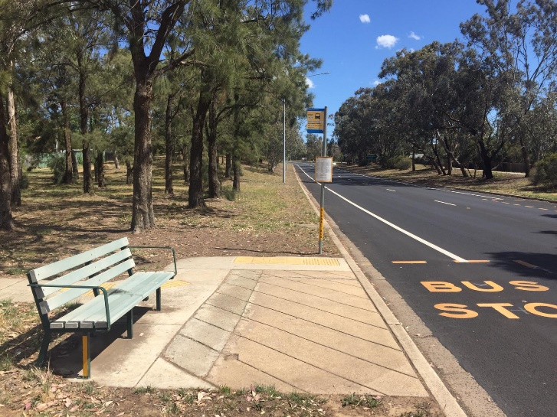

Figure 35: Bus stop 4273.
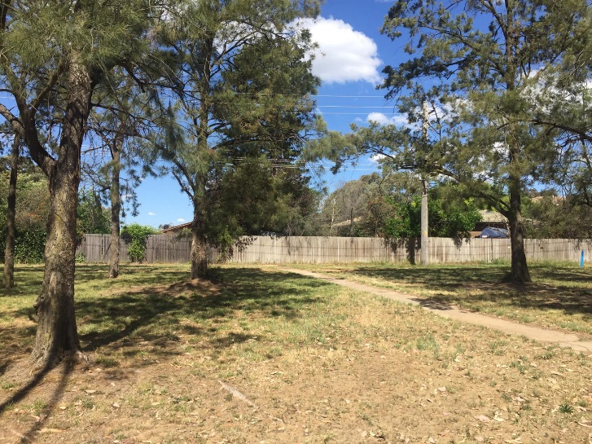
Figure 36: Path through greenspace from bus stop.

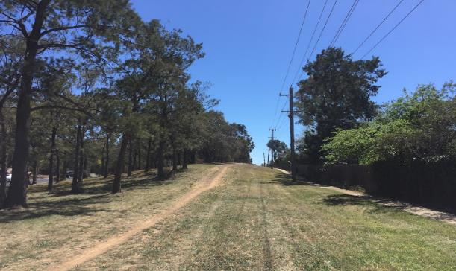
Figure 37: Area behind bus stop 4273.

360 degree view of bus stop 4273
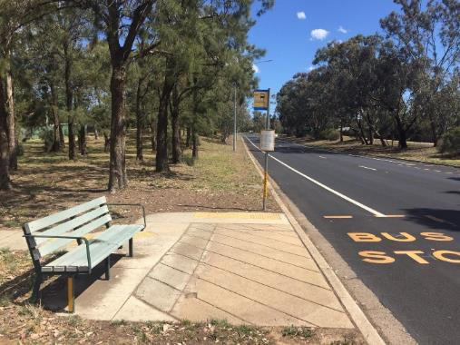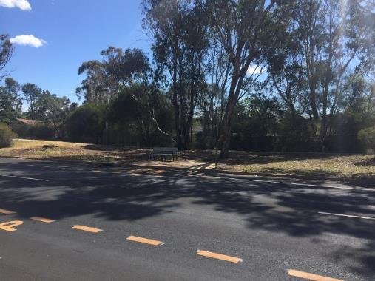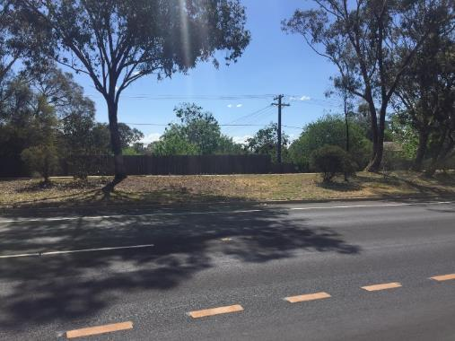
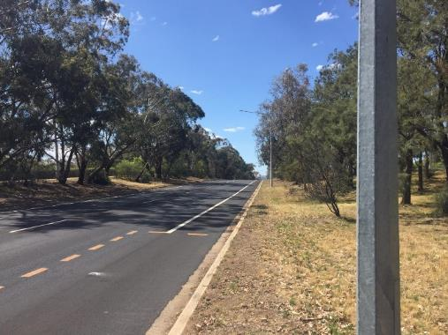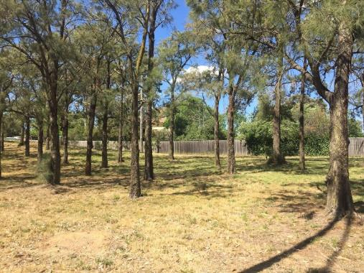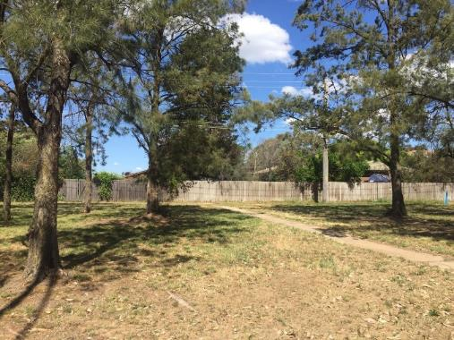

Bus stop 4274
Bus stop 4274 is on Coulter Drive in Weetangera. The street is a very busy main road, especially at peak times. The bus stop on the opposite side of the road is 4273.
Bus stop 4274 has no lighting above it. There is streetlighting on the other side of the road which might provide some illumination, but not to the path leading away from the bus stop.
Behind bus stop 4274, it is shadowy and dark from trees, even in the daytime, as shown in Figure 38. Heading towards the residential area in Weetangera there is a path, which is unlit at night, parallel to the road. The path has trees overshadowing it and is close to the back fences of housing (see Figure 38 and 39). There is a small embankment behind the path leading away from the bus stop, which may be a possible entrapment site as it is not totally visible from the road. The closest entrance to the suburb, and access to Line Pl, is down an alleyway that has no lighting and no access to housing until you enter Line Pl.
If travelling to the suburb on the opposite side of the road, a woman would have to cross a very busy street and walk into a green space. The green space has a path that is hidden from the road in some places and is not illuminated. Macquarie residential area is only entered through an unlit alley way.
This bus stop is on an arterial road where there are only housing back fences. It has numerous possible entrapment sites and paths that would be dark and not visible from the road at night.
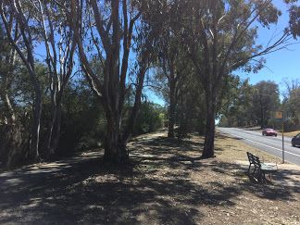
Figure 38: Area behind bus stop 4274.
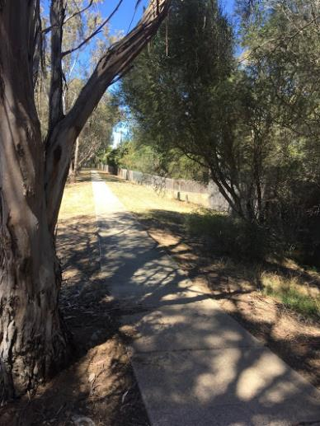
Figure 39: Path leading to closest alleyway.

360 degree view of bus stop 4274
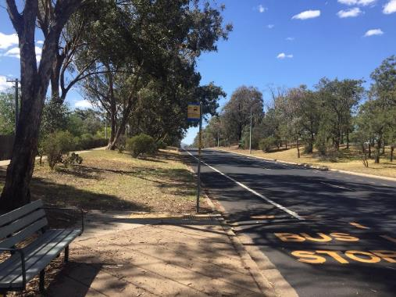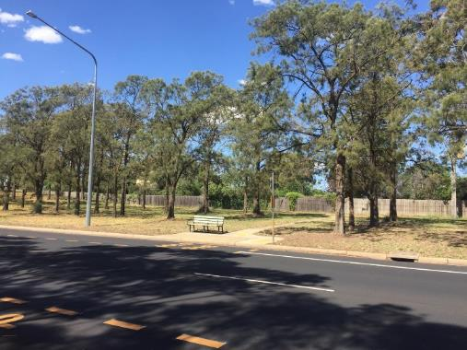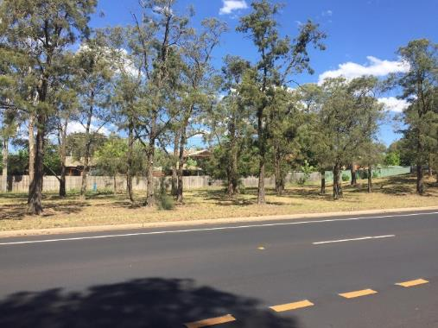
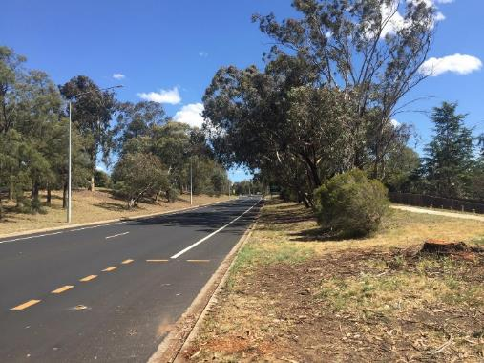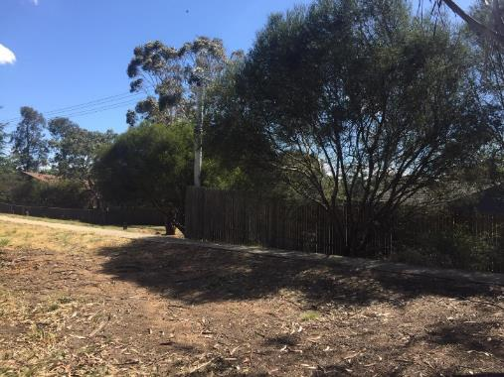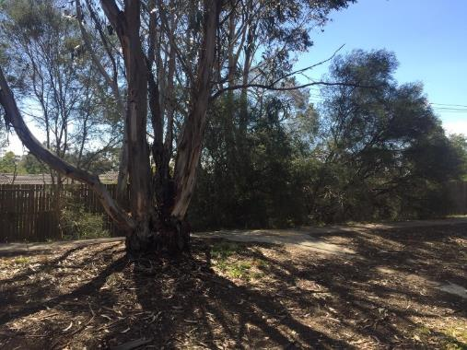

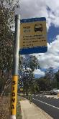
Bus stop 4275
Bus stop 4275 is on Coulter Drive in Macquarie. The street is a very busy main road, especially at peak times. These bus stops have been upgraded recently to include the access island in the middle of the road. Bus stop 4276 is on the opposite side.
“The path along Coulter Dr from the bus stop to the laneway I walk through is dark, overgrown and mostly covered in dirt/weeds.”
The bus stop has street lighting on the opposite side of the road only. There is no lighting illuminating bus stop 4275, as shown in Figure 40. Heading home to Macquarie is tricky, as the only way to get to a path is to trek over the hill behind the bus stop or walk next to the road. Neither has a path (see Figure 41 and 42). There is no lighting that illuminates the hill or the path behind the hill, which is isolated and out of view from traffic. The path leads to an alley way to get into the suburb. The alleyway would be very dark at night due to the lack of lighting.
Accessing Weetangera is easier, as there is a path that leads to an alley way and is near street lighting. Even so, the alley way would be dark at night, and has poor visibility to the road, so would feel isolated.
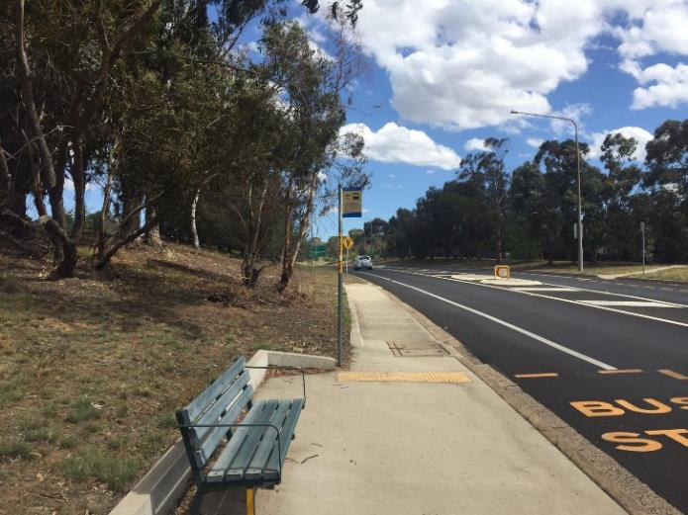
Figure 40: Bus stop 4275.
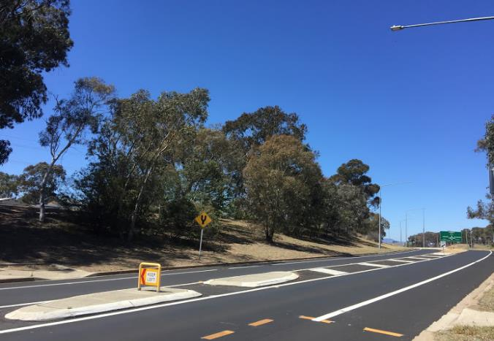
Figure 41: Area between bus stops 4276 & 4275.

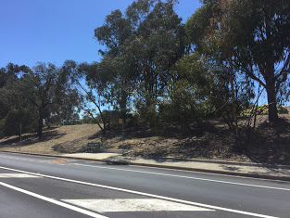
Figure 42: Bus stop 4275 with possible entrapment zone behind hill.

360 degree view of bus stop 4275
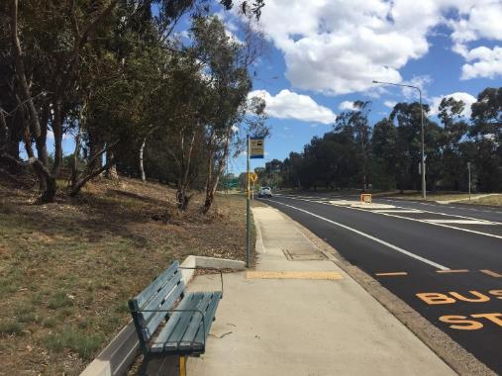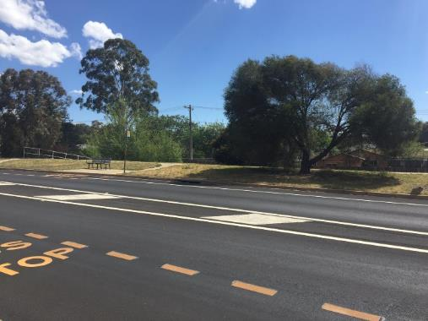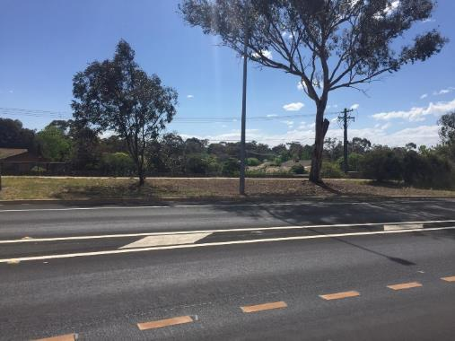
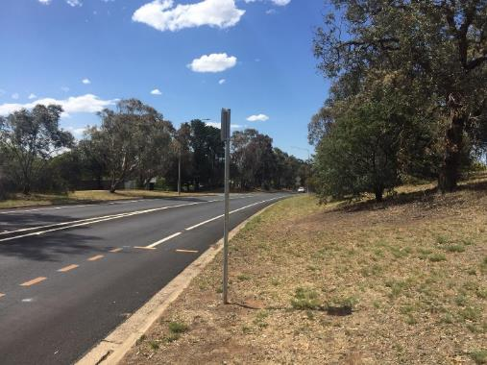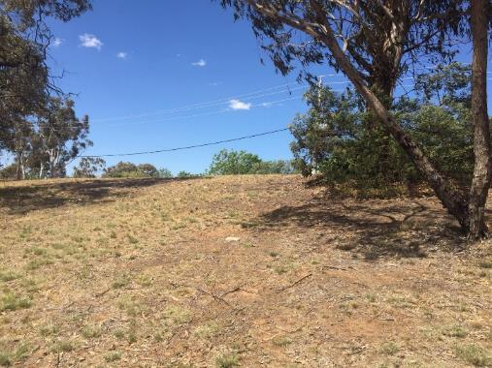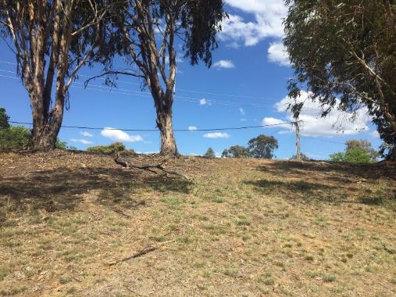

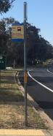
Bus stop 4276
Bus stop 4276 is on Coulter Drive in Macquarie. The street is a very busy main road, especially at peak times. The bus stops have been upgraded recently to include the access island in the middle of the road. The bus stop on the opposite side of the road is 4276.
“The path along Coulter Dr from the bus stop to the laneway I walk through is dark, overgrown, and mostly covered in dirt/weeds.”
The bus stop has streetlighting a small distance away but not directly above the bus stop (shown in Figure 44). There is no lighting that illuminates paths leading to and from the bus stop, which are 3 metres from the side of the road. There is a dark alleyway nearby that leads to McLachlan Cres in Weetangera near bus stop 4276, which has no lighting and would be very dark at night (Figure 45). There are only back fences nearby, and bushy areas which could be possible entrapment sites.
There are multiple areas which can’t be seen from the road, trees, and bushes directly behind the bus stop and the alley way. To get to Macquarie on the other side of the road, a woman would need to either cross the road at the bus stop and trek up a small hill with no path or lighting, or walk down a dark path and cross further down the road. Both options require walking in the dark.
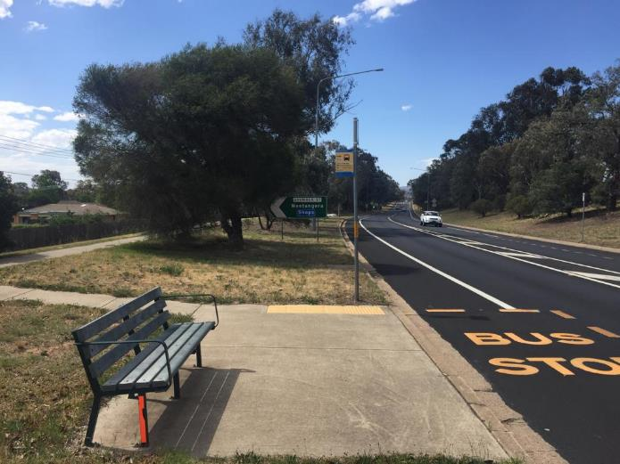
Figure 43: Bus stop 4276.
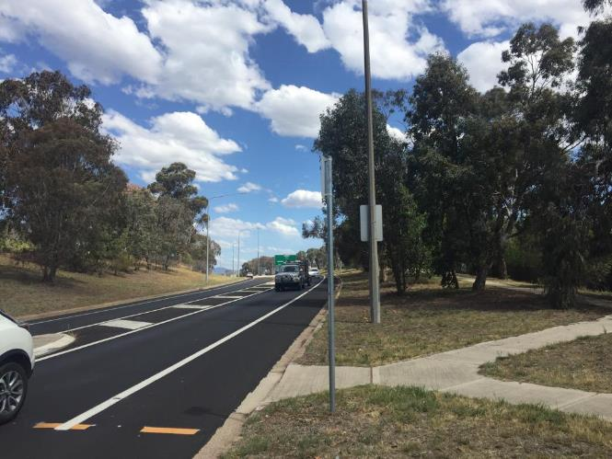
Figure 44: Closest lighting to the bus stop and bushy area near bus stop.

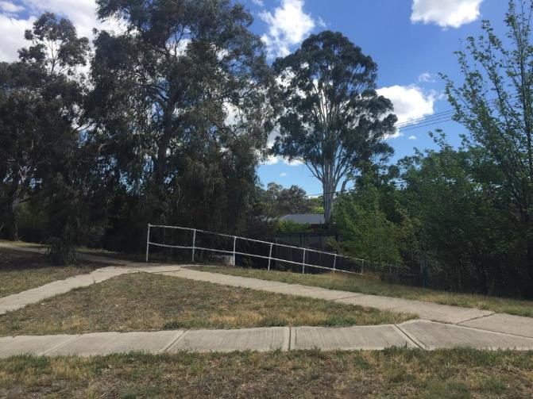
Figure 45: Alley way leading to Weetangera near bus stop 4276.

360 degree view of bus stop 4276
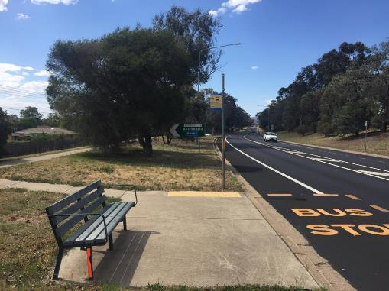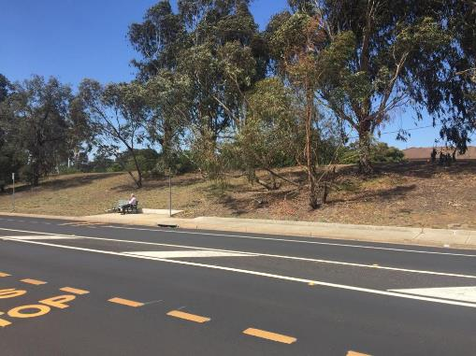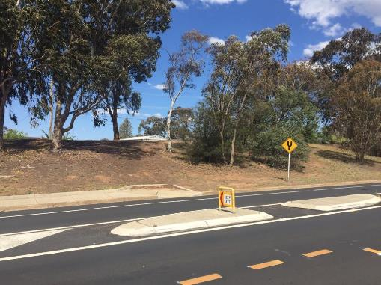
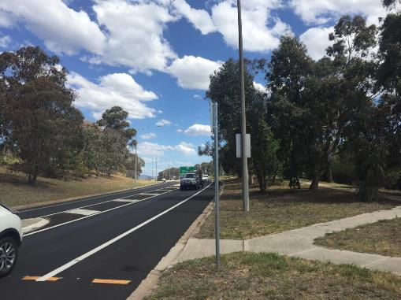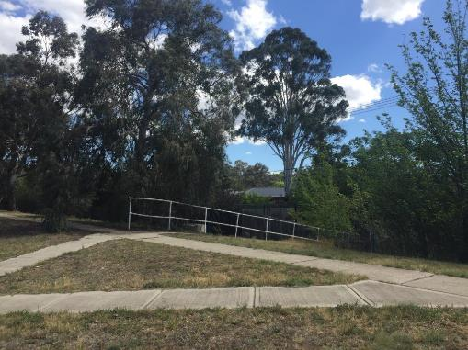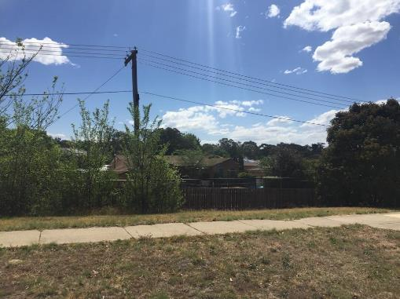

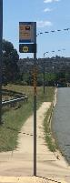
Bus stop 4064
Bus stop 4064 is on John Cleland St in Florey located behind the Florey shops. The bus stop is on a street with a medium amount of car traffic, with a large green space behind the bus stop and housing back fences on the opposite side of the road. The bus stop on the opposite side of the road is 4065.
“The lighting is a major issue especially when walking down the foot path from the shops...”
Bus stop 4064 has streetlighting illuminating the bus stop, but would be very dark behind the bus stop where there is a large park (Isla Carys park) with no lighting. To gain access to the Florey shops or to residential areas near the shops, there is a path that is hidden from the road (Figure 46) as it is lower than street level. The path would be very dark at night due to lack of lighting, and is a possible entrapment site due to poor visibility to the road (Figure 47). The path leads to an underpass which is also dark at night and a possible entrapment site.
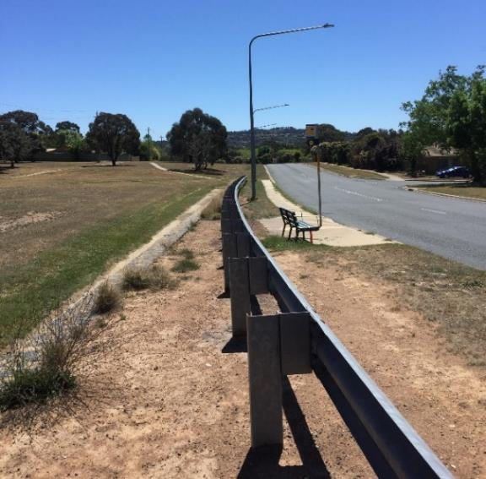
In the opposite direction, the path leads away from the bus stop near the road for approximately 100 metres, then into the unlit park, past housing back fences for 100 metres, and through alleyways to get to residential areas (such as Mallor St or Brunnich Pl).
Figure 46: Hidden path behind bus stop 4064.

The closest housing to this bus stop is on the opposite side of the street on Tattersall Cres.
There are numerous possible entrapment sites at this bus stop which is isolated due to the large open spaces and lack of visibility to houses.
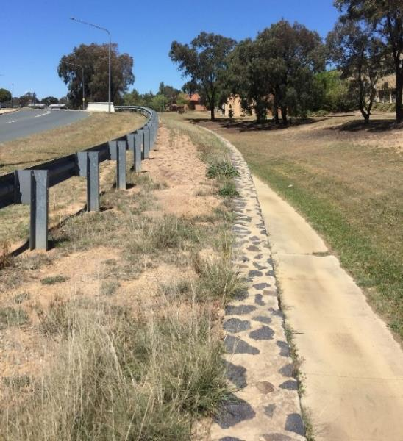
Figure 47: Hidden path behind bus stop 4064 leading to underpass.

360 degree view of bus stop 4064
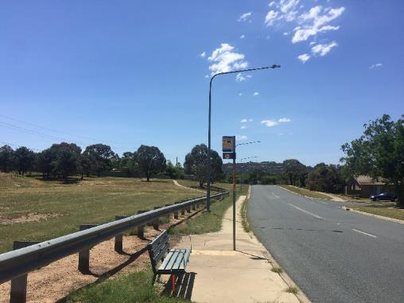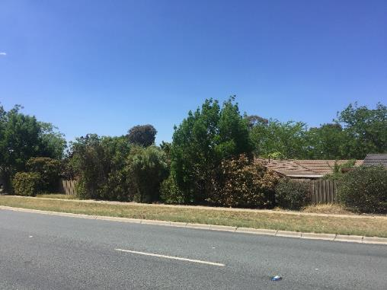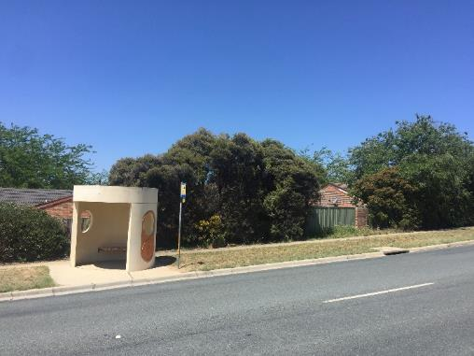
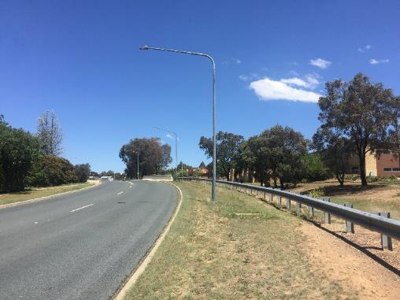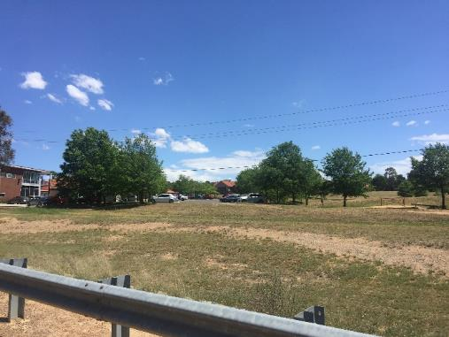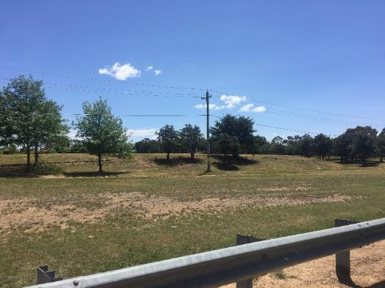

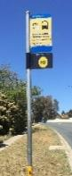
Bus stop 4065
Bus stop 4065 is on John Cleland St in Florey located near the Florey shops. The bus stop is on a street with a medium amount of car traffic, with a small area of bushes and housing back fences behind the bus stop and a large green space on the other side of the road. The bus stop on the opposite side of the road is 4064.
“The lighting is a major issue, especially when walking down the foot path from the shops...”
Bus stop 4065 has no immediate lighting illuminating the bus stop, although there is street lighting on the other side of the road. Directly behind the bus stop there are dense bushes that could be possible entrapment sites (Figure 48 and 50). There are no lights on the path leading away from the bus stop towards the closest residential area, Tattersall Cres.
To get to a residential area down the road (towards Ginninderra Drive), a woman can either walk on the path that is on the side of the bus stop, which is not illuminated at night, or walk on the opposite side of the road which has a dark park next to it. To get to Mallor St, women need to walk 100 metres on a path that heads into the park past the back fences of housing.
Heading towards the Florey shops or to residential areas near the shops there is a path that leads to the underpass. The path is not well lit, but it is close to the road which has lighting on the opposite side. The underpass has one light illuminating the entrance, but no lighting inside the tunnel (Figure 49). Women are more likely to cross the road rather than use the tunnel.
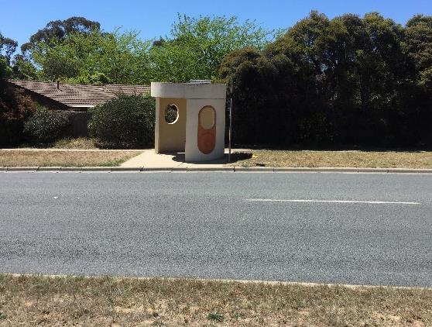
Figure 48: Bus stop 4065.
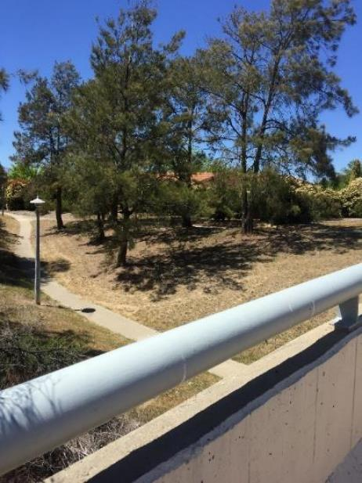
Figure 49: Lights near underpass.

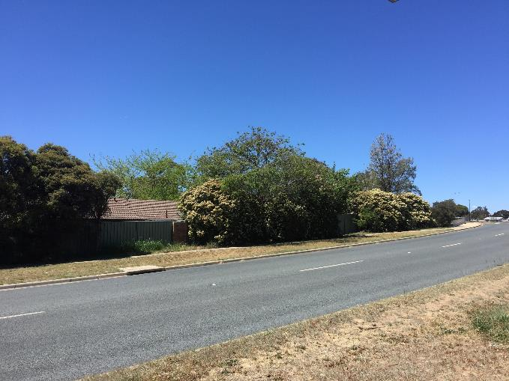
Figure 50: Bushes close to bus stop 4065.

360 degree view of bus stop 4065
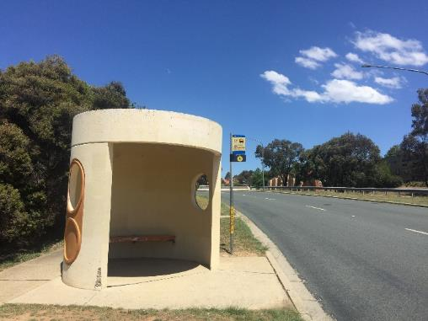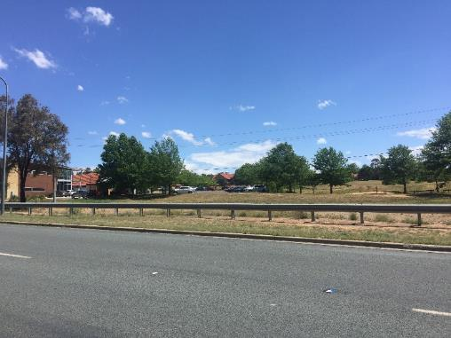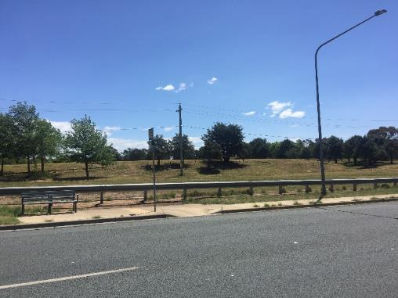
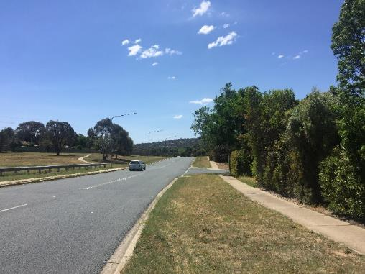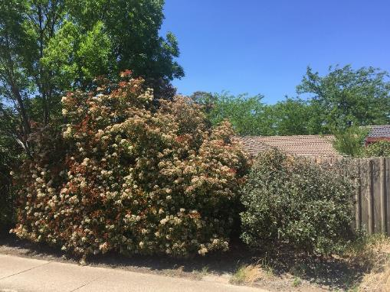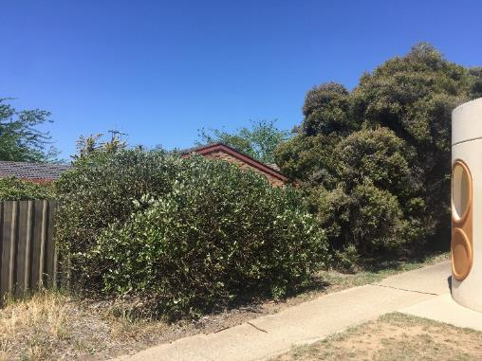

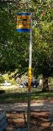
Bus stop 2340
Bus stop 2340 is on Goyder Drive in Narrabundah. The bus stop is on the street with minimal car traffic, with housing on close by and a green space on the opposite side of the road. The bus stop on the opposite side of the road is 2341.
Bus stop 2340 has a light close to the bus stop, which illuminates the area and the entry of the alleyway nearby. There are no streetlights on the road leading away from the bus stop. Bus stop 2340 has unlit paths leading to and from the bus stop. The alleyway to access Tallara Pkwy, is dark even though there are two lights, and is long, and narrow. It is also a possible entrapment site due to its poor visibility to the road (see Figure 52 and 53).
The whole of the area around Goyder Dr is not well lit. There is a building on the opposite side of the road which is desolate, providing no additional lighting. There is also a reserve area which is isolated and would be particularly dark at night. This green space extends the whole of Goyder Drive until Jerrabomberra Drive. The empty, dilapidated building gives the additional feeling of isolation (see bus stop 2341).
At night, the bus stop areas are extremely dark and quiet, and would feel very uncomfortable (see Figure 54). In addition, there is no shelter at the bus stop.
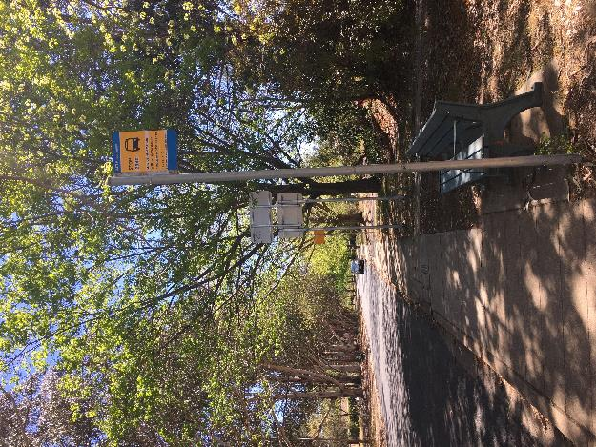
Figure 51: Bus stop 2340

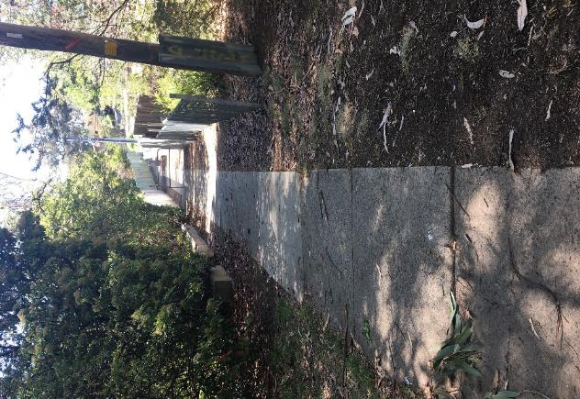
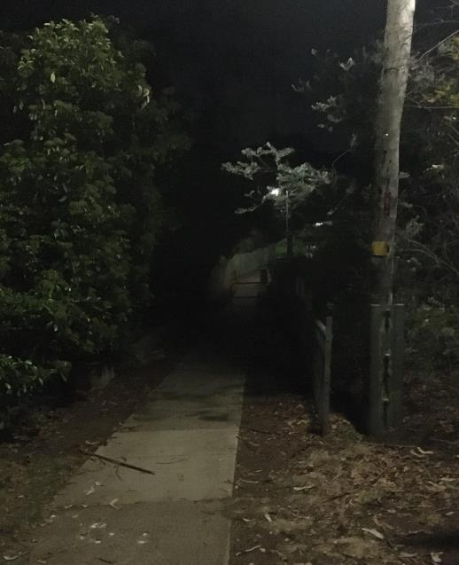
Figure 52: Long alleyway close to bus stop 2340 on Goyder Drive. Arrow is pointing to light poll which illuminates 2340.

Figure 53: Long alleyway close to bus stop 2340 on Goyder Drive pictured at night.

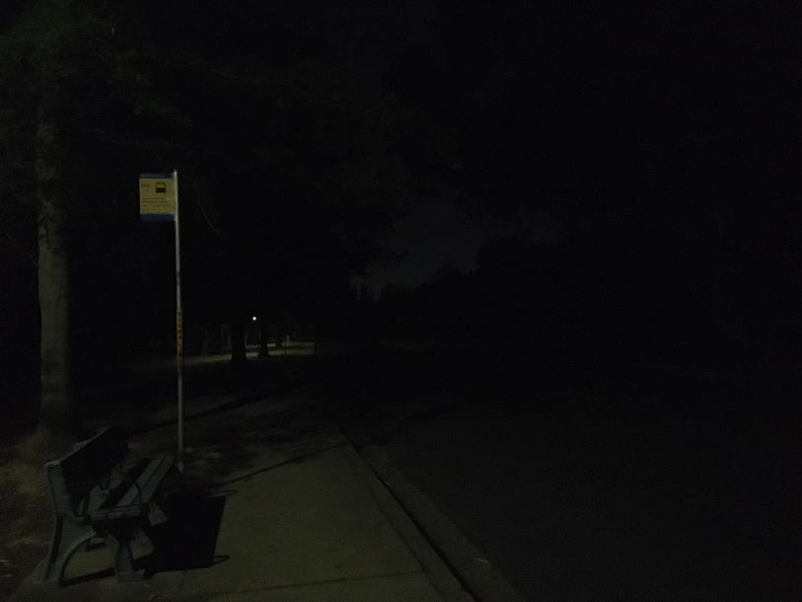
Figure 54: Bus stop 4340 at night.

360 degree view of bus stop 2340
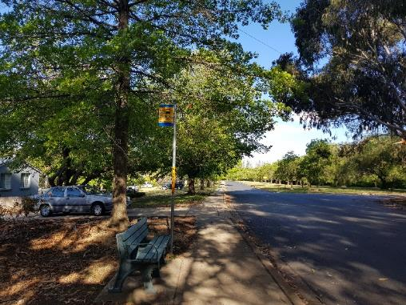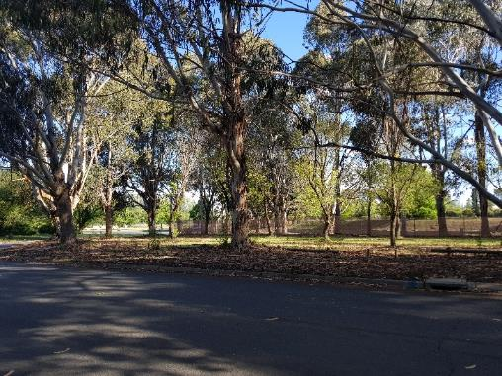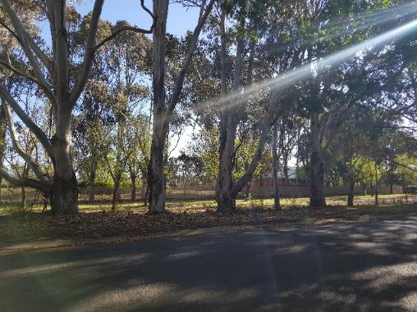
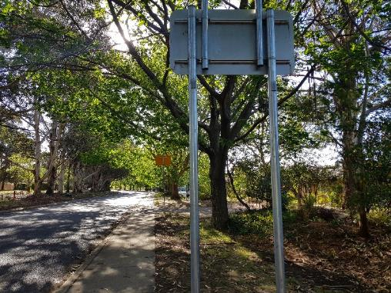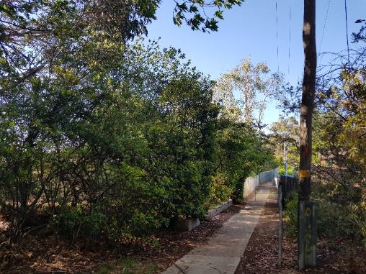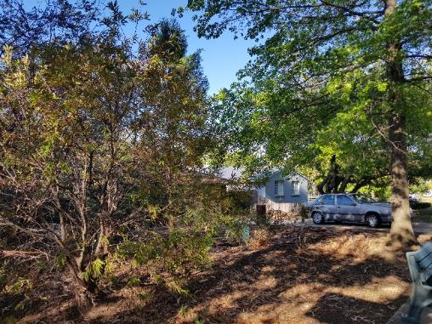

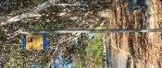
Bus stop 2341
Bus stop 2341 is on Goyder Drive in Narrabundah. The bus stop is on a street with minimal car traffic, with housing on one side and a green space on the other. The bus stop on the opposite side of the road is 2340.
Bus stop 2341 has no immediate lighting at or around the bus stop. There are no streetlights on the road (there is no path) leading away from the bus stop, see Figure 55. There is a reserve directly behind bus stop 2341 which is isolated and would be particularly dark at night. The tall gum trees provide possible entrapment sites due to the darkness at night. The green space extends the whole of Goyder Drive until Jerrabomberra Drive. The desolate dilapidated building pictured in Figure 55, gives the additional feeling of isolation.
The only path is on the opposite side of the road, which is also where housing is. If a woman lived on Goyder Dr, this would be an easy commute home. The lighting on the path on the opposite of Goyder Dr is dim, it is approximately 50 metres apart, and there are trees blocking the light. Walking away from the bus stop towards the opposite side bus stop (bus stop 2340), there is an alleyway that connects Goyder Dr to Tallara Pkwy. While it has lighting illuminating the alleyway, it is long and a possible entrapment site due to poor visibility to the road.
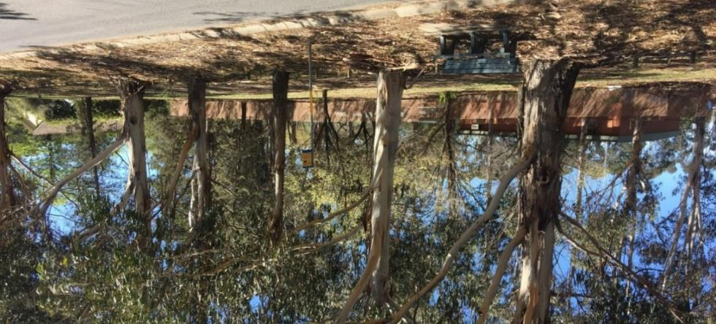
This bus stop has poor lighting at night, is isolated, and has areas that are possible entrapment sites, such as the green space behind the bus stop.
Figure 55: Bus Stop 2341 on Goyder Drive.

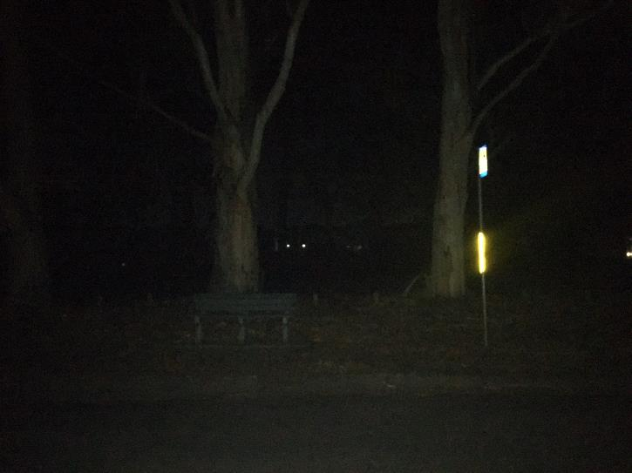
Figure 56: Bus stop 2341 at night using camera flash to illuminate stop

360 degree view of bus stop 2341
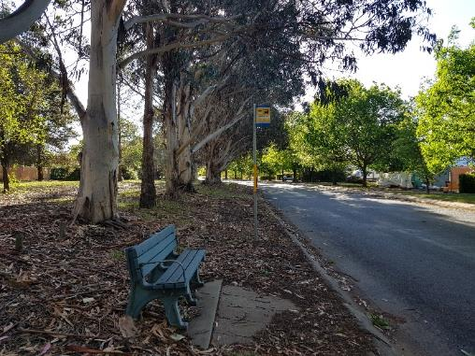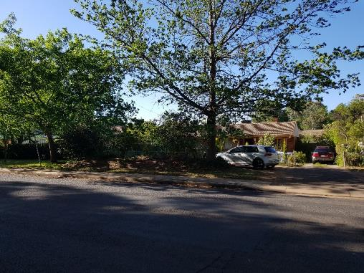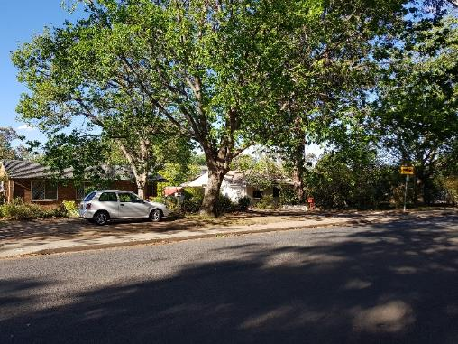
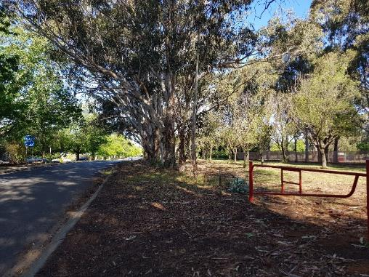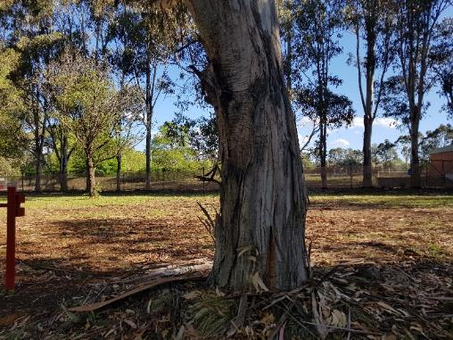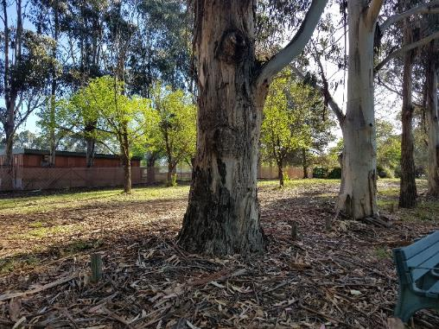

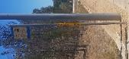
Bus stop 2016
Bus stop 2016 is located on Carruthers St in Hughes, which is a four-lane road separated by a gravel median strip. It is directly opposite to bus stop 3025. The traffic here is high speed but somewhat low during day and night.
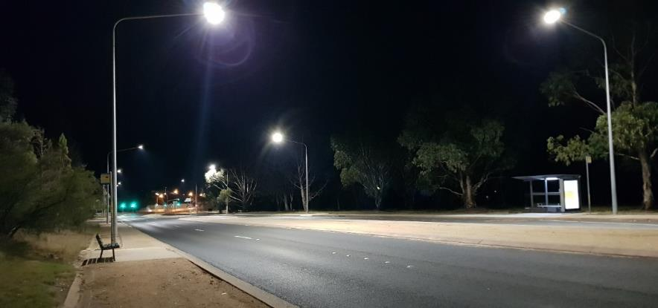
The bus stop only has a seat with one cemented pathway on the left along Carruthers St towards Groom St, and no pathway on the right of the bus stop towards Denison St as shown in Figure 57. Carruthers St is well-lit with evenly spaced streetlighting including light directly at bus stop 2016. Behind the bus stop is very dense bushland at a steep incline. To reach Denison St, women would have to walk up to Groom St to reach a curb cut at the next streetlight, and then walk down on the other side of Carruthers St. Alternatively, women would have to jaywalk to cut across the median strip and reach the opposite path (see Figure 58). Walking on the opposite side where bus stop 3025 is located, would mean travelling alongside large green space with lots of trees and no line of sight beyond that when in the dark (for further description see bus stop 3025). Walking parallel to Carruthers St is isolating due to little foot and road traffic and no residential areas until turning into Groom St or Denison St. Sighted in Groom St, are two decommissioned bus stops at St Andrews Retirement Village at about 400 metres walk from bus stop 2016 (Figure 59). The isolation of bus stop 2016 could also be uncomfortable for women waiting at the bus stop.
Figure 57: Bus stop 2016 (left) and 3025 (right) with streetlights along the road and at the bus stops.

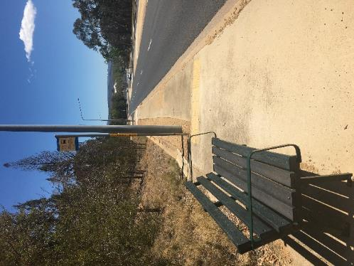
Figure 58: Bus stop 2016 with lighting and curb cut at the next streetlight near Groom St.

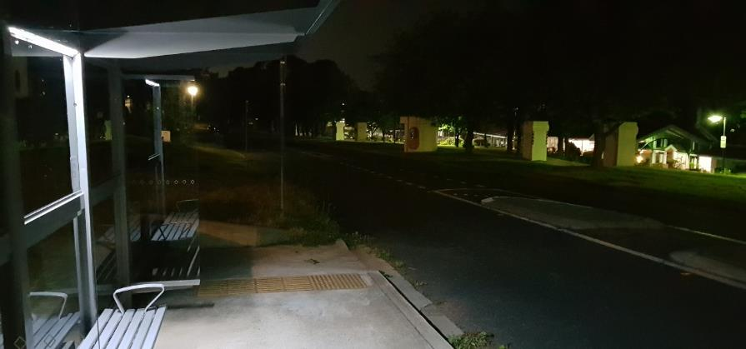
Figure 59: Decommissioned bus stops (left and right) near St Andrews Retirement Village (on right).

Bus stop 3025
Bus stop 3025 is located on Carruthers St in Hughes, which is a four-lane road separated by a gravel median strip. It is directly opposite to bus stop 2016. The traffic here is high speed, but somewhat low volume during day and night.
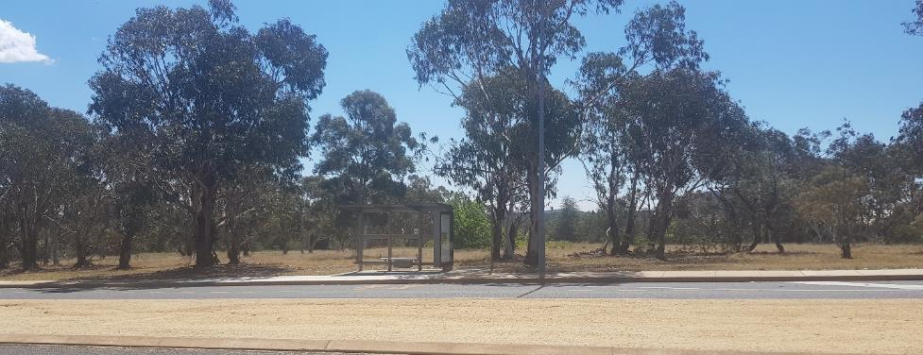
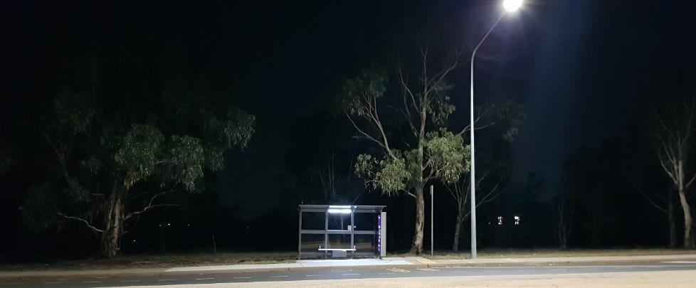
The bus stop is well lit, with seating and shelter as shown in Figure 60 and 61. Carruthers St is well-lit with evenly spaced streetlighting, including light directly at bus stop 3025. However, there is a large green space behind the bus stop where it is difficult to see beyond a few metres at night. This may pose dangers for women waiting at the bus stop whose immediate location is only visible to themselves and passing motorists. The area is travelled by few motorists with the closest housing either on the left of bus stop 3025 on Denison St, or on the right across the road at Groom St. Due to low visibility from passers-by and no residential areas within line of sight, the area is isolating for women waiting and travelling at this bus stop.
Figure 60: The greenspace behind bus stop 3025 and the gravel median strip between four-lane Carruthers St.
Figure 61: Bus stop 3025 at night.

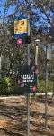
Bus stop 2593
Bus stop 2593 is located on Melbourne Ave in Barton. The bus stop is on a fairly busy road (especially at peak hour) that is surrounded by embassies. The buses are express routes to the city and Woden town centre. The bus stop on the opposite side of the road is 2271.
“It is very dark with poor lighting along the whole of Melbourne Avenue.”
There is dim street lighting, but none illuminating the bus stop. The yard behind the fence and hedge behind the bus stop has no lighting and is a large bushy area which does not contain a house. To access housing on Sommers Cres which is roughly 50 metres away, there is a short path next to the road, but it is poorly lit.
Travelling to housing on the opposite side of Melbourne Avenue, a woman needs to cross the large green space in the middle of the road which has no lighting and no path. The whole area is very dark at night, with the only light illuminating the tree but not the bus stop (Figure 62 and 63). The large verge, while lit during the day, is very dark at night and would be a possible entrapment site. Anyone crossing the road would most likely walk on the road rather than crossing the green space (Figure 64 shows green space).
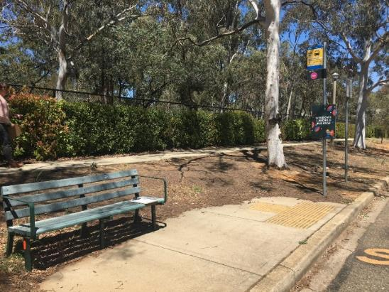
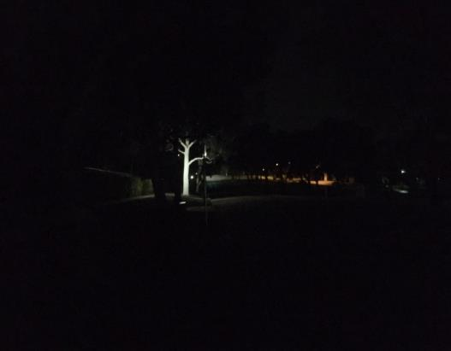
Figure 62: Bus stop 2593.
Figure 63: Lighting near bus stop 2593 but not illuminating it. Arrow pointing to the bus stop pole.

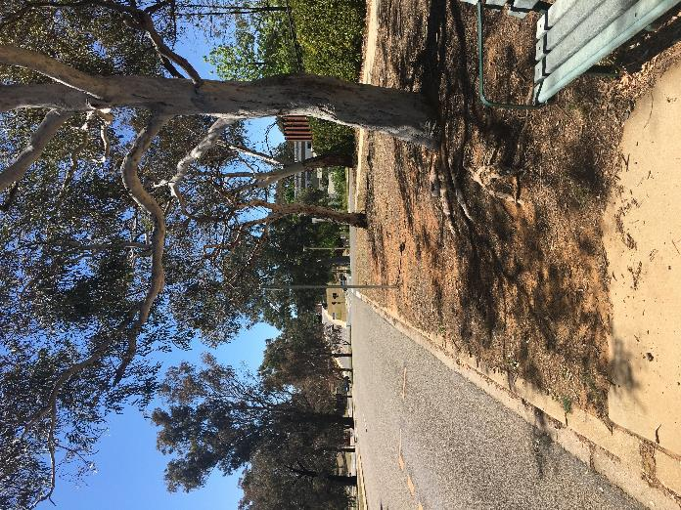
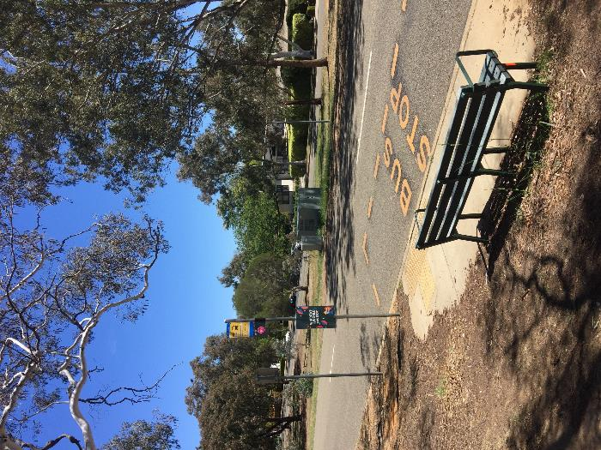
Figure 65: Bus stop 2593.
Figure 64: Bus stop 2593 showing green space in the middle of road.

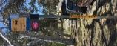
Bus stop 2217
Bus stop 2217 is located on Melbourne Ave in Barton and is across the road from 2593. The bus stop is on a fairly busy road (especially at peak hour) that is surrounded by national embassies. The buses are express routes to the city and to Woden town centre. The bus stop on the opposite side of the road is 2593.
“No lights at the stop, have to cross wide bush intersection with no lights.”
Bus stop 2217 is not well lit, even though there is a lamp post three metres away. The nearest illuminated area is approximately 90 metres away. There is housing nearby that has high hedges and locked gates which block line of sight when turning the corner into Canterbury St, making this a concern as a possible entrapment site for women (see Figure 66).
To get to housing on the opposite side of Melbourne Ave, a large green space needs to be crossed. The green space contains bushes and trees (and no housing), but has no path and is not illuminated (a yellow arrow is pointing to the green space in Figure 66). Walking anywhere in that area after dark would be concerning for a woman.
This bus stop would feel very isolated and unsafe at night due to limited lighting and possible entrapment sites (Figure 67 and 68).
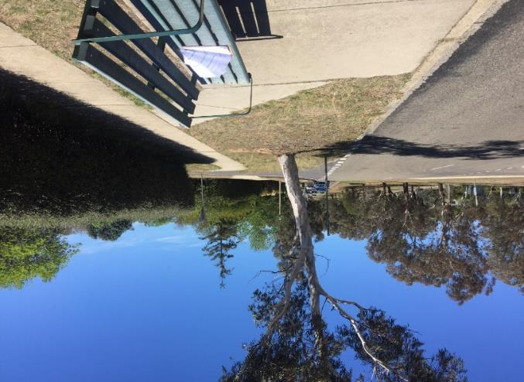
Figure 66: Bus stop 2217 featuring large green space nature strip (yellow arrow pointing to green space).
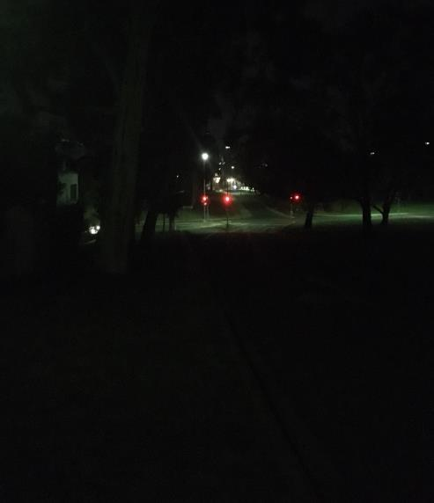
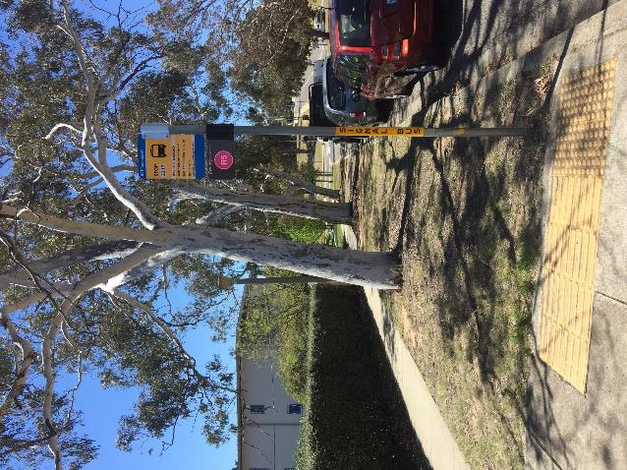
Figure 68: Traffic lights to the left of bus stop 2217 towards the Parliament House is the closest illuminated area.
Figure 67: Bus stop looking towards nearest intersection.

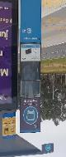
Bus stop 1908
Bus stop 1908 is on Athlon Drive in Kambah. The bus stop has been recently updated with shelters and lighting. It sits on a very busy road which has green space behind. The bus stop on the opposite side of the road is 1909.
“The only lit route home requires me to walk twice the distance as a direct route from the stop as I need to double back to walk where there are street lights. Even this route makes me feel unsafe.”
Bus stop 1908 is very well lit (see Figure 69). The only path that leads away from the bus stop to get to the residential area in Kambah, is well lit until the path intersects the bike path in the wooded reserve shown in Figure 70 and 71. To continue to the residential area (in the direction Oldfield St or Livingston Ave), a woman needs to continue further past the bike path where there is only a desire line path through a green space past housing back fences. There is one lamp post approximately 100 metres towards housing on the desire line path.
Crossing the road to access either the Wanniassa shops, Wanniassa Park & Ride or residential housing, a woman needs to cross the road via traffic lights. The path to Wanniassa Park & Ride or Rylah St Wanniassa is very lit up but it is not visible from the road or the park and ride that it leads to. This is an entrapment site for women as they would not be heard or seen if an incident occurred.
The bus stop has good lighting at the bus stop and the paths leading away. However, the wooded area is isolated and is a possible entrapment site.
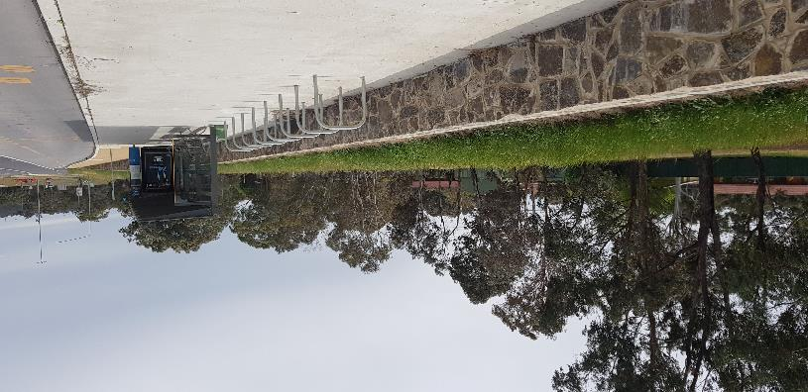
Figure 69: Bus stop 1908.

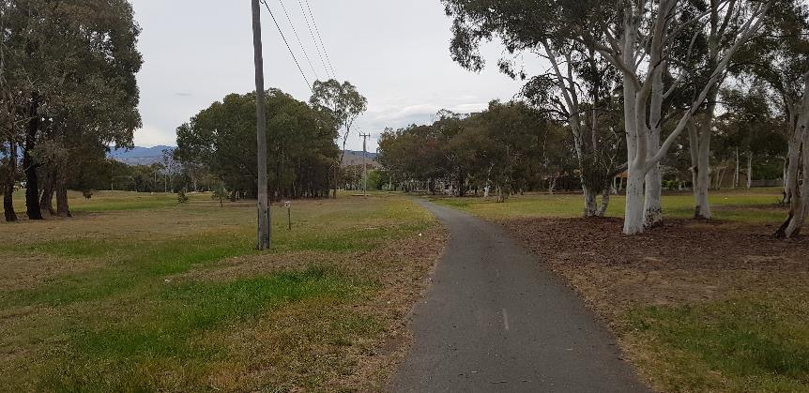
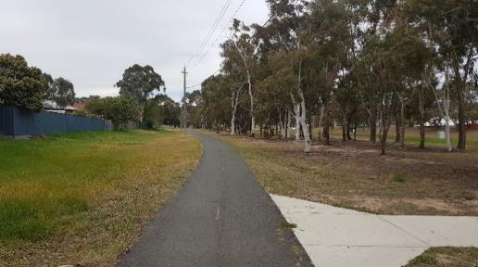
Figure 71: Opposite direction of bike path showing wooded green space.
Figure 70: Bus stop path leads to a bike path.

Bus stop 1909
Bus stop 1909 is on Athllon Drive in Wanniassa. The bus stop has been recently updated with shelters and lighting. The bus stop on the opposite side of the road is 1908.
“The only lit route home requires me to walk twice the distance as a direct route from the stop as I need to double back to walk where there are street lights. Even this route makes me feel unsafe.”
The bus stop is very well lit and there is adequate lighting on the path that heads away from the bus. The bus stops sit on a very busy road (Figure 72) which does not have any housing or shop fronts nearby. Behind the bus stop is the Wanniassa Park & Ride to the bus stop is down a small floodway valley. This valley is very isolated as it is an area that cannot be seen from Athlon Dr or Rylah Cres, the road that the Wanniassa Park & Ride is on (Figure 73 and 74).
Crossing to the opposite side of the road to get to Kambah, there are traffic lights which makes it safe to cross this very busy road. Some of the path to walk to homes in Kambah is only lit until halfway into the wooded area. The wooded area feels isolated even during the day. At night it would be dark due to the lack of lighting (see bus stop 1908).
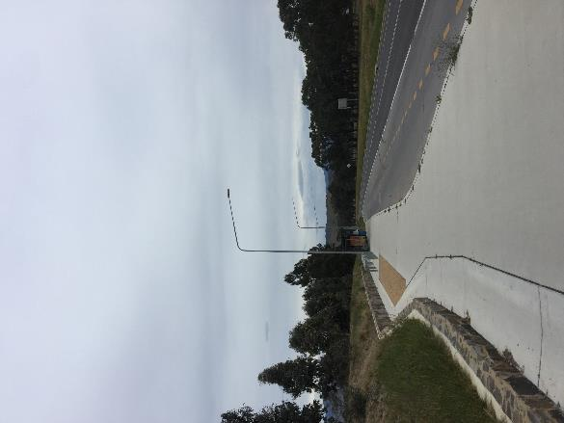
The bus stops have good lighting at the bus stop and the paths leading away. However, there are entrapment zones and areas that are isolated.

Figure 72: Bus stop 1909.
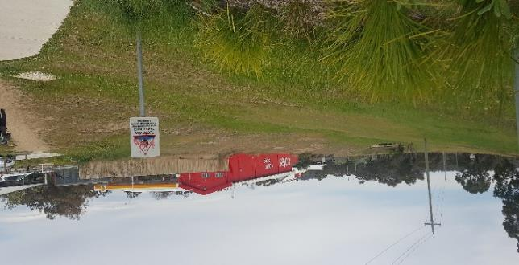
Figure 73: Photo of floodway valley between bus stop and park and ride car park.

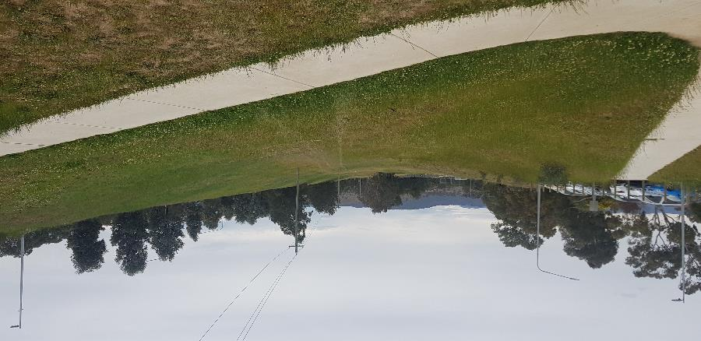
Figure 74: Floodway valley between bus stop and park and ride carpark.

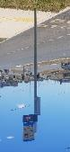
Bus stop 2822
Bus stop 2822 is located on Cotter Rd in Holder. It is on a very busy multi-lane road and near a road bridge over Weston Creek.
“The footpaths are dimly lit and there are many blind spots/isolated areas to walk between the bus stop and the houses at the eastern end of Coombs.”
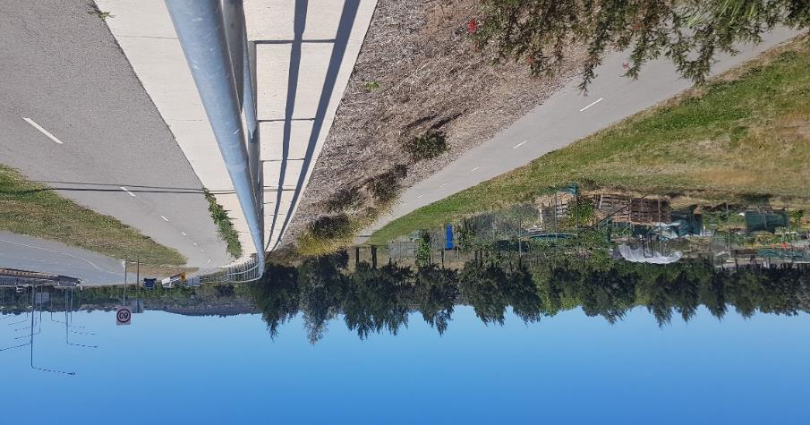
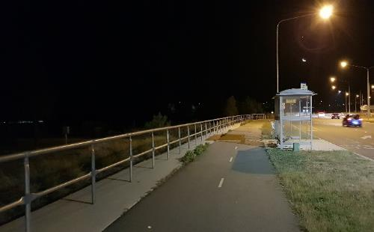
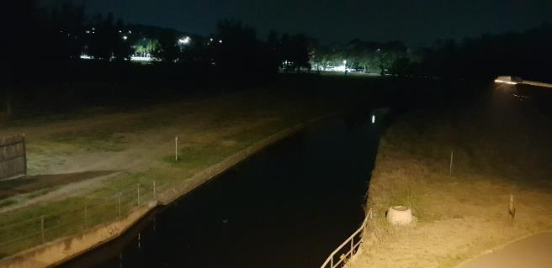
The bus stop is sheltered with seating and surrounded by green space as shown in Figure 75. The closest residential area is at least 200 metres walk to the right towards Weston and the closest shopping area is 600 metres beyond that. Cotter Rd is well-lit being lined with streetlights and the closest light about 10 metres away from bus stop 2822. However, pathways towards Coombs (opposite the bus stop) and Holder (behind the bus stop) have minimal or no lighting where the shared pedestrian and cycle path towards Holder is hidden away from motorists at below street level towards Weston Creek and passing Holder Community Garden (Figure 76 and 77). Women travelling to Coombs are required to cross traffic light to the right of the bus stop and from there either walk parallel to Cotter Rd before entering Coombs via reserve or immediately enter the reserve under Cotter Rd bridge and walk around the creek below street level (Figure 78). The reserve is a green space with many trees and no lighting on the shared paths except near the bridge and creek similarly to the Holder side.
Figure 76: Shared pedestrian and cycle pathway towards Holder and Weston Creek with no lighting below street level between Cotter Rd and Holder Community Garden behind bus stop 2822.
Figure 75: Streetlighting near bus stop 2822.
Figure 77: Weston Creek runs from Holder to Coombs under Cotter Rd bridge. Lighting is available on the shared pathway only at the brink of creek. (Picture taken from bridge).
Green spaces at the bottom of embankment behind bus stop 2822 towards Holder and the opposing reserve towards Coombs, opens many possible entrapment sites where women would not be able to seek help or be noticed by passers-by from the road and where there are no residents nearby. This is particularly risky after hours when there is no lighting as well as more isolating with less people travelling through the park.
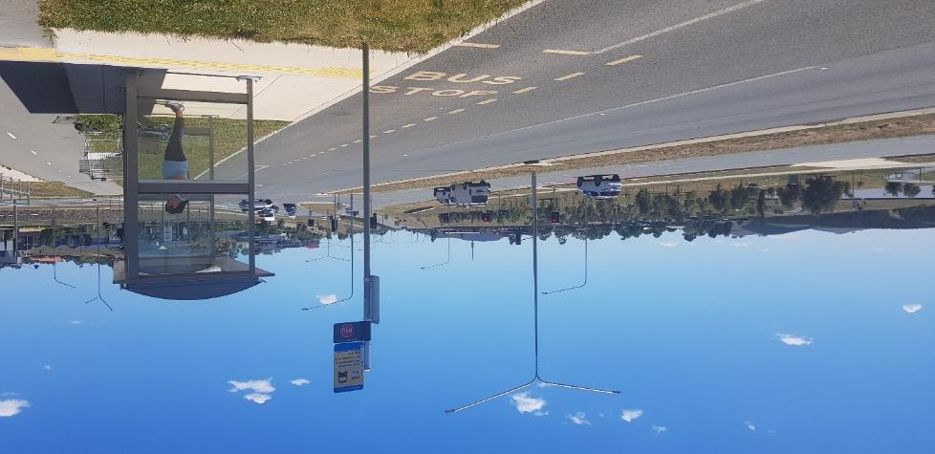
Bus stop 2822 itself covers all essentials of lighting, shelter and seating but the pathways to access the bus stop are lacking in safety due to the remoteness away from the road and residents. It seems like lighting is prioritised for road users but not for pedestrians.
Figure 78: Reserve and creek in Coombs (left) opposite of bus stop 2822.

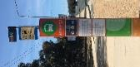
Bus stop 4005
This bus stop is along Haydon Dr, a busy road during the day, however, there is a wooded park behind it and parking lot behind half of the wooded area.

The stop is along a main road where there is adequate lighting spaced approximately 20 meters apart along either side of the stop. The light nearest the bus stop is about 10 meters away. There is no housing that is visible nearby, the bus stop is surrounded by offices, green spaces and schools/university. This bus would be accessed by women working in the area, attending school or from their home. The wooded area behind the bus stop is dark at night (Figure 81 and 82). To access the carpark or offices there is a steep embankment where people walk as there is a desire path. This area is hidden from view of the road and is a possible entrapment site, especially when dark at night.
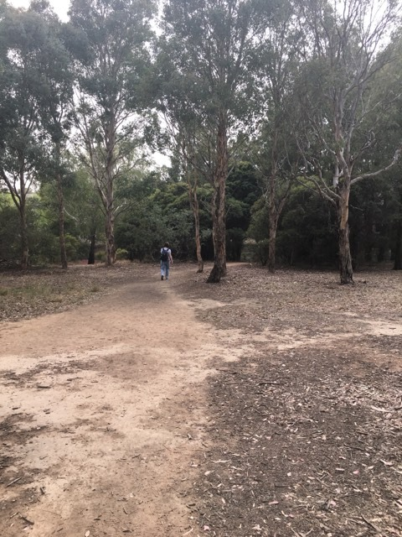
This bus stop is used by commuters that live in the Bruce area near Thynne St, as there is no bus that runs through the area that goes to the city. To access Thynne St area there is a short walk up Haydon Dr (towards the intersection of Haydon Dr and College St) then either through a carpark, or down a gravel path through a wooded green space for approximately 150 metres which diverts behind office buildings and around the pink lake to Eardley St (path shown in Figure 79 and 80). Both the carpark and the green space are dark and isolated at night and are possible entrapment sites for women. The alternative route is a longer walk up Haydon Dr having to cross a major intersection.
Figure 79: Path in green space from Haydon Dr to Eardley St.

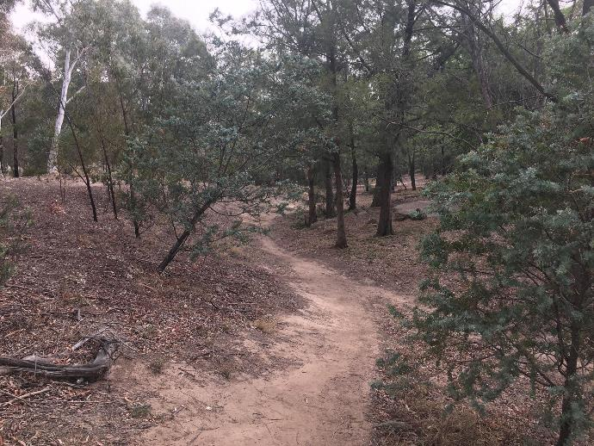
Figure 80: Path from Haydon Dr to Eardley St.

The closest residential housing is on Baudinette St in Bruce which requires a woman to walk a short distance down the road (away from Haydon Dr and College St intersection) and then through an alley way to the left. While the alley way is quite visible from the main road it would be quite dark and feel isolated at night.
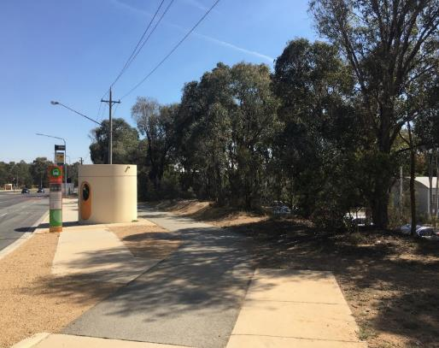
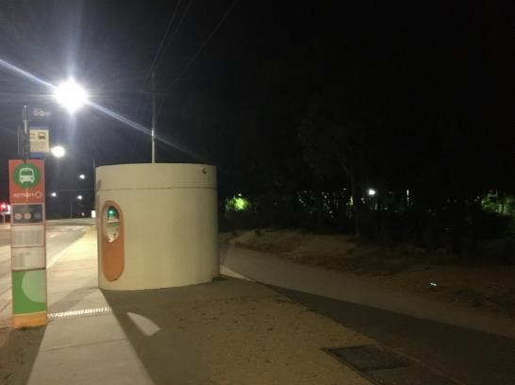
Figure 81: Path leading to bus stop 4005 with trees behind.
Figure 82: Bus stop at night.

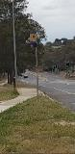
Bus stop 1340
Bus stop 1340 is located on Sternberg Crescent in Wanniassa. The four-lane road is busy, separated by a thin gravel median strip. This bus stop is on the express route towards the city and behind it is Erindale shopping area.
“I have to walk all the way down to Erindale shop, where there can be groups of youths from the school, PCYC etc.”
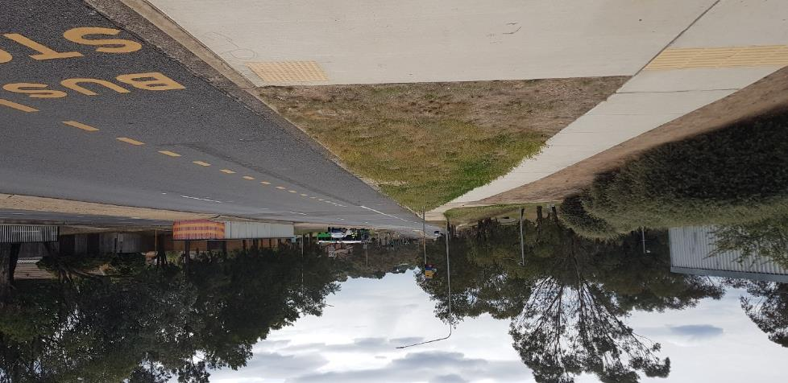
This bus stop has no seating or shelter, it is only marked by a pole as shown in Figure 83. There is street lighting beside the bus stand and along Stenberg Cres. Directly behind bus stop 1340 are dense hedges lining the side of a building which at the time of audit, had evidence of vandalism and secret hangout area where passers-by may not notice to assist without entering the confined area between the hedge and building as shown in Figure 84. Immediately to the left of the bus stop is a bridge over an underpass (Figure 85). There is a well-lit declining pathway from the bus stop that diverts in three directions: (1) the shopping area that is well-lit and high visibility, (2) towards Erindale College which is through green space among some trees and has no lighting, and (3) to the underpass to reach opposite side of road. However, the slope is quite steep, and the walking distance would be more than jaywalking straight across Sternberg Cres, so it is highly likely women would not choose to use the underpass that has broken glass, is isolated, and cannot be seen by passers-by at street level. However, travelling straight beyond the opposite side of the road means walking more than 150 metres before reaching a residential area, and is below street level between green spaces with bushy trees and housing back fences on a pathway that only has a streetlamp at the exit of the underpass. For those travelling left or right on the opposite side of the bus stop and parallel to Sternberg Cres, the pathway is lined with trees and housing back fencing or green spaces for at least 120 metres before reaching the front yards of houses.
Figure 83: Dense hedges (left) line the pathway towards bus stop 1340 on Sternberg Cres.
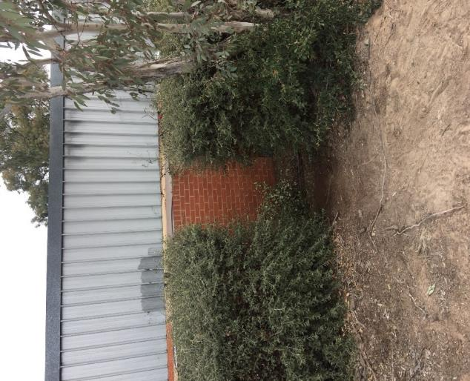
As this bus stop has lighting and is near a busy area with diverse groups visiting, it can provide a sense of safety in the daytime. However, at night there would be less road and foot traffic that would require women to take more caution in the area. Women may choose to jaywalk across the street rather than loop through the underpass to reach the opposite side of the road for safety and efficiency reasons. However, those with accessibility issues may have difficulty with either option due to the steepness of reaching the underpass.
Figure 84: Confined area between hedge and building near bus stop 1340 where vandalism and secret hangout area was found.

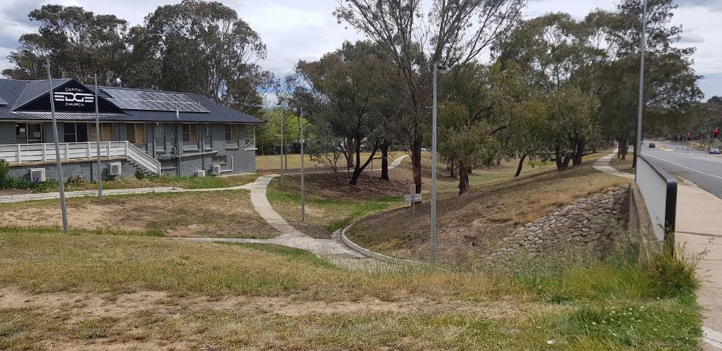
Figure 85: Pathway diversion including underpass entrance is well-lit behind bus stop 1340.

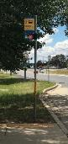
Bus stop 2650
Bus stop 2650 is located on Athllon Drive in Phillip where traffic is busy at 60km/hr all times on four-lane road that is separated by a very thin median strip. The bus stop is on express route headed from the south to the city with frequent buses. It is diagonally opposite to bus stop 2651 by about 100 metres.
“On the old system, after dark, I walked to the nearest main road and was not exposed. Now I have to walk through Phillip shops when they’re all closed, past the car yards etc. I am disabled and cannot run to safety if I need to. I no longer go out after dark at all.”
This bus stop has seating and shelter, however no lighting at the stop as shown in Figure 86. Street lighting is evenly spaced out on Athllon Dr, with the closest light from the bus stop around 10 metres to the right. Women travelling home from this bus stop are most likely to go right and turn inwards via Shea St through Phillip shops to reach Chifley. Due to the pathway of bus stop, either right or left, and proximity to the road, the path would be illuminated by the street lighting. Although the streets of Phillip shops are well-lit, the businesses are closed after hours and women may feel isolated with low road and pedestrian traffic when going home towards Chifley past Melrose Drive (Figure 87 and 88).
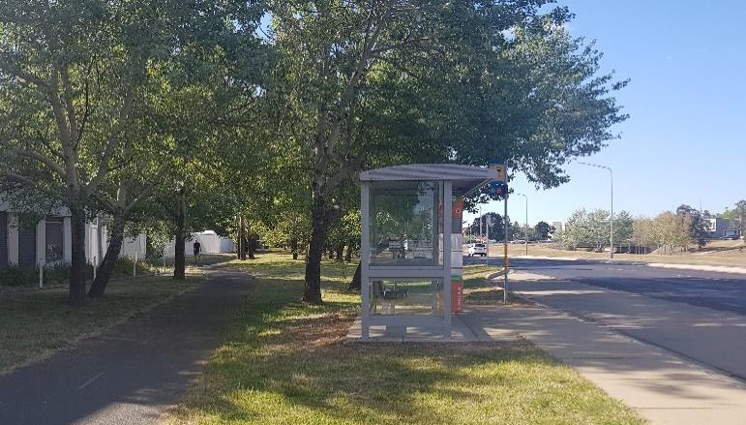
Figure 86: Bus stop 2650 without streetlight and pathway and warehouse directly behind.

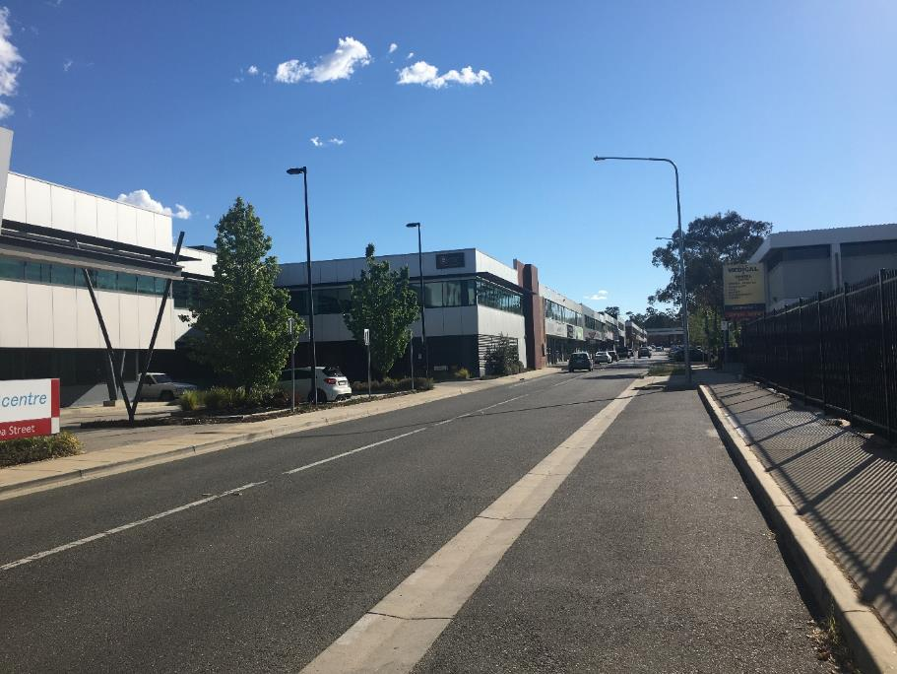
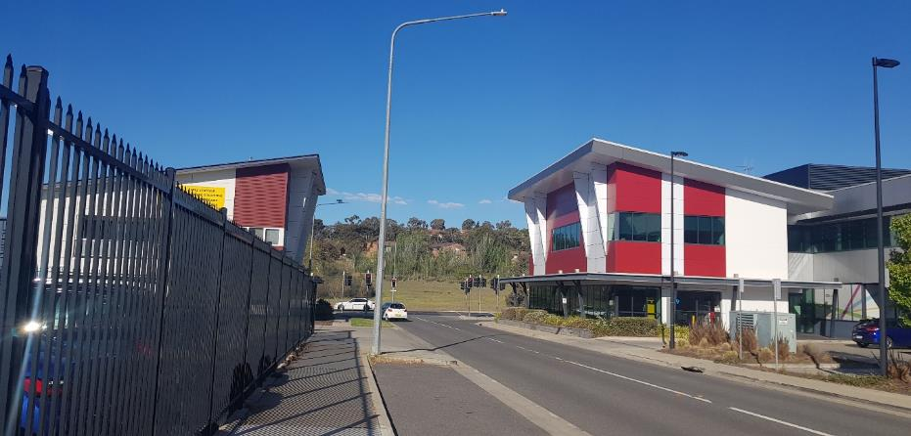
Figure 88: Shea St towards Chifley with nearby businesses and street lighting.
Figure 87: Intersection of Athllon Dr and Shea St with nearby businesses.

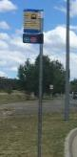
Bus stop 2651
Bus stop 2651 is located on Athllon Drive in Phillip where traffic is busy at at all times, at speeds od 60km/hr on a four-lane road that is separated by a concrete median strip. The bus stop is on express route headed from the city to the south with frequent buses. It is diagonally opposite to bus stop 2650 by about 100 metres.
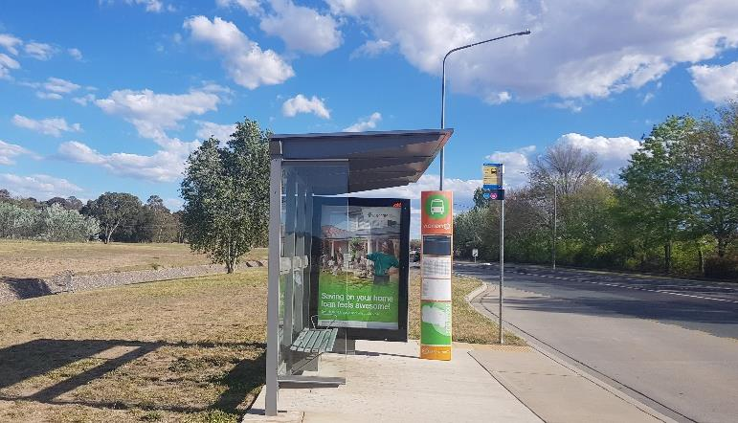
The bus stop is sheltered with seating and a streetlight as shown in Figure 89. Athllon Dr is a well-lit road with spaced out lighting along the road. As shown in Figure 90, women travelling from this bus stop would cross the street either by following the designated pathway on the right towards the traffic lights to Shea St and head west towards Chifley residential area (see bus stop 2651), or jaywalk across the concrete median strip and walk through an alley between the Woden Bus Depot and business building (Figure 91). This alleyway could be particularly isolated at night due to the narrowness and nearby businesses being closed after hours. Directly behind the bus stop is very large green space with trees and a long aqueduct (Yarralumla Creek) which cannot be seen at street level. Women waiting at this bus stop may feel vulnerable due to not being seen or heard by passing motorists if trapped in the aqueduct as shown in Figure 89, 90, 92 and 93.
Figure 89: Bus stop 2651 with streetlight and aqueduct (behind).

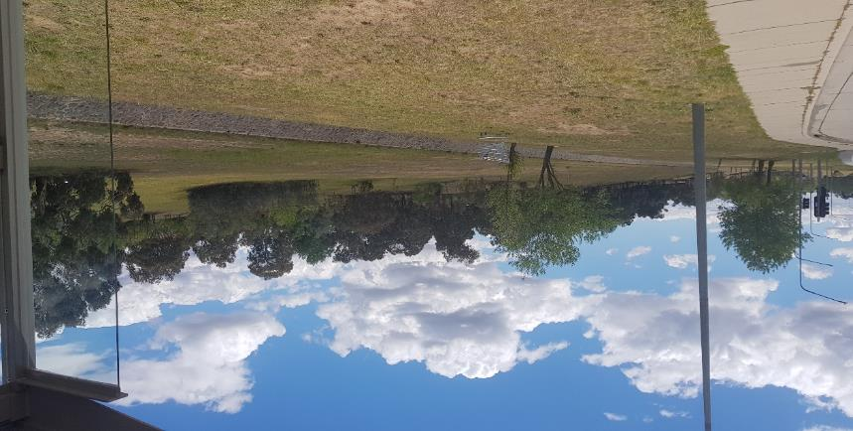
Figure 90: Pathway from bus stop 2651 to traffic lights at Shea St is parallel to Athllon Dr on the left, and green space and aqueduct to the right.

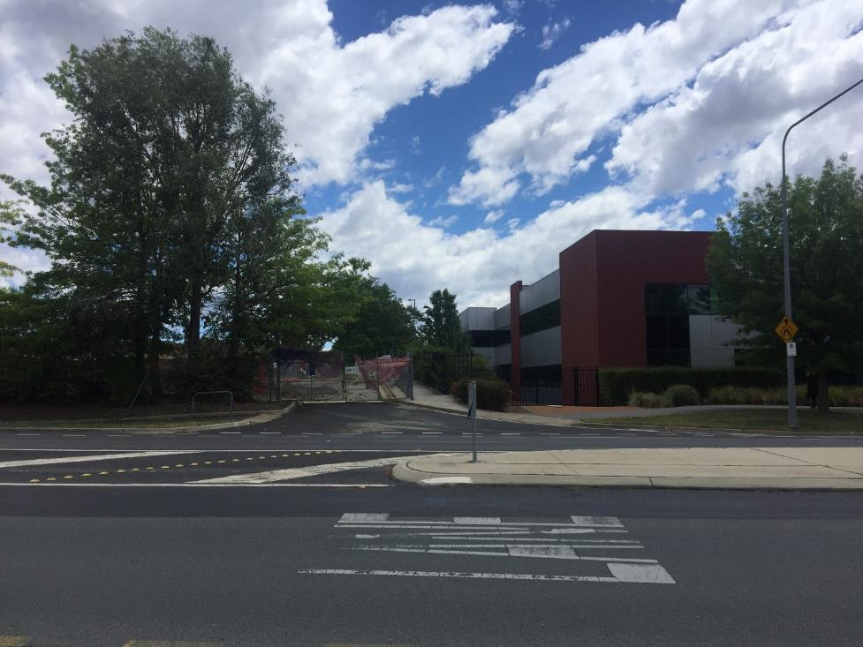
Figure 91: Directly opposite bus stop 2651 is an alleyway between the maroon business building (right) and fenced Woden Bus Depot (left).

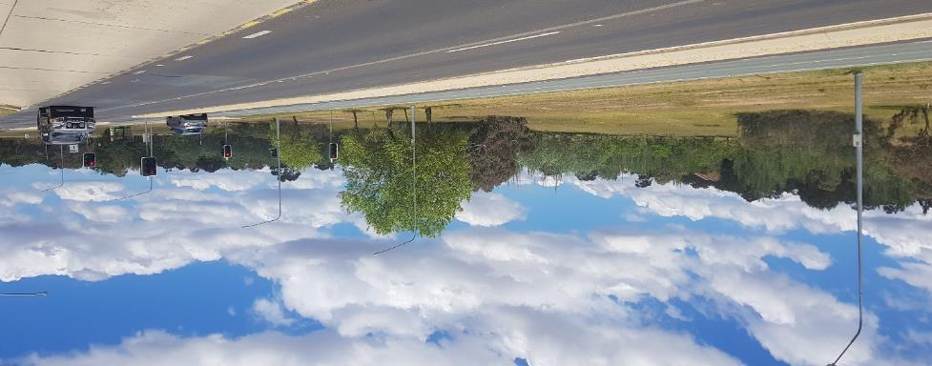
Figure 92: Green space behind bus stop 2651(far right) with aqueduct that is below street level and invisible to motorists.
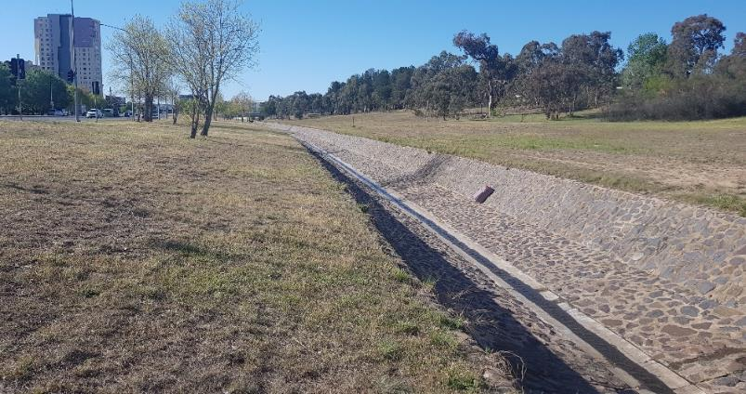
Figure 93: Aqueduct and green space behind bus stop 2651.

LawLink NSW 1999, Plan It Safe: A Guide For Making Public Places Safer For Women, p.3, retrieved 18 February 2011, http://www.lawlink.nsw.gov.au/swp/swp.nsf/pages/swp_intro
E Davidson, What makes public spaces safer for ACT women? Women’s Centre for Health Matters, Canberra, 2019.
Women’s Centre for Health Matters, Where do older women feel unsafe and why?, Canberra, 2015, retrieved on the 29th of October 2019.
E Davidson, What makes public spaces safer for ACT women? Women’s Centre for Health Matters, Canberra, 2019.
Women’s Centre for Health Matters, Where do older women feel unsafe and why?, Canberra, 2015, retrieved on the 29th of October 2019.
The legislative assembly for Australian Capital Territory, The ACT Women’s Plan, Canberra, 2016, retrieved on the 29th of October 2019; https://www.communityservices.act.gov.au/__data/assets/pdf_file/0019/1108306/ACT-Womens-Plan_Report_2016_2026.pdf
Foster S, Hooper P, Knuiman M, Christian H, Bull F and Giles-Corti B, “Safe RESIDential Environments? A longitudinal analysis of the influence of crime-related safety on walking, International Journal of Behavioral Nutrition and Physical Activity, 2016, p 5, viewed 11 December 2018: https://ijbnpa.biomedcentral.com/track/pdf/10.1186/s12966-016-0343-4
Women's Centre for Health Matters, Where do older women feel unsafe and why?, 2015, Canberra, viewed 14 December 2018: http://www.wchm.org.au/resources/resources-for-women/draft-womens-safety-matters/
E Davidson, What makes public spaces safer for ACT women?, Women’s Centre for Health Matters, January 2019, Canberra, viewed 28 November 2019: http://www.wchm.org.au/what-makes-public-spaces-safer-for-act-women/
ibid, p 18
ACT Government, Summary of Context Analysis: Data, Community Feedback and Gender Analysis, October 2019, Canberra, viewed 28 November 2019: https://www.communityservices.act.gov.au/women/resources
ACT Government, City and Gateway Urban Design Framework, Canberra, December 2018, p 16, viewed 28 November 2019: https://www.nca.gov.au/planning-and-heritage/policy-and-strategy/city-and-gateway-urban-design-framework/city-and-gateway
ACT Government, ACT Crime Prevention & Urban Design Resource Manual, Canberra, 2000.
Department of Sustainability and Environment, Safer Design Guidelines for Victoria, Victorian Government, Victoria, June 2005, viewed 28 November 2019 https://www.healthyplaces.org.au/userfiles/file/Safer+Design+Guidelines%20Victoria.pdf
https://www.google.com.au/maps/place/35%C2%B010'14.2%22S+149%C2%B007'00.1%22E/@-35.170604,149.1144983,17z/data=!3m1!4b1!4m5!3m4!1s0x0:0x0!8m2!3d-35.170604!4d149.116687
https://www.google.com.au/maps/place/35%C2%B010'11.3%22S+149%C2%B006'58.6%22E/@-35.169793,149.1140743,17z/data=!3m1!4b1!4m5!3m4!1s0x0:0x0!8m2!3d-35.169793!4d149.116263
https://www.google.com.au/maps/place/35%C2%B010'08.6%22S+149%C2%B005'59.8%22E/@-35.168803,149.0984126,17.75z/data=!4m5!3m4!1s0x0:0x0!8m2!3d-35.169051!4d149.099937
https://www.google.com.au/maps/place/Horse+Park+Dr+after+Overall+Av/@-35.1704432,149.0958145,17z/data=!4m13!1m7!3m6!1s0x6b17ab5752bb0eaf:0x85d38715e37a3804!2sOverall+Ave,+Casey+ACT+2913!3b1!8m2!3d-35.1740187!4d149.0911753!3m4!1s0x6b17ab520156ef97:0xfb754e01564a9d65!8m2!3d-35.170485!4d149.0987641
https://www.google.com.au/maps/place/35%C2%B022'38.5%22S+149%C2%B003'23.7%22E/@-35.377347,149.0544033,17z/data=!3m1!4b1!4m5!3m4!1s0x0:0x0!8m2!3d-35.377347!4d149.056592
https://www.google.com.au/maps/place/35%C2%B013'07.6%22S+149%C2%B003'14.3%22E/@-35.218764,149.0517823,17z/data=!3m1!4b1!4m5!3m4!1s0x0:0x0!8m2!3d-35.218764!4d149.053971
https://www.google.com.au/maps/place/35%C2%B013'07.0%22S+149%C2%B003'15.3%22E/@-35.218604,149.0520563,17z/data=!3m1!4b1!4m5!3m4!1s0x0:0x0!8m2!3d-35.218604!4d149.054245
https://www.google.com/maps/place/Southern+Cross+Dr+after+Kingsford+Smith+Dr/@-35.2256733,149.03307,17z/data=!4m13!1m7!3m6!1s0x6b17adbadb9337c5:0x6918bebfea70bf0e!2sKingsford+Smith+Dr,+Florey+ACT+2615!3b1!8m2!3d-35.2234254!4d149.0390889!3m4!1s0x6b17adec85f97f5b:0x9cbaa58e26f071ec!8m2!3d-35.2267708!4d149.0328381
https://www.google.com/maps/place/Southern+Cross+Dr+after+O'Loghlen+St/@-35.2259362,149.0332148,18z/data=!4m13!1m7!3m6!1s0x6b17adbadb9337c5:0x6918bebfea70bf0e!2sKingsford+Smith+Dr,+Canberra+ACT!3b1!8m2!3d-35.2234254!4d149.0390889!3m4!1s0x6b17adec84998b39:0xc550b2fd2b7fdf2d!8m2!3d-35.226573!4d149.033044
https://www.google.com.au/maps/place/35%C2%B015'09.5%22S+149%C2%B003'17.0%22E/@-35.252645,149.0525413,17z/data=!3m1!4b1!4m5!3m4!1s0x0:0x0!8m2!3d-35.252645!4d149.05473
https://www.google.com.au/maps/place/35%C2%B015'09.9%22S+149%C2%B003'16.5%22E/@-35.252735,149.0524013,17z/data=!3m1!4b1!4m5!3m4!1s0x0:0x0!8m2!3d-35.252735!4d149.05459
https://www.google.com.au/maps/place/35%C2%B015'18.3%22S+149%C2%B003'14.8%22E/@-35.255078,149.0519333,17z/data=!3m1!4b1!4m5!3m4!1s0x0:0x0!8m2!3d-35.255078!4d149.054122
https://www.google.com.au/maps/place/35%C2%B015'18.9%22S+149%C2%B003'14.3%22E/@-35.255246,149.0517893,17z/data=!3m1!4b1!4m5!3m4!1s0x0:0x0!8m2!3d-35.255246!4d149.053978
https://www.google.com.au/maps/place/35%C2%B013'29.0%22S+149%C2%B003'18.0%22E/@-35.224726,149.0528113,17z/data=!3m1!4b1!4m5!3m4!1s0x0:0x0!8m2!3d-35.224726!4d149.055
https://www.google.com.au/maps/place/35%C2%B013'29.2%22S+149%C2%B003'18.5%22E/@-35.224788,149.0529543,17z/data=!3m1!4b1!4m5!3m4!1s0x0:0x0!8m2!3d-35.224788!4d149.055143
https://www.google.com.au/maps/place/35%C2%B020'12.1%22S+149%C2%B009'12.7%22E/@-35.336696,149.1513273,17z/data=!3m1!4b1!4m5!3m4!1s0x0:0x0!8m2!3d-35.336696!4d149.153516
https://www.google.com.au/maps/place/35%C2%B020'12.3%22S+149%C2%B009'10.5%22E/@-35.336754,149.1507373,17z/data=!3m1!4b1!4m5!3m4!1s0x0:0x0!8m2!3d-35.336754!4d149.152926
https://www.google.com/maps/place/Carruthers+St+before+Groom+St/@-35.3268637,149.0913697,17z/data=!4m5!3m4!1s0x6b17b35ad4fdbc37:0x95cafccc68aeb1d3!8m2!3d-35.3269167!4d149.0900107
https://www.google.com/maps/place/Carruthers+St+opp+Groom+St/@-35.3268874,149.0896992,20z/data=!4m22!1m16!4m15!1m6!1m2!1s0x6b17b35b697ebc5b:0x2351f208fc587073!2sSt+Andrews+Village,+Groom+Street,+Hughes+ACT!2m2!1d149.0880327!2d-35.3277794!1m6!1m2!1s0x6b17b35ad4fdbc37:0x95cafccc68aeb1d3!2sCarruthers+St+before+Groom+St,+Hughes+ACT+2605!2m2!1d149.090011!2d-35.326917!3e2!3m4!1s0x6b17b3452ad1f295:0x7b5aaf3a20b61092!8m2!3d-35.326753!4d149.089967
https://www.google.com.au/maps/place/35%C2%B018'46.5%22S+149%C2%B007'13.9%22E/@-35.312928,149.1183363,17z/data=!3m1!4b1!4m5!3m4!1s0x0:0x0!8m2!3d-35.312928!4d149.120525
https://www.google.com.au/maps/place/35%C2%B018'43.8%22S+149%C2%B007'14.0%22E/@-35.312177,149.1183523,17z/data=!3m1!4b1!4m5!3m4!1s0x0:0x0!8m2!3d-35.312177!4d149.120541
https://www.google.com.au/maps/place/35%C2%B023'22.5%22S+149%C2%B005'04.9%22E/@-35.389589,149.0824973,17z/data=!3m1!4b1!4m5!3m4!1s0x0:0x0!8m2!3d-35.389589!4d149.084686
https://www.google.com.au/maps/place/35%C2%B023'24.6%22S+149%C2%B005'00.8%22E/@-35.390179,149.0813703,17z/data=!3m1!4b1!4m5!3m4!1s0x0:0x0!8m2!3d-35.390179!4d149.083559
https://www.google.com.au/maps/place/Cotter+Rd+After+Streeton+Dr/@-35.326456,149.0511282,17z/data=!4m5!3m4!1s0x6b17b47f4ce58ad5:0x4cdd8101513fd546!8m2!3d-35.326971!4d149.05264
https://www.google.com/maps/place/Haydon+Dr+opp+Radford+College/@-35.24282,149.090759,15z/data=!4m5!3m4!1s0x0:0xc5be7238adf779df!8m2!3d-35.24282!4d149.090759
https://www.google.com.au/maps/place/Sternberg+Cr+after+Comrie+St/@-35.4015654,149.0984977,21z/data=!4m5!3m4!1s0x6b17b54bd71c3a85:0xcf9abda445bac240!8m2!3d-35.401696!4d149.098671
https://www.google.com/maps/place/Athllon+Dr+after+Shea+St/@-35.3517469,149.0898829,17z/data=!4m13!1m7!3m6!1s0x6b17b4b9843b94fb:0xfcbd21b045a7be33!2sShea+St,+Phillip+ACT+2606!3b1!8m2!3d-35.3519327!4d149.0907387!3m4!1s0x6b17b4ba251928b1:0x8c2890cf048735ed!8m2!3d-35.3512768!4d149.0906947
https://www.google.com/maps/place/Athllon+Dr+opp+Shea+St/@-35.3524209,149.0912347,3a,75y,41.55h,90t/data=!3m6!1e1!3m4!1seLxhQDqAEmm6mH6MzR6CAw!2e0!7i13312!8i6656!4m13!1m7!3m6!1s0x6b17b4b9843b94fb:0xfcbd21b045a7be33!2sShea+St,+Phillip+ACT+2606!3b1!8m2!3d-35.3519327!4d149.0907387!3m4!1s0x6b17b4b9f335c7f5:0xb4c5bec192245bd4!8m2!3d-35.352368!4d149.0912779

