Below the surface

The hidden women in the ACT in middle income households at risk of ending up in poverty

Emma Davidson
June 2019

Acknowledgements
Thanks to the 2017 study Hidden disadvantage in the ACT: Report for ACT Anti-Poverty Week by the National Centre for Social and Economic Modelling (NATSEM), which was commissioned by the ACT Council of Social Service Inc. in partnership with Anglicare NSW South, NSW West & ACT; Belconnen Community Service; Marymead; St Vincent de Paul Society, Canberra/Goulburn; UnitingCare Kippax; Woden Community Service; and YWCA Canberra. The findings from this study provided us with the opportunity to work with NATSEM using the same data, but to explore the gendered difference in disadvantage in the ACT, and in a different household income group.
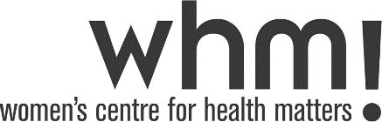
Publication/Copyright Information
ISBN 978-0-6484409-4-9

© 2019 Women’s Centre for Health Matters Inc. Published by Women’s Centre for Health Matters Inc.
This publication is protected by copyright. Apart from any use permitted under the Copyright Act 1968, no part may be reproduced without acknowledgement.
Supported by ACT Health Directorate.
About the author
Emma Davidson is the Deputy CEO of the Women’s Centre for Health Matters. She has completed a Bachelor of General Studies from Griffith University. She has experience using quantitative and qualitative data to support the development of community understanding of the lived experience of women.

About the contributors from NATSEM
Associate Professor Riyana Miranti, Professor Robert Tanton, Dr Yogi Vidyattama, and Dr Sajeda Tuli, at NATSEM, University of Canberra compiled the ABS Census 2016 data and maps which enabled WCHM to drill down into small areas of the ACT using the latest data from the 2016 Census of Population and Housing from the ABS. They also supported the author by providing feedback and comments.

About NATSEM
The National Centre for Social and Economic Modelling (NATSEM) is one of three research centres within the Institute for Governance and Policy Analysis (IGPA) at the University of Canberra. NATSEM is one of Australia’s leading economic and social policy research centres and is regarded as one of the world’s foremost centres of excellence for micro-data analysis, microsimulation modelling and policy evaluation. NATSEM contributes to social and economic policy debate and analysis by undertaking independent and impartial research with activities aiming to have significant policy impact and lead to social and economic change.

About Women’s Centre for Health Matters Inc.
The Women’s Centre for Health Matters Inc. (WCHM) is a community based organisation which works in the ACT and surrounding region to improve women’s health and wellbeing. WCHM believes that the environment and life circumstances which each woman experiences affects her health outcomes. WCHM focuses on areas of possible disadvantage and undertakes social research, advocacy, community development and health promotion to influence systems change with the aim to improve women’s health and wellbeing outcomes.
Contents
Acknowledgements 2
Executive Summary 4
Terminology 6
Introduction 8
Findings 10
Women by age group 11
Women who are single with children 13
Women in employment 19
Women and housing affordability 24
Women who do not speak English well 26
Geographic distribution of middle income women in the ACT 28
Discussion 30
Women who are single with children 31
Women in employment 31
Women and housing affordability 32
Women who do not speak English well 36
Geographic distribution of women in middle income households in the ACT 37
Conclusion 39
Appendix A: Disadvantage in the ACT by Gender 40
Notes 42

Executive Summary
From our 2018 report, Hidden disadvantage among women in the ACT, we knew that women are disproportionately represented among those living in the ACT’s lowest income households. This is especially true for single women with children, where there are two and a half times more women than men who are sole parents on a low income.
We also learned from that report, and from the previous 2017 study Hidden disadvantage in the ACT: Report for ACT Anti-Poverty Week by the National Centre for Social and Economic Modelling (NATSEM), that disadvantage is concentrated into geographic areas in the ACT that are smaller than suburb size, and that those areas can be masked by high average incomes across whole suburbs.
From the 2014 report Staying Home After Domestic Violence by Domestic Violence Crisis Service (DVCS), we also know that many women who have experienced domestic violence have difficulty with the high costs of rent or mortgage, even if they have paid employment. As a result, 54.6 per cent of home owners in that study, and 62.5 per cent of families in private rental housing, lost their homes within 12 months of leaving a domestic violence relationship.
This difficulty with housing affordability was also expressed by women who participated in WCHM’s Hear me out research, who reported that they could not afford housing payments without the income of their abusive partner or access to additional financial resources. Unequal and lengthy property settlements, and fear of their partner, led to women who had been home owners settling for less. Women in the rental market faced the combined barriers of reduced income and scarce availability of affordable properties in the ACT market.
The impact of the loss of a partner’s income can also impact women’s ability to pay for other necessary living expenses, such as childcare, healthcare, transport, education, and recreational activities. This might result in difficulty in maintaining employment if they cannot afford childcare or transport to and from work, in paying for school excursions or sports, in affording the costs for maintaining their health and wellbeing.
In our report, Beyond Crisis: Working with Canberra’s professional firms and businesses to make safer choices easier for survivors of domestic violence, WCHM described the difficulties faced by women who were in the “missing middle” income group. These are women who have an income level that is high enough to preclude their access to many Government or community sector services and supports, but which is not high enough to enable them to maintain housing, employment, education, and healthcare on their own.
Domestic violence is not the only vulnerability faced by women living in middle income households. Where the main source of income is not provided by the woman herself, loss of the relationship with her partner through death or divorce can also result in a precarious financial situation. Disability or loss of employment may also mean that a household loses a vital income source.
We wanted to understand how many women in the ACT are in a position where death, disability, divorce, domestic violence, or decreased income from employment could lead to falling into the bottom 20 per cent of household incomes.
The results of this research show that many women could end up in the bottom 20 per cent of household incomes if something happened to the income of their partner, as it is their partner’s income that put them in a middle income category. In 2016, 11.8 per cent of women and girls in the ACT lived in households with an equivalised income of $500 per week ($26,000 per year) or less. Another 44.8 per cent lived in households with an equivalised household income of $52,000 to $103,999 per year. But of those, 46.4 per cent were likely to be dependent on parent or partner income to be in that middle income household.
These middle income households had some level of income other than welfare support payments. Women in these households are unlikely to be eligible for government or community sector support programs that are usually targeted at the most financially disadvantaged. As a result, middle income households must cover the costs of living from their own resources.
Despite its goal of being an inclusive city with a good standard of living, Canberra is a city where affordable housing has become scarce, healthcare affordability is limited by the lack of bulk billing GPs and specialists, public education often comes with expensive extra-curricular costs, and public transport is not always suitable to get to and from work or education.
For women, simply finding work is not a pathway out of poverty. The industries employing the highest percentages of ACT women are also the industries with the lowest average wage. For many women on their own, finding work means moving from the bottom 20 per cent of household incomes, to the second lowest 20 per cent – not even into the middle income group in this study. In the ACT, this may not be not enough to move them into a standard of living where they no longer have to choose between paying the electricity bill and paying the rent.
To avoid falling back into the lowest 20 per cent of household incomes, ACT women in middle income households may need support in the event of relationship breakdown or the loss of the primary earner’s income. This may include:
- support to find and stay in affordable, appropriate long-term housing;
- access to quality, affordable healthcare;
- support to provide for the education needs of their children; and
- an affordable and safe public and active transport network that enables all Canberra residents to get to the places they need to go.
Without this support to women in middle income households during a time of crisis, these women and their families are at risk of poverty and homelessness in the ACT.

Terminology

Small areas and suburbs
Small areas are references to Australian Statistical Geography Standard (ASGS) Statistical Area Level 1 (SA1), as used by the Australian Bureau of Statistics (ABS) for the purposes of Census data. An SA1 contains an average of 150 households.
Suburbs are references to ASGS Statistical Area Level 2 (SA2), as used by the ABS for the purposes of Census data.
We were not able to access all the same data by gender as was analysed for the 2017 study, Hidden disadvantage in the ACT: Report for ACT Anti-Poverty Week , down to the SA1 level (smaller areas within suburbs). However, we were able to access data down to the SA2 level (suburbs).
As a result, references to small areas analysed in the 2017 study refers to SA1 level, and references to suburbs in the data analysed for this report refers to SA2 level.

Women and girls
References to women means females aged 15 years or older, and girls refers to females aged under 15 years.

Equivalised household income
Equivalised household income means the income is divided by an equivalising factor of one for the first adult; 0.5 for each additional household resident aged over 15; and 0.3 for each household resident aged under 15.
We used this measure rather than gross household income, as it accounts for the impact of the size of the household, not just the household’s income, on living standards. An income of $52,000 for a single woman living alone will enable a higher standard of living than an income of $52,000 for a single woman with two children to support, or a family of two adults and three children with a total income of $52,000.

Low income households
References to low income households are to households with an equivalised household income of $500 per week or less, the closest Census income category to half the median equivalised household income (or closest to the bottom 20%). Half of median equivalised household income is typically referred to as the poverty line.

Middle income households
References to middle income households in this report are to households with an equivalised household income of $52,000 to $103,999 per year, equivalent to households between 47 and 78 per cent of ACT equivalised household incomes, the closest Census income category to the 50th to 75th percentiles.

High or very proportions
References to high or very high proportions of women in a group is a comparison with the Australian greater capital cities average.

Single parents
Single parent families include households where the main source of income is from employment, from welfare support payments, or from other sources such as investments or superannuation (eg business owners with children, or retirees who are raising their grandchildren in situations where the parents are unable to).

Gini coefficient
The Gini coefficient is a summary measure of inequality. A Gini coefficient of 0 represents perfect equality (every person has the same income or wealth), while a coefficient of 1 implies perfect inequality (one person has all income or wealth). The closer the Gini coefficient is to zero, the more equal the distribution; the closer to 1, the more unequal. The Gini coefficient is not a complete measure of socio-economic disadvantage, as it measures income but does not account for accumulated wealth or other factors that might impact a person’s ability to access material resources.

The SEIFA Index of Relative Socio-Economic Advantage and Disadvantage
The SEIFA Index of Relative Socio-Economic Advantage and Disadvantage (SEIFA IRSAD) combines measures of a number of different Census areas to produce a score for a geographic area (eg a suburb) in which advantage and disadvantage are combined. The measures include:
- Household income;
- Education level;
- Occupation – high levels of some occupations in an area contribute to disadvantage, while other occupations in high concentration contribute to advantage;
- Unemployment;
- Occupied homes with no internet connection;
- Occupied homes with no car;
- Overcrowding vs houses with four or more bedrooms;
- People under 70 years old who have disability or health conditions that require assistance with core activities;
- Single parent families with dependent children; and
- People aged 15 and over who are separated or divorced.
An area with the highest IRSAD quintile of 5 ranks in the 20 per cent of the population with the most socio-economic advantage and least disadvantage. The area with the lowest IRSAD quintile of 1 ranks in the lowest 20 per cent, with the least socio-economic advantage and the most disadvantage.

Introduction
In the 2017 study by the National Centre for Social and Economic Modelling (NATSEM) - Hidden disadvantage in the ACT: Report for ACT Anti-Poverty Week - of the Australian Bureau of Statistics' (ABS) 2016 Census data for the ACT, there was an examination of data about people in low income households in very small areas (Statistical Area Level 1 or SA1) of around 150 households per area. These areas were then compared to the capital city average.
In most small areas of the ACT, the levels of disadvantage were no higher than the capital city average. But in 38 per cent of small areas in the ACT, there was at least one indicator of disadvantage that was higher than the capital city average. In 18.9 per cent of the small areas, there were multiple disadvantage factors. And in two small areas, all five disadvantage indicators were higher than the capital city average.
What this meant was that there were hidden pockets of disadvantage within ACT’s larger suburban communities, and that the people living in these low-income households were experiencing severe impacts on their quality of life as a result.
However, the data provided in the 2017 study did not include a gendered perspective on disadvantage in the ACT. It also did not include analysis of disadvantage for people in middle income households.
In June 2018, the report Hidden disadvantage among women in the ACT was published by Women's Centre for Health Matters, providing analysis of suburb-level (Statistical Area Level 2) data on women in low income households (equivalised household income of less than $500 per week), using 2016 Census data provided by NATSEM.
But we know that women experiencing economic difficulty in the ACT are not confined solely to the lowest income households. So we wanted to explore the findings for women living in middle income households in the ACT, and their potential characteristics of disadvantage, as these may be hidden.
In this second report on the economic status of women in the ACT, we looked at the data provided by NATSEM about women in the ACT who lived in households with an equivalised household income of $52,000 to $103,999 per year to explore their risk of disadvantage.
We used this measure rather than gross household income, as it accounts for the impact of the size of the household, not just the household’s income, on living standards. An income of $52,000 for a single woman living alone will enable a higher standard of living than an income of $52,000 for a single woman with two children to support, or a family of two adults and three children with a total income of $52,000.
Many of the terms used in this report are described in the Terminology section, such as equivalised household income, women and girls, and small areas and suburbs. For a technical description of the methods used, refer to Appendix A.
Most people in this household income range will not be eligible to join the public housing waiting list, or to access welfare payments other than a small Family Tax Benefit payment, or access Commonwealth rent subsidies. Many will be reliant on lower paid jobs or casual employment for individual income, will rely on a combined family income, or will be entirely dependent on the income of parents or a partner.
We looked at the factors that may disadvantage this group, including having a cost of living that they cannot easily reduce. These included being a single parent, young and therefore in the early stages of a career or still studying (15-24 years), being over retirement age (65 years or older), working in a low paid industry, or not speaking English well. This is because any of these factors can reduce a person’s availability to access full time paid work, or their ability to find work at a median or higher salary.
In addition, high housing costs relative to their household income may increase financial pressure for this group by reducing the ability to cope with a sudden reduction in household income, or with unexpected costs in healthcare, education, or transport. Examples could include not being rostered for as many hours of casual work as expected, needing repairs for the car that is used to get to work or school, or having a household member needing healthcare that includes a gap fee, requires a specialist, or which requires travel outside the ACT.

Findings
Canberra is well known for its high average income levels. But as the 2017 study Hidden disadvantage in the ACT: Report for ACT Anti-Poverty Week found, those high averages mask pockets of disadvantage within the ACT. Average incomes can be higher than the median (where 50 per cent of the population are either above or below) and can also be higher than the mode (where most of the population are).
We found that this is the case for women in the ACT: the higher average income levels mask the lower income for most households in which women and girls live.
While the proportion of women living in middle income households in the ACT was higher than the Australian greater capital cities average, 46.4 per cent of those women were likely to be reliant on the income of parents or partners to remain in that income category.
A total of 44.8 per cent of women in the ACT lived in households with an equivalised household income of $52,000 to $103,999 per year. An additional 11.8 per cent lived in low income households with an equivalised household income of $500 per week or less.

Women by age group
Overall, 44.8 per cent of all women and girls in the ACT lived in middle income households with an equivalised household income of $52,000 to $103,999 per year.
More than 40 per cent of women in every age group under 65 years lived in middle income households in the ACT. Just under 30 per cent of women aged 65 years or over lived in middle income households. The age group with the highest percentage of women in middle income households was 25 to 44 years.

Figure 1 Women and girls in the ACT living in households with equivalised income of $52,000 to $103,999 per year
For women aged 25 to 44 years and 45 to 64 years, the suburbs with high or very high percentages of women in middle income households were dominated by the outer fringes of Canberra. Every suburb in Tuggeranong had a high or very high percentage of women aged 45 to 64 years in middle income households.
But for women aged 65 years or older, most suburbs with high or very high percentages were in the inner north, inner south, Weston Creek, and outer northern suburbs, with lower concentrations in Tuggeranong suburbs.
Suburbs with a high or very high percentage of girls aged 0-14 years in middle income households were also suburbs with a high or very high percentage of women aged 25 to 44 years.
The suburbs with high or very high percentages of women aged 15 to 24 years in middle income households included most of Tuggeranong, west Belconnen, Gungahlin, Weston Creek, and the inner south.
There were 15,079 girls under 15 years, and 6,435 women over 65 years old in those households, who are unlikely to have much opportunity to earn personal income from paid employment due to their age.
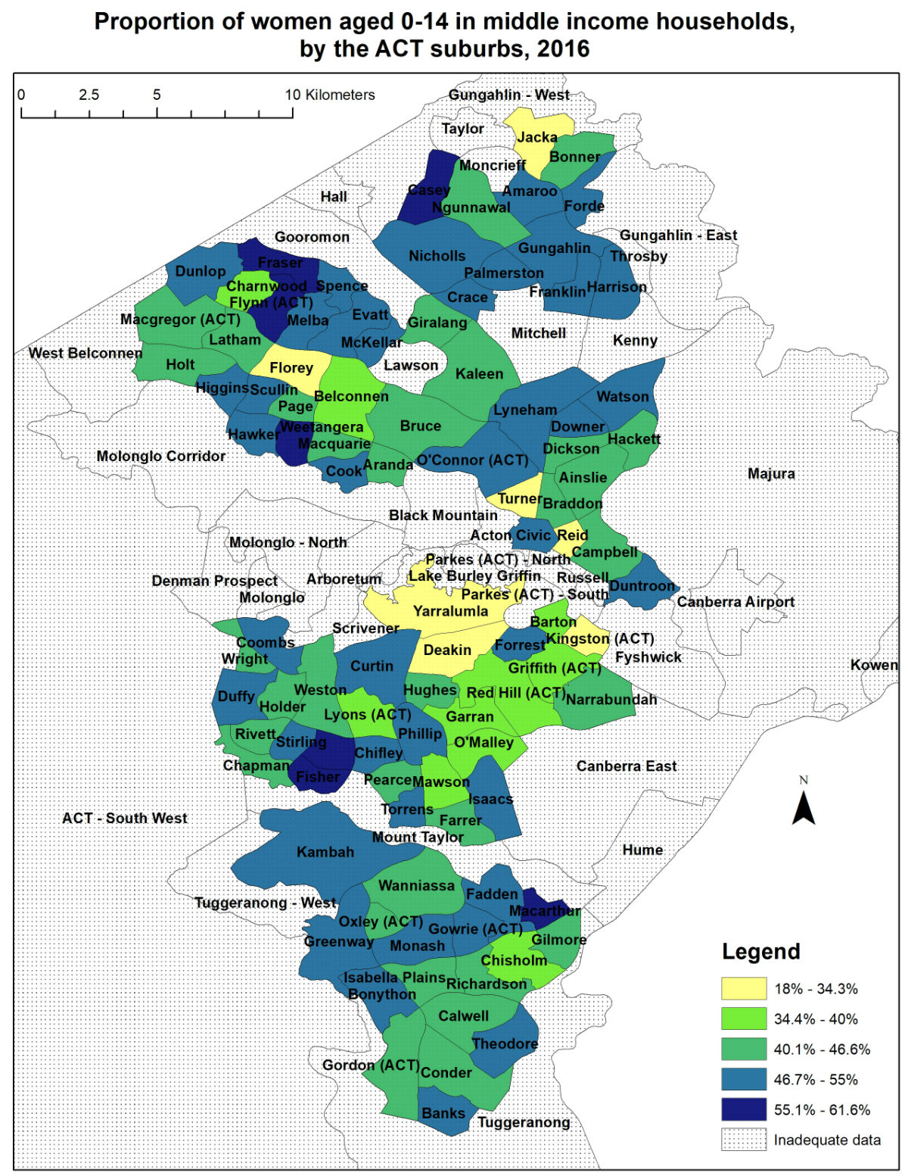
The maps on the following pages show the areas with high or very high (in blue colour) proportions of women and girls in middle income households compared to the Australian greater capital cities average, by age group.

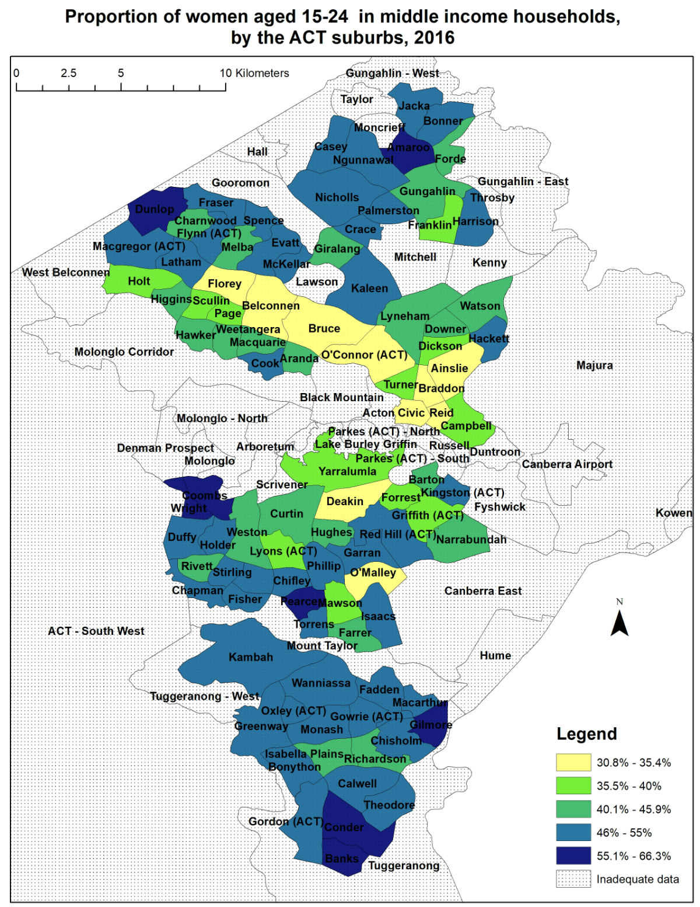
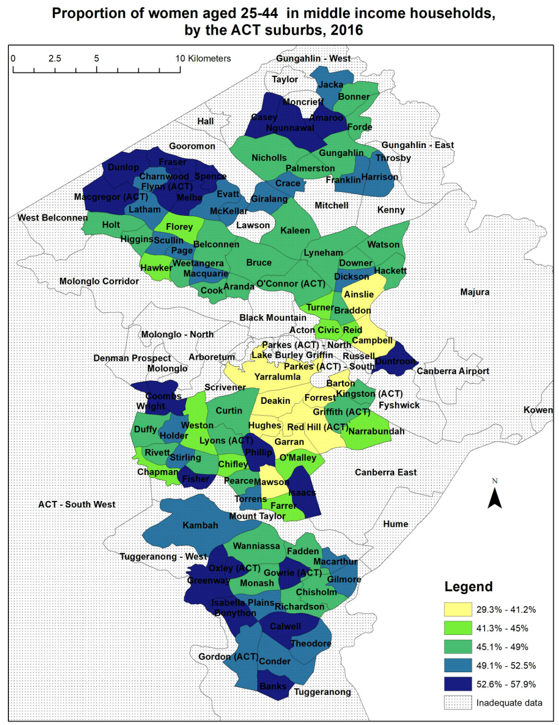
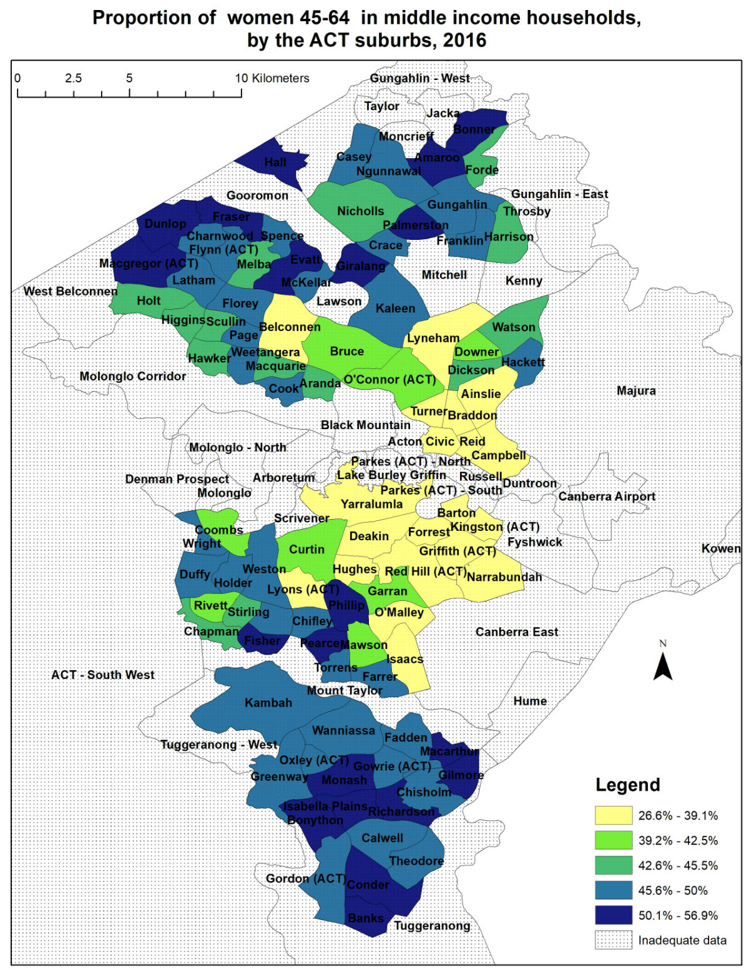
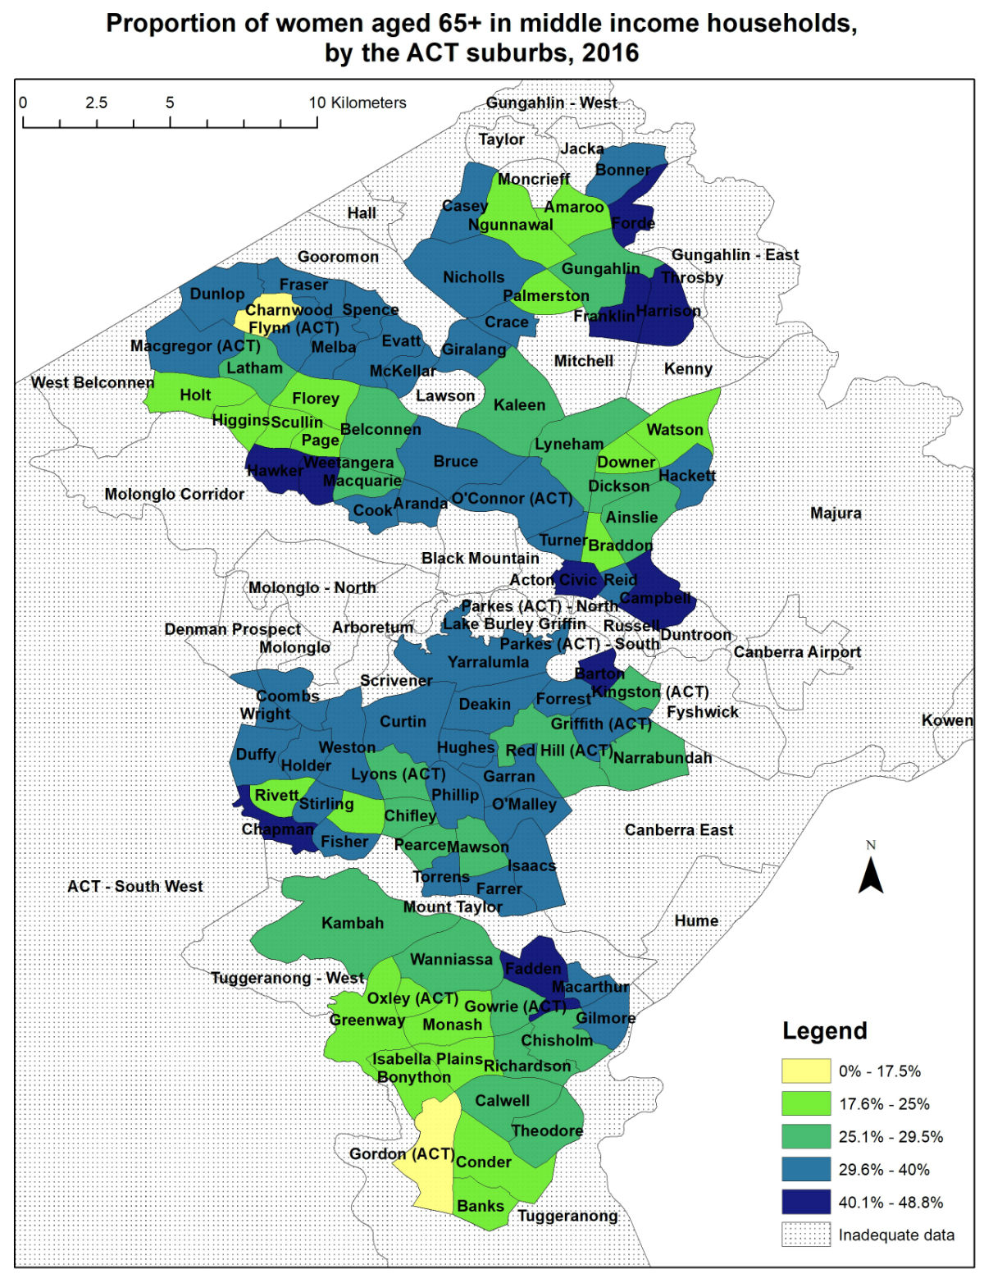
Women who are single with children
Our data showed that there were 14,129 families in the ACT where a single parent was raising children under 15 years old. Of these single parents, 80 per cent were women.
There were 3,775 single women raising children under 15 years old in the ACT in middle income households. This represents 3.01 per cent of all ACT women, based on the 2016 Census. The Australian capital cities average proportion of women who were single with children in middle income households was 2.10 per cent.
We found that there were 3,477 single women with children in the ACT who were in low income households, which was more than two and a half times the number of single men with children in the ACT in low income households (1,355 men). The Australian capital cities average proportion of single women with children on a low income was 4.1 per cent.
In the ACT, 30.8 per cent of single women with children were in a low income household, rather than a middle or high income household. The Australian capital cities average was 43.4 per cent.
This means that the ACT had a lower than Australian capital cities average of single women with children on low incomes, but a higher than average proportion of middle income single women with children who were juggling paid work and parenting.
The map on the following page shows the areas with high or very high (in blue colour) proportions of women who are the head of a single parent middle income household with children.
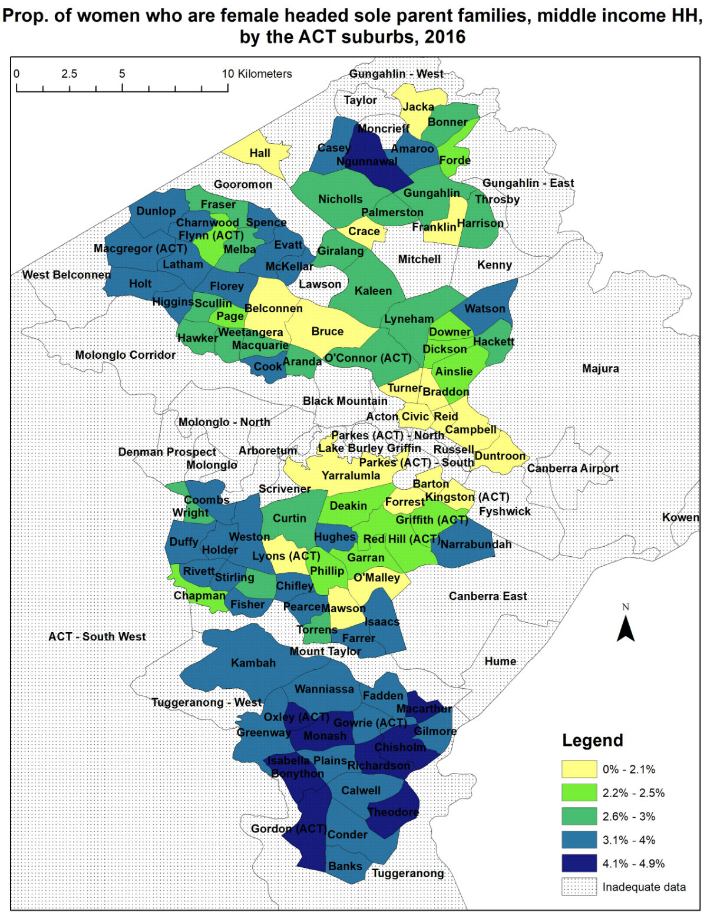

Women in employment
Our data showed that most women in the ACT in middle income households were not unemployed. They were either in paid employment, or not in the labour force (eg retired, unable to work due to disability or illness, studying, or caring for children or other family members).
The proportion of women in the ACT who were unemployed and lived in middle income households was only 1.4 per cent.
6.75 per cent of the ACT women who lived in middle income households worked part time in low paid industries, and 6.17 per cent worked full time in low paid industries. This is a total of 12.92 per cent of women in the ACT who lived in middle income households and worked in low paid industries.
Low paid industries included hospitality, retail, arts and recreation services, administrative and support services, and community services (including childcare, aged care, disability care, and the community sector). The full list is available in Appendix A.
Regardless of household income, Australian women have a lower median personal income than men. ABS Estimates of Personal Incomes for Small Areas, based on data provided by the Australian Taxation Office, show that the median employee personal income for ACT women was lower than the median income for ACT men.

The gap between the genders has not changed significantly in the past 6 years in the ACT. While women's median personal income has gradually improved, so has men's median personal income, so that the gap remains. A woman on a middle income in the ACT continues to earn less than a man on a middle income.
The employee income gap between genders in the ACT begins to diverge more sharply from 35 years, peaking with the largest gap in the 45 to 54 years age group.

There was a total of 12,659 women who were unemployed or who were working in low paid industries, and living in middle income households in the ACT. In addition, there were 15,079 girls under 15 years who would be reliant on parent income.
There were 6,435 women over 65 years old, who would most likely be reliant on partner income due to low average superannuation income for women in this age group.
At least 34,174 women and girls in middle income households in the ACT (44.7 per cent of all ACT women and girls in middle income households) are therefore likely to be reliant on parent or partner income for their middle income household status.
The following maps show suburbs in the ACT with a high or very high (shown in blue) proportion of women in middle income households who are unemployed, or work in low paid industries.
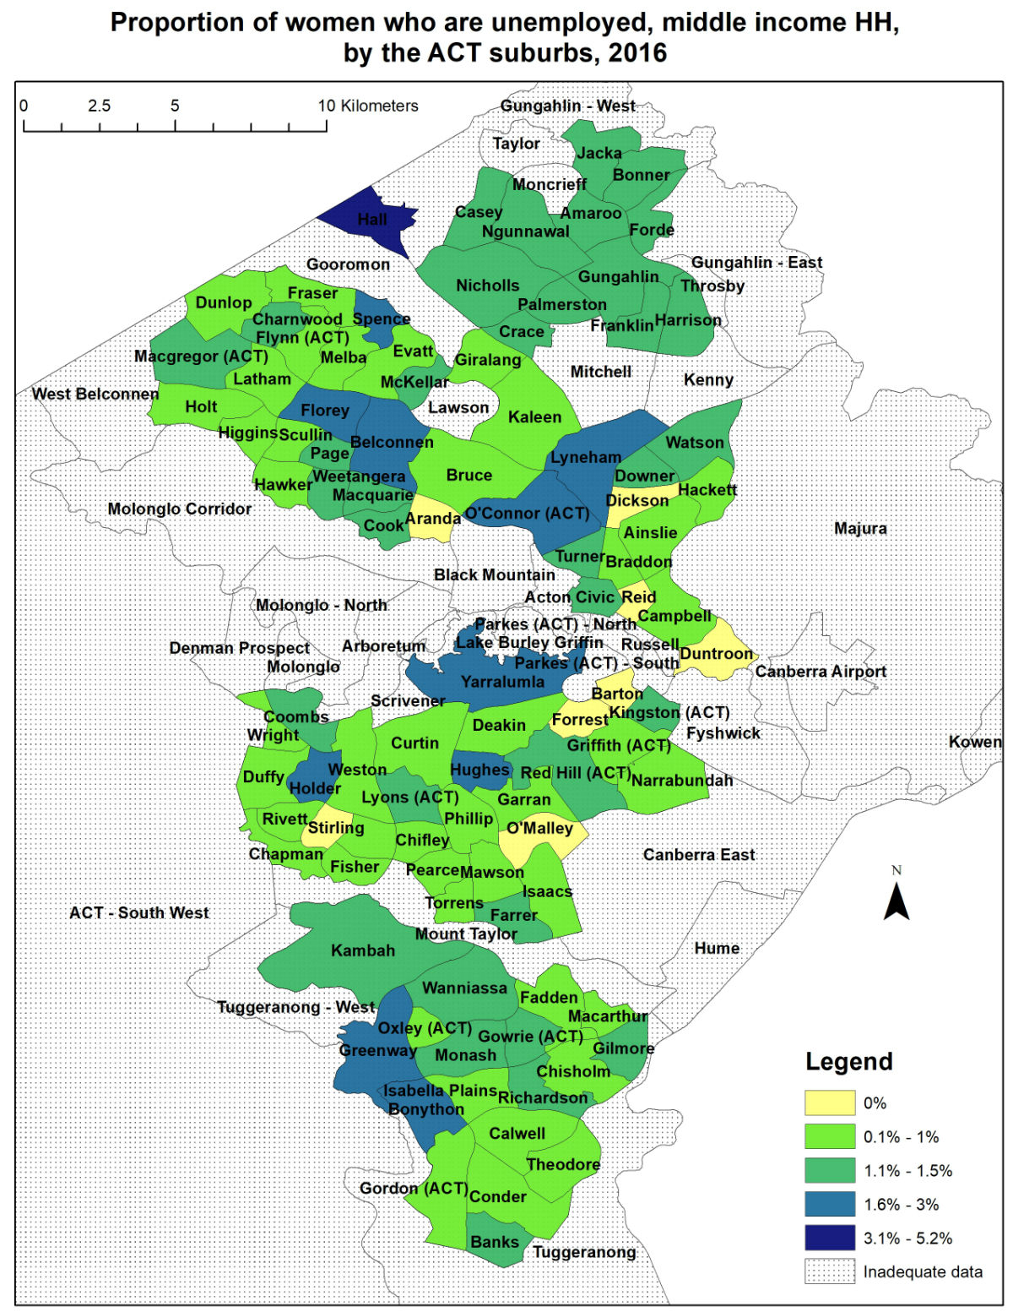
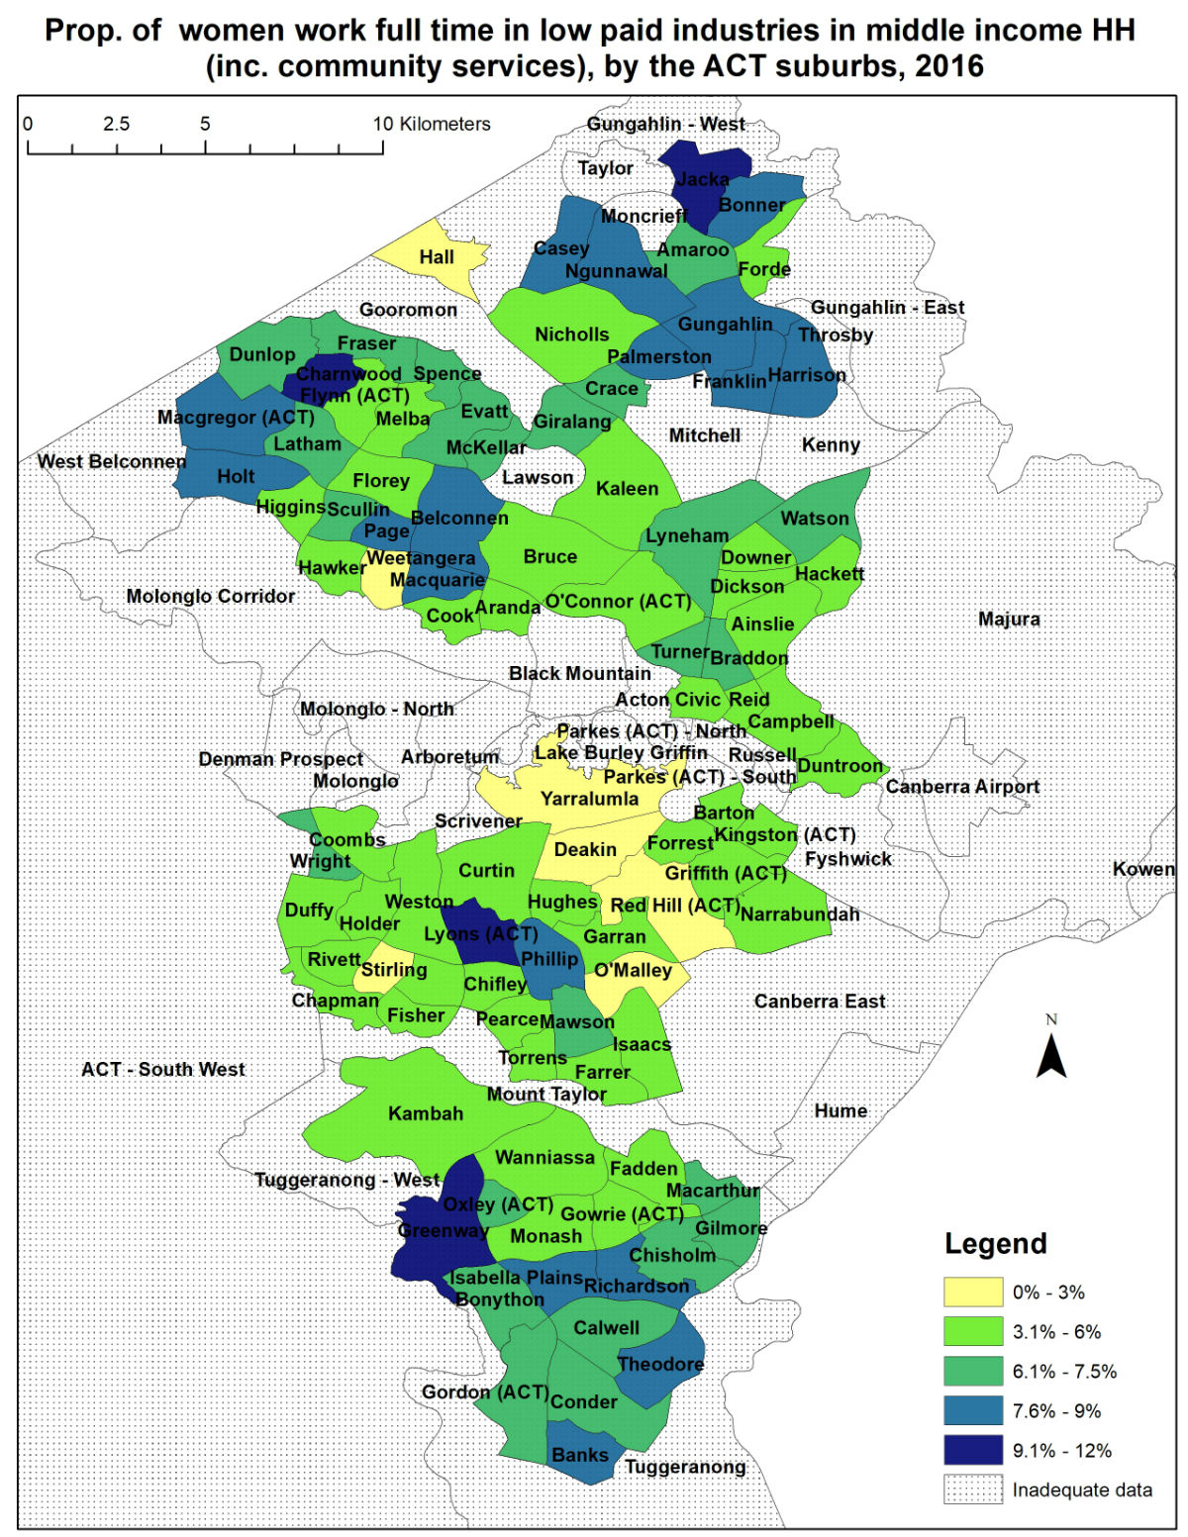
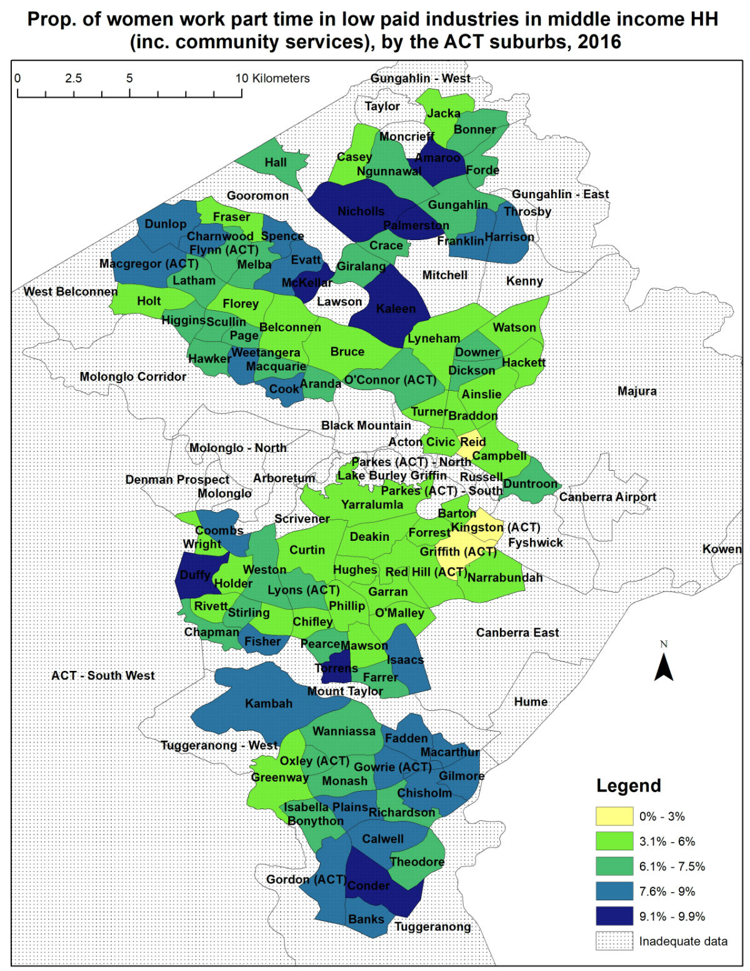

Women and housing affordability
Housing is one of the largest living expenses for many ACT households. Households in housing stress (paying more than 30 per cent of their income on housing costs) are often unable to save the deposit required for home ownership. Those in casual or contract work are often unable to borrow money due to their lack of permanent employment, making it harder to move from renting to paying off a mortgage. In addition, paying more than 30 per cent of household income on housing means less money available for expenses such as education, health, electricity, food, transport, and other costs.
The 2017 study found there were 161 small areas in the ACT (16 per cent) paying more of their gross income on rent than the capital city average of 23.2 per cent, with two small areas in the ACT paying an average of 40 per cent of gross income on rent. There were 23 small areas in the ACT (2.3 per cent) paying more than 30 per cent of their gross income on rent.
Publicly available ABS 2016 Census data does not allow calculation of the exact number of households in housing stress under the 30 per cent rule, as individual household incomes are published in income groups. However, with some estimation of median income in an area based on the income ranges available, the 2017 NATSEM study calculated the ratio of median rent to median income for small areas from the census data. This is the closest possible estimation of housing stress for small areas of the ACT using publicly available data.
Our analysis of 2016 Census data showed that more than 19.3 per cent of ACT households with a total income of $52,000 to $103,999 per year who paid rent other than to a State or Territory housing authority were in housing stress. When looking only at single parents in a three bedroom dwelling in the ACT, with total income of $52,000 to $103,999 per year, paying rent other than to a State or Territory housing authority, more than 27.2 per cent were in housing stress.
For this WCHM report, NATSEM calculated the proportion of women in public housing, and paying mortgages in middle income households. There were 40,366 women and girls in the ACT in middle income households with a mortgage, amounting to 24 per cent of all women and girls in the ACT. This was higher than the Australian capital cities average of 19.3 per cent.
By comparison, only 0.5 per cent of women and girls in the ACT lived in middle income households in public housing.
This means that a sudden reduction in income could have an immediate impact on housing stress in middle income households in the ACT if it meant the household was committed to mortgage payments which were more than 30 per cent of their reduced income.

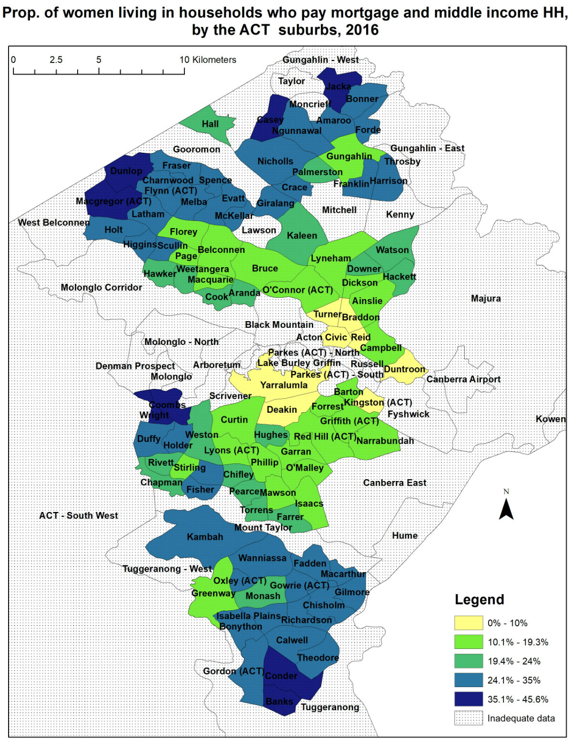

Women who do not speak English well
One potential area of disadvantage that was not looked at in the 2017 ACTCOSS report was English language fluency. For this report, the NATSEM data showed that 0.8 per cent (1,285) of women in the ACT did not speak English well, but lived in a middle income household. The Australian capital cities average is 0.9 per cent.
There were 6 suburbs with a proportion of two per cent or more of women in middle income households who did not speak English well. This is a very high proportion of women in middle income households who did not speak English well by comparison to both the Australian capital cities average of 0.9 per cent, and the ACT average of 0.8 per cent.
The NATSEM data showed that, except for Gungahlin, all the suburbs with a very high proportion of women in middle income households who did not speak English well also had a high or very high proportion of women in middle income households aged 65 years or older.
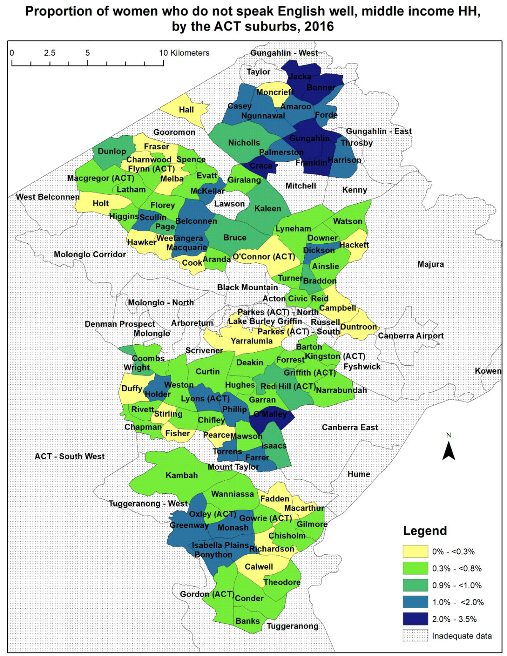

Geographic distribution of middle income women in the ACT
Of 97 suburbs studied, there were 82 that had a high or very high proportion of women in middle income households with at least one of the following criteria:
- aged between 15 and 24 years;
- 65 years or older; or
- single women with children in middle income households.
There were 75 suburbs that had a high or very high proportion of at least two of these three criteria.
Of the 52 suburbs that had a high (between 46 and 55 per cent) or very high (above 55 per cent) proportion of women aged 15 to 24 years living in middle income households, only 10 suburbs did not also have a high or very high proportion of women aged 45 to 64 years in middle income households.
There were 4 suburbs that did not have high or very high proportions of any of these issues, nor did they have high or very high proportions of women in middle income households who were unemployed, or who do not speak English well. However, these suburbs had very high proportions of women in low income households. Braddon had a very high proportion (14.49 per cent) of women and girls in low income households. In Mawson, there were very high proportions of women and girls in low income households (14.28 per cent) and single women with children in low income households (2.59 per cent). In Downer, there were very high proportions of women and girls in low income households (16.58 per cent), single women with children in low income households (3.32 per cent), and women who did not have at least a Year 10 level education (7.97 per cent). The exception was Duntroon, where all residents were attached to the Australian Defence Force Academy.
Two well established ways of measuring disadvantage in an area are Gini coefficient, and Socio-Economic Indexes for Areas (SEIFA). The Gini coefficient is an internationally comparable indicator of the level of inequality for an area. A high Gini coefficient (approaching one) indicates a wider gap between the lowest and highest income earners in the area, while a low Gini coefficient (approaching zero) indicates that the area has a more equal distribution of income.
The ABS Estimates of Personal Incomes for Small Areas calculated the Gini coefficient for each of the ACT's suburbs. For the whole of the ACT in 2016, the Gini coefficient, based on equivalised household income, was 0.266. The whole of Australia Gini coefficient was 0.323.
Of the 53 suburbs with a high Gini coefficient compared to the whole of ACT, 26 suburbs also had high or very high proportions of women in middle income households with more than one of the following demographics:
- aged 15 to 24 years;
- aged 65 years or older;
- single women with children;
- unemployed; or
- do not speak English well.
There were 38 suburbs that did not have a high Gini coefficient compared to the whole of ACT, of which 32 had more than one of the above demographics. Nine suburbs did not have a published Gini coefficient, of which four had more than one of the above demographics.
This means that a high Gini coefficient did not correlate with high proportions of women in middle income households with more than one of these demographics. In fact, the correlation is with suburbs with a low Gini coefficient. This means there is a correlation between suburbs where income inequality is more evenly distributed than the ACT average distribution of inequality, and suburbs with women in middle income households experiencing more than one of the measured demographics.
Using gross incomes, the ABS also publish the SEIFA IRSAD. In 2016, there were 18 suburbs with a high or very high proportion of women in middle income households in at least three of the following demographics:
- aged 15 to 24 years;
- aged 65 years or older;
- single women with children;
- unemployed; or
- do not speak English well.
Of these 18 suburbs, 17 had a SEIFA IRSAD of Quintile 4 or 5. One was Quintile 3. This means that none of the 18 suburbs with at least three of the above demographics fell in the national bottom or second bottom 20 per cent of socio-economic disadvantage.
Women in middle income households who are experiencing multiple disadvantages are mostly living in suburbs with a high socio-economic index. In addition, suburbs with a low level of wealth inequality were more likely to have a high proportion of women experiencing multiple disadvantages.

Discussion
The factors we studied to determine whether a woman in a middle income household was at risk for ending up in a low income household were:
- aged 15 to 24 years;
- aged 65 years or older;
- single women with children;
- unemployed; or
- do not speak English well.
Women aged 15 to 24 years are still studying, or are early in their career. They are likely to have limited opportunities to earn a median or higher wage, because they do not yet have the qualifications or experience for those jobs.
Women aged 65 years or older are likely to be retired, and therefore unable to increase their income through paid work. Many women in this age group also have low personal superannuation balances. Most women did not start to receive superannuation until 1992, when the superannuation guarantee came into effect. By then, a woman aged 65 or older would have already been at least 38 years old. If she was in the labour force at that point, she may have been working part time or casual while caring for other family members, and therefore still earning less than the threshold amount before superannuation guarantee payments were required. This reduction in the amount paid into superannuation accounts for women, combined with the compound personal interest they weren’t earning on that money, explains why so many women over retirement age today have so little in superannuation.
Single women with children must balance the opportunity to increase their income from paid employment with the cost of childcare or out of school hours care, and the hours required to do all the domestic and child caring work without the assistance of a partner.

Women who are single with children
The ACT had a lower than Australian greater capital cities average of single women with children on low incomes, but a higher than capital cities average proportion of middle income single women with children who were in middle income households. There were more single women with children in middle income households than in low income households.
This means most single women with children in the ACT were in some paid employment, and a higher proportion of ACT single women with children were in some paid employment than the Australian greater capital cities average for single women with children.
For single women with children in paid work, the high cost of childcare in the ACT reduces the income available to pay for other living costs, such as housing. The Productivity Commission found that the median cost of full time long day care for one child in the ACT in 2017 was $545 per week, or $520 per week for family day care. For a woman who is a sole parent on $55,000 per year with one child under 5 years old in full time long day care, this leaves her out of pocket $209.35 per fortnight even after the new Child Care Subsidy (in effect from 2 July 2018) is applied. She will spend 9.9% of her gross wages on out-of-pocket costs for childcare. For women with multiple young children, or children with additional health needs, appropriate and affordable care may be impossible to find.
In addition, single women with children are impacted by difficulties in getting children to care or school, and then get themselves to work. This means that the distance from home to care or school and then to work, public transport routes, and access to affordable car parking makes a difference to how many hours she can work, and what schools her children can access. When the time between home and work is over an hour by bus, or parking is expensive and scarce by 9am when they arrive, or there is no local public primary school within walking distance and no public school bus service (a situation that impacts some suburbs in Canberra), hard choices have to be made. It just may not be possible to accept paid employment if they cannot get to work on time, or she may not have the choice to send her children to a school outside her local area.

Women in employment
The 1.4 per cent of women who were unemployed, and the 12.92 per cent of women working in low paid industries, were living in a middle income household because of the contribution from their partner's income. Should their partner lose their income, or the relationship breaks down, those 12,659 women in would be at risk of being unable to meet their living costs, including housing.
The NATSEM data showed that most single women with children in the ACT juggled paid work with parenting, rather than relying solely on welfare support. Women in low paid industries, such as retail, hospitality, and community services such as aged care and childcare, have said that they often experience difficulty getting shifts that they are able to work around their caring responsibilities, even when their employer knows their available hours and caring responsibilities. For women who are carers for children or other family members, the ability to make genuine choices about their work hours is important.

Women and housing affordability
It is widely accepted that paying more than 30 per cent of income on rent will result in housing stress, increasing pressure on other living expenses such as food, education, health, and transport, and increasing vulnerability to homelessness should there be an increase in other living expenses or decrease in income. The ACT Government's Towards a New ACT Housing Strategy Discussion Paper stated in 2017 that an affordable rental for Quintile 1 households earning up to $55,000 per year was up to $321 per week.
Based on the scarcity of affordable and appropriate private rental housing, a single mother on a middle income in the ACT is likely to be living with housing stress or making compromises on the suitability of housing to avoid unaffordable rent. This also applies to couples with children in middle income households, even if both parents are in paid employment. A family in this situation may be vulnerable to homelessness if one income earner loses their job or is unable to work due to illness or disability.
A 2015 report by the Housing and Homelessness Policy Consortium, ACT found that housing stress in the ACT was highest among workers in the retail (43%) and accommodation and food services (33%) industries. This contributes to the modelled prediction that 55% of workers facing housing stress are women, and that 45% of workers in housing stress are aged 25-34 years. An additional 10% are predicted to be aged 18-24 years, but this figure would be higher if young people in this age group were not able to continue living with their parents.
The average wait time for priority housing in ACT public housing in 2018 was 274 days, and 983 days for standard applicants for public housing. While 24 per cent of women and girls in the ACT live in middle income households with a mortgage, only 0.51 per cent live in middle income households in public housing. A rise in unemployment rates or mortgage interest rates is likely to have a bigger impact on the waiting list for public housing than a reduction in the number of middle income households who are already in public housing. In addition, middle income families who lose their public housing are unlikely to be able to find affordable housing in the private rental market anywhere in the ACT, and will be pushed into housing stress or forced to make compromises on other expenses such as food, education, health, and transport.
It is important to consider not just the cost of housing, but its suitability for the household living in it. A family with two adults and two children needs a property with more than one bedroom to avoid overcrowding. The annual Anglicare Rental Affordability Snapshot considers the number of bedrooms in a property as well as its rental cost. Canberra has not fared well in the annual affordability snapshot. In 2012, it was Australia's worst capital city for housing affordability, with a notable lack of affordable properties for minimum wage workers or people reliant on welfare. Should a middle income household have an unexpected change in circumstances, they may find they are reliant on minimum wage or welfare payments, but unable to find housing they can afford.
This is because the 2018 Anglicare Rental Affordability Snapshot showed that in the ACT, only 6.2 per cent of available rental properties were appropriate and affordable for a household on minimum wage income. There was nothing affordable in the ACT for a single parent with 2 children on Parenting Payment, or a single parent with 1 child on Newstart Allowance (parents move from Parenting Payment to Newstart when their youngest child turns 8 years old). Nationally, only 5.3 per cent of rental properties would be affordable for a single parent with 2 children earning minimum wage plus Family Tax Benefits A & B (no data is available for just the ACT).
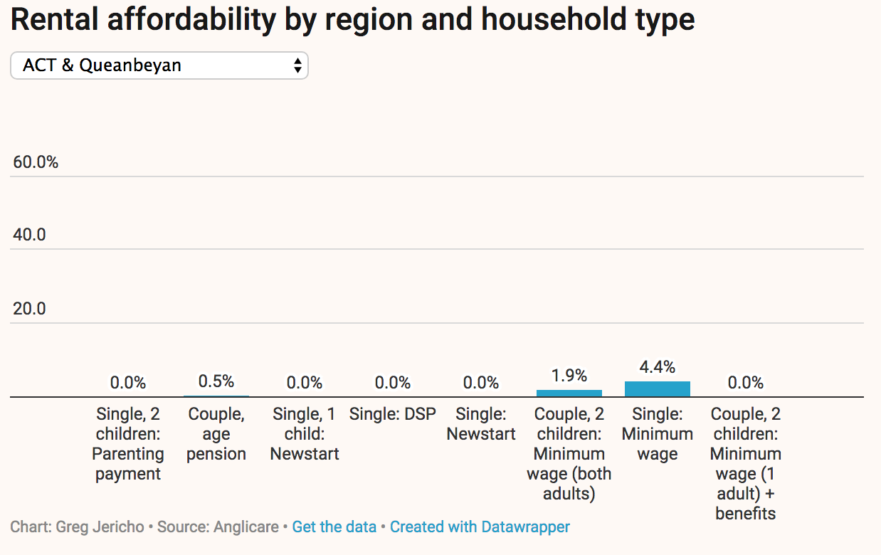
Figure 2 Rental affordability by region and household type based on 2018 Anglicare Rental Affordability Snapshot data, chart created by Greg Jericho
The 2019 Anglicare Rental Affordability Snapshot shows that the situation in the ACT is worse than ever. Data provided to WCHM by Anglicare for the ACT shows that the only households on minimum wage or Centrelink payment income that could afford any appropriate rental property in the ACT were a couple on Age Pension (but not a single person on Age Pension), a single person with no children on minimum wage (but not a single person with children on minimum wage), or a couple with two children on minimum wage plus Family Tax Benefit Part A and B (but only if both parents are working and earning at least minimum wage).
The household that fared the best – single person on minimum wage – could still afford only 4.7 per cent of advertised properties, which is far less than the 8.3 per cent they could afford in 2014. There have been no affordable properties for a single person with children, whether on Newstart Allowance or Parenting Payment, since 2014, apart from 0.1 per cent of properties for a single person with two children receiving Parenting Payment in 2016. In 2015 and 2016, 0.1 per cent of rental properties in the ACT were affordable for a single parent with two children if they earned a full time minimum wage and received Family Tax Benefit A and B.
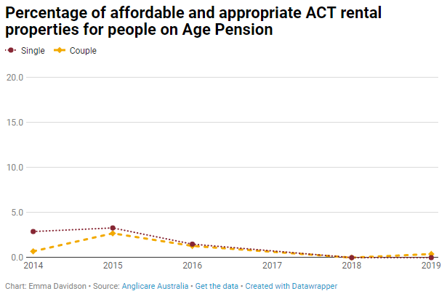
Figure 3 Declining proportion of rental properties in the ACT affordable for people on Age Pension
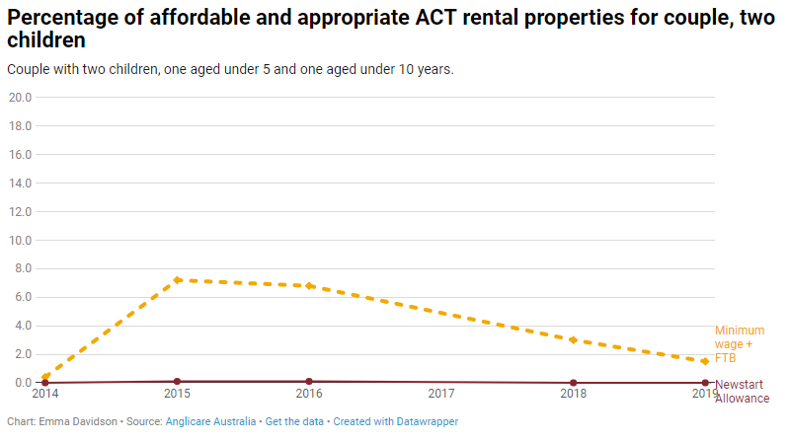
Figure 4 Declining proportion of rental properties in the ACT affordable for a couple with two children. Note that minimum wage means both parents earn a full time minimum wage, while Newstart means neither parent has paid work
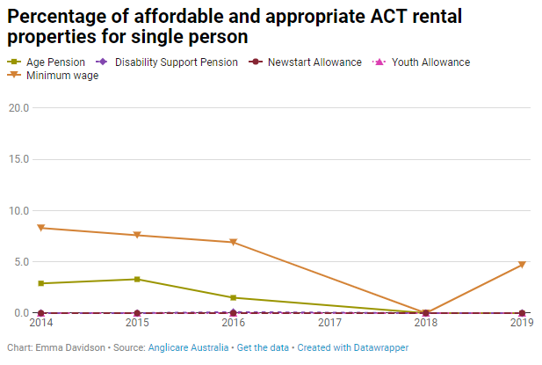
Our analysis of NATSEM’s data shows that twenty four per cent of all women and girls in the ACT lived in a middle income household with mortgage repayments, higher than the Australian capital cities average. An estimated 19.3 per cent of ACT middle income households who paid rent other than to a State or Territory housing authority were already in housing stress, and 27.2 per cent of single parents in three bedroom homes in the ACT were in housing stress.
Figure 5 Declining proportion of rental properties in the ACT affordable for a single person with no children.
Should the women in these households experience a sudden reduction in household income, they would be at risk of being unable to meet mortgage repayments or rent, it would be difficult to find anything affordable in the rental market, and the wait time for public housing is around nine months. These women are at risk of homelessness if this happens.
A 2014 report from Domestic Violence Crisis Service, Staying Home After Domestic Violence, showed most ACT women stayed home after an incident of violence. They also found that 54.6 per cent of women with home ownership and 62.5 per cent of women renting lose their homes within a year of separation.
This is why it is so important that women who have been living in middle income households, but have experienced an unexpected financial setback, are able to access services and support to maintain their existing housing, and that the ACT needs a much higher supply of housing affordable for low income households. Neither the private rental market nor public housing are meeting the needs of women in these circumstances.

Women who do not speak English well
There were 27 suburbs with a high or very high proportion of women in middle income households who do not speak English well, compared to the ACT and the Australian capital cities average. This is close to one third of the suburbs studied having a higher than average proportion of women in middle income households who may need language assistance to access services.
Given the geographic distribution of these women, it is therefore not possible to assume that centralising services that include language assistance will be a solution to their accessibility needs. All services need to be able to accommodate the need for language assistance, such as access to telephone interpreting services, as well as appropriate training for staff in recognising language support needs and the services available to help.

Geographic distribution of women in middle income households in the ACT
High or very high proportions of women in middle income households in the ACT with at least one factor impacting their ability to increase their income were found in 82 of the 97 suburbs studied. These were women still studying or in early career, older than the retirement age, or single and with children impacting their availability for paid work. These women do not have the choice to work more hours, or at a higher hourly rate, to increase their income.
We note that most suburbs in Tuggeranong and west Belconnen had high or very high proportions of women in middle income households with multiple risk factors for their personal financial circumstances, including young women (15 to 24 years), single women with children, and women in middle income households paying mortgages.
There was a correlation between suburbs with a high or very high proportion of young women (15 to 24 years) in middle income households, and those with high or very high proportions of women aged 45 to 64 years in middle income households. Given the high cost of housing in the ACT, and that younger women are more likely to be in insecure or low paid employment, this correlation may reflect that younger women were still living with their parents.
Women at risk were geographically dispersed across the ACT. There is no correlation between factors that put women in middle income households at risk and suburbs with a higher than ACT average Gini coefficient, or a SEIFA IRSAD quintile below 3.
This means their risk of slipping down the socio-economic ladder is not based on living in a suburb that already has high levels of inequality within the suburb, or a generally high level of socio-economic disadvantage. These at risk women are invisible but everywhere in the ACT.
However, we know from previous work by ACTCOSS that there are pockets of disadvantage within Canberra’s suburbs at the SA1 level. Because these are areas of around 150 households, they are much smaller than the size of a suburb. These areas are less visible when looking at the socio-economic situation of the suburb as a whole because of high income households bringing up the average for the suburb.
The impact of parking costs, cost of maintaining a car, or additional time required to use public transport on education and employment choices can have flow-on effects for future choices. This creates a compounding effect for women who are already struggling to improve their and their family’s socio-economic status.
It may also mean that a woman is unable to seek paid work that would improve her personal income if it requires a dramatic increase in travel time, or parking is too expensive.
Women in outer suburbs, such as Tuggeranong and West Belconnen, with very high proportions of women in low income and middle income households, may find that their location further away from services that have only one location in Canberra (often in the city) impacts on their ability to find the information and services they need if they experience an unexpected change from middle to low household income.

The following chart shows that when looking at an area as large as a suburb in the ACT, levels of disadvantage do not show up in high proportions.
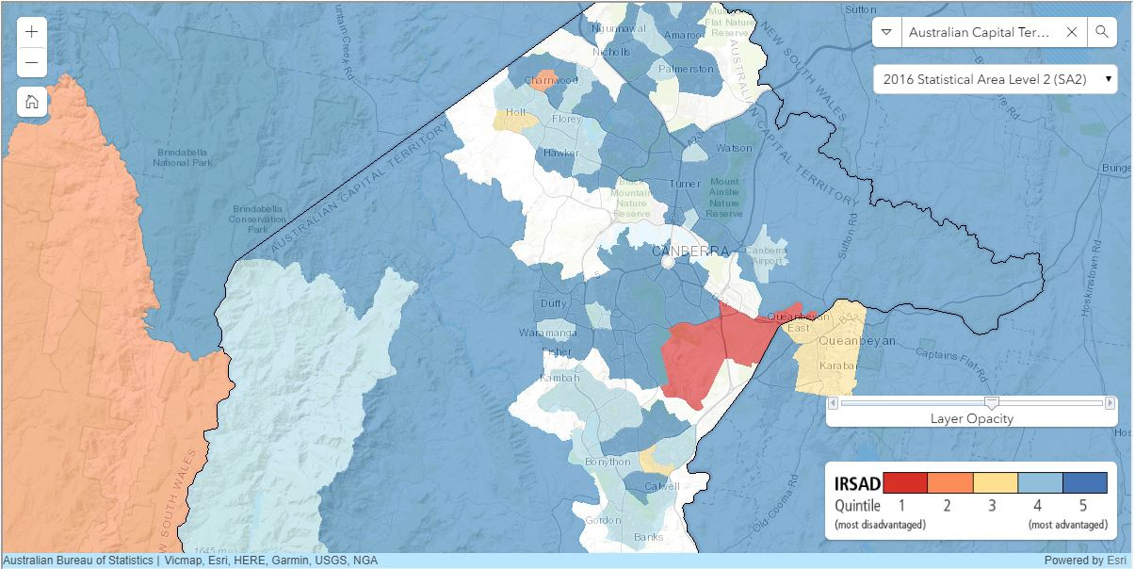
Figure 6 Map of SA2 (suburb) areas in the ACT. Most of the areas are dark blue or light blue, representing the top 40% of the national SEIFA IRSAD index (socio-economic advantage and disadvantage). The red area is Symonston, where most of the area is industrial and the only residents were in a long stay caravan park.
But when looking at areas smaller than suburbs, of around 150 households, we can see that there are small areas of the ACT with high proportions of disadvantage, and that there are more of these small areas with high proportions of people experiencing disadvantage in Tuggeranong and West Belconnen than in the middle of the city:
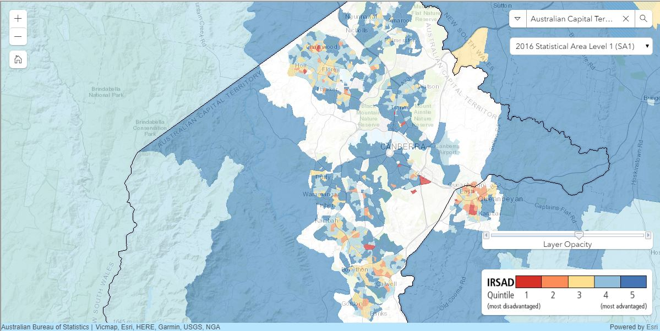
Figure 7 Map of SA1 areas (around 150 households) in the ACT. There are a mix of 5 different colours, representing the quintiles of the national SEIFA IRSAD index (socio-economic advantage and disadvantage). The areas of Symonston that had no residents no longer appear red, and instead are unshaded.

Conclusion
Many women living in the ACT were living in either low or middle income households. Many of these women had low personal incomes, and were reliant on parent’s or partner’s income for their middle income status. At least 44.7 per cent of all ACT women and girls in middle income households are most likely only in a middle income household due to parent or partner income. Because these women were dispersed across most suburbs in the ACT, their situation was masked by high averages, and their need for support may not be obvious to the community. These women and girls would be at risk of living in poverty if family relationships break down, or the primary income earner experiences a loss of income.
The ACT had a higher than average proportion of single women with children earning middle incomes who were juggling paid work with child caring responsibilities. These women were unlikely to be eligible for government services and supports because of their income from paid employment, but they still faced high housing and childcare costs in the ACT. In fact, single women with children in the ACT were more likely to be in paid work than reliant only on welfare support as an income source.
The ACT also had a higher than capital cities average proportion of women in middle income households who were paying a mortgage. Given the high cost of private rental housing in the ACT, supporting women in middle income households to stay in their home after a relationship breakdown or loss of income would reduce further housing stress and homelessness. An increase in private rental market properties that are affordable for low and middle income households, preferably to the level where affordable housing is in oversupply, would also provide options for those who need to move to more affordable housing if their circumstances change, or who want to save for a deposit to move to home ownership.
It is said that a rising tide floats all boats. But in the case of women in the ACT, the rising tide of wages growth has not changed the inequality gap between men and women, and has not changed the fact that many women are only in a middle income household because of their partner’s higher income. This has left them in a housing market that expects a capacity to pay that, for many women without the financial support of parents or partner, simply does not exist.
Women living in middle income households in the ACT are at risk of homelessness if they experience a relationship breakdown, loss of employment for the higher income earner in the household, loss of security of tenure on their rented home, or death of the higher income earner in their household. Any of these events may be more than they have the resources to manage without assistance. This may result in difficulty in paying for housing, carer costs for children or family members with a disability, education, transport (which may be necessary to maintain employment), healthcare, or food.
Added to this risk for women is the invisibility of their situation when looking at suburbs as communities. While this reduces the risk of stigmatising an entire suburb, it doesn’t take away the disadvantage being experienced by some people who live in an upper middle class suburb. Instead, it runs the risk of sweeping that disadvantage under the carpet where nobody sees it, and so nobody is thinking about ways in which to better support those people in our community who need our help.
Death, disability, domestic violence, divorce, or decreased work income can happen to anyone. But when it happens to a woman in a middle income household in the ACT, particularly if she is then single with children and on a lower income, it can lead to homelessness, pressure to cut costs on other necessities, or increased debt to avoid homelessness. It is important that we understand that these women are everywhere in the ACT, and that suburbs where socioeconomic disadvantage is not noticeable do have women who need support.

Appendix A: Disadvantage in the ACT by Gender

- Proportion of women living in middle income households is calculated as:
$$=\frac{\begin{aligned}Number of women in the area living in households where the \\ equivalised income is between \$52-\$103,999 per year \end{aligned}}{\begin{aligned}Total number of women living in households with \\ stated income in the area\end{aligned}}$$
- Proportion of women aged 0-14 living in middle income households is calculated as:
$$=\frac{\begin{aligned}Number of women aged 0-14 \\ in the area living in households where the \\ equivalised income is between \$52-\$103,999 per year \end{aligned}}{\begin{aligned}Total number of women aged 0-14 living in households with \\ stated income in the area\end{aligned}}$$
- Proportion of women aged 15-24 living in middle income households is calculated as:
$$=\frac{\begin{aligned}Number of women aged 15-24 \\ in the area living in households where the \\ equivalised income is between \$52-\$103,999 per year \end{aligned}}{\begin{aligned}Total number of women aged 15-24 living in households with \\ a stated income in the area\end{aligned}}$$
- Proportion of women aged 25-44 living in middle income households is calculated as:
$$=\frac{\begin{aligned}Number of women aged 25-44 \\ in the area living in households where the \\ equivalised income is between \$52-\$103,999 per year \end{aligned}}{\begin{aligned}Total number of women aged 25-44 living in households with \\ a stated income in the area\end{aligned}}$$
- Proportion of women aged 45-64 living in middle income households is calculated as:
$$=\frac{\begin{aligned}Number of women aged 45-64 \\ in the area living in households where the \\ equivalised income is between \$52-\$103,999 per year \end{aligned}}{\begin{aligned}Total number of women aged 45-64 living in households with \\ stated income in the area\end{aligned}}$$
- Proportion of women aged 65 and over living in middle income households is calculated as:
$$=\frac{\begin{aligned}Number of women aged 65 and over \\ in the area living in households where the \\ equivalised income is between \$52-\$103,999 per year \end{aligned}}{\begin{aligned}Total number of women aged 65 and over living in households with \\ stated income in the area\end{aligned}}$$

- Proportion of women who are female headed sole parent families and living in middle income households is calculated as:
$$=\frac{\begin{aligned}Number of women in the area who are female headed sole parent families living in households \\ where equivalised income is between \$52-\$103,999 per year \end{aligned}}{\begin{aligned}Number of women living in households with stated income excluding \\ dependent children and students\end{aligned}}$$
- Proportion of women who are unemployed and living in middle income households is calculated as:
$$=\frac{\begin{aligned}Number of women in the area who are employed and living in households where the \\ equivalised income is between \$52-\$103,999 per year \end{aligned}}{\begin{aligned}Number of women living in househeolds with stated income and \\ stated labour force status excluding not in the labour force\end{aligned}}$$
- Proportion of women working full time in low paid industries and living in middle income households is calculated as:
$$=\frac{\begin{aligned}Number of women in the area who work full time in low paid industries and living in households \\ where the equivalised income is between \$52-\$103,999 per year\end{aligned}}{\begin{aligned}Number of women living in households with stated income and stated labour force status \\ \left(employed only\right)\end{aligned}}$$
- Proportion of women working part time in low paid industries and living in middle income households is calculated as:
$$=\frac{\begin{aligned}Number of women in the area who work part time in low paid industries and living in households \\ where the equivalised income is between \$52-\$103,999 per year\end{aligned}}{\begin{aligned}Number of women living in households with stated income and stated labour force status \\ \left(employed only\right)\end{aligned}}$$
- Proportion of women who do not speak English well and living in middle income households is calculated as:
$$=\frac{\begin{aligned}Number of women in the area who do not speak English well or do not speak English at all and \\ living in households where equivalised income is between \$52-\$103,999 per year\end{aligned}}{\begin{aligned}Number of women living in households with stated income and stated proficiency in English\end{aligned}}$$
- Proportion of women living in public housing and living in middle income households is calculated as:
$$=\frac{\begin{aligned}Number of women in the area who live in public housing and \\ households where equivalised income is between \$52-\$103,999 per year\end{aligned}}{\begin{aligned}Number of women living in households with stated income and stated tenure type\end{aligned}}$$
- Proportion of women living in households who pay mortgage and in middle income households is calculated as:
$$=\frac{\begin{aligned}Number of women in the area who live in households who pay mortgage and \\ households where equivalised income is between \$52-\$103,999 per year\end{aligned}}{Number of women living in households with stated income and stated tenure type}$$

Notes
The small area unit we use is SA2 which is a general-purpose medium-sized area which aims to represent a community that interacts together socially and economically. SA2s generally have a population range of 3,000 to 25,000 persons. SA2s are aggregations of whole SA1s. (ABS, 2016).
Equivalised household income is total household income adjusted by the application of an equivalence factor to facilitate comparison of income levels between households of differing size and composition, reflecting the requirement of a larger household to have a higher level of income to achieve the same standard of living as a smaller household (ABS, 2016b). This factor is one for the first adult; 0.5 for each additional household resident aged over 15; and 0.3 for each household resident aged under 15.
When looking at very small areas, if the numerator is very small, then a small change in the denominator can cause a large change in a percentage. For example, if there are 10 women in an area and one is on a low income, then another one on low income adds 10 per cent to the low income rate. This can lead to significant instability. For this reason, any areas with less than 30 units (women in the respective denominator for each indicator) are removed from our analysis.
Low paid industries include five industries which were at the bottom five of industries with the lowest average weekly total cash earnings (rates of pay) according to the ABS, Employee Earnings and Hours, May 2016:
- accommodation and food services;
- retail trade;
- arts and recreation services;
- other services (repair and maintenance, personal and other services, private households employing staff and undifferentiated goods and services-producing activities of households for own use, other services nfd, (not further defined)); and
- administrative and support services
and those who work in the community services industry which covers:
- residential care services: aged care residential services, other residential services, and residential care services, nfd (not further defined); and
- social assistance services: child care services, other social assistance services and social assistance services, nfd (not further defined).

E Davidson, Hidden disadvantage among women in the ACT, Women’s Centre for Health Matters, Canberra, June 2018, viewed online 31 May 2019: http://www.wchm.org.au/hidden-disadvantage-among-women-in-the-act/
Women’s Centre for Health Matters, Beyond Crisis: Working with Canberra’s professional firms and businesses to make safer choices easier for survivors of domestic violence, Canberra, July 2017, p 14, viewed online 31 May 2019: http://www.wchm.org.au/beyond-crisis-working-canberras-professional-firms-businesses-make-safer-choices-easier-survivors-domestic-violence/
ibid
Ibid, pp 13-18
R Tanton, R Miranti & Y Vidyattama, Hidden disadvantage in the ACT: Report for ACT Anti-Poverty Week, Canberra, October 2017
ibid
R Tanton, R Miranti & Y Vidyattama, Hidden disadvantage in the ACT: Report for ACT Anti-Poverty Week, Canberra, October 2017
E Davidson, Hidden disadvantage among women in the ACT, Women’s Centre for Health Matters, Canberra, June 2018, viewed online 31 May 2019: http://www.wchm.org.au/hidden-disadvantage-among-women-in-the-act/
R Tanton, R Miranti & Y Vidyattama, Hidden disadvantage in the ACT: Report for ACT Anti-Poverty Week, Canberra, October 2017
Australian Bureau of Statistics, 2017, 2016 Census Quickstats: Australian Capital Territory (Statistical Area Level 4), viewed 21 January 2019, http://quickstats.censusdata.abs.gov.au/census_services/getproduct/census/2016/quickstat/801?opendocument
Australian Bureau of Statistics, 2016 Census Quickstats, viewed 28 June 2018, http://www.censusdata.abs.gov.au/census_services/getproduct/census/2016/quickstat/801?opendocument
E Davidson, Hidden disadvantage among women in the ACT, Women’s Centre for Health Matters, Canberra, June 2018, p 11, viewed online 31 May 2019: http://www.wchm.org.au/hidden-disadvantage-among-women-in-the-act/
Australian Bureau of Statistics 2018, Estimates of Personal Income for Small Areas, 2011-16, “Table 4c ESTIMATES OF PERSONAL INCOME, Employee Income by age and sex, 2011-16, Statistical Area Level 3, Tas., NT, ACT and Other Territories (a)”, data cube: Excel spreadsheet, cat. no. 6524.0.55.002, viewed 19 June 2018, http://www.abs.gov.au/AUSSTATS/abs@.nsf/ProductsbyReleaseDate/974D8F81A12F336BCA257521000D8620?OpenDocument
Tanton, R., Miranti, R. and Vidyattama, Y., (2017), Hidden disadvantage in the ACT: Report for ACT Anti-Poverty Week, NATSEM, Institute for Governance and Policy Analysis (IGPA), University of Canberra. Report commissioned by the ACT Council of Social Service Inc.
Australian Bureau of Statistics, 2016 Census - Selected Dwelling Characteristics, TableBuilder. Findings based on use of ABS TableBuilder data.
Data on Gini coefficients based on equivalised household income provided by NATSEM. See also R Tanton, Y Vidyattama, B Nepal, and J McNamara, 2011, “Small area estimation using a reweighting algorithm”, Journal of the Royal Statistical Society: Series A (Statistics in Society), 174(4), 931–951. doi:10.1111/j.1467-985X.2011.00690.x
Australian Bureau of Statistics, 2018, Socio-Economic Indexes for Areas (SEIFA) 2016, viewed 15 June 2018: http://www.abs.gov.au/ausstats/abs@.nsf/Lookup/by%20Subject/2033.0.55.001~2016~Main%20Features~IRSAD%20Interactive%20Map~16
Productivity Commission, Report on Government Services 2018, Part B, Chapter 3 – Early Childhood Education and Care, Chapter 3 – Attachment tables, viewed online 28 June 2018, https://www.pc.gov.au/research/ongoing/report-on-government-services/2018/child-care-education-and-training/early-childhood-education-and-care
Legislative Assembly for the Australian Capital Territory, Standing Committee on Education, Employment and Youth Affairs, 8 September 2017, Inquiry into the extent, nature and consequence of insecure work, Transcript of Evidence, Canberra, p 48, viewed online 28 June 2018, http://www.hansard.act.gov.au/hansard/2017/comms/education03a.pdf
Environment, Planning and Sustainable Development Directorate, Towards a New Housing Strategy: An ACT Community Conversation, Canberra, July 2017, viewed online 9 May 2018, https://www.yoursay.act.gov.au/application/files/5215/2342/3267/discussion_paper.pdf
Housing affordability and the labour market in the ACT, Housing and Homelessness Policy Consortium, ACT, 2015, viewed 29 June 2017, https://www.actcoss.org.au/sites/default/files/public/publications/2016- consortium-project-2-report-housing-affordability-and-the-labour-market-in-the-act.docx
ACT, Parliamentary Debates, Legislative Assembly, 11 April 2018, p. 1289, viewed online 9 May 2018: http://www.hansard.act.gov.au/hansard/2018/pdfs/20180411.pdf
Anglicare Australia, 2018 Rental Affordability Snapshot, Canberra, 2018, p. 5.
E Davidson, Lock up your lattes, the housing revolution is coming!, On Line Opinion, Australia, 10 May 2012, viewed online 9 May 2018, http://www.onlineopinion.com.au/view.asp?article=13599
Women’s Centre for Health Matters, Beyond Crisis: Working with Canberra’s professional firms and businesses to make safer choices easier for survivors of domestic violence, Canberra, July 2018, pp 13-14

